CamHiPro APPInstructions V2.4



IOS Android

Content

1. Software description 3
2. Add camera 3
2.1 Add device via Bluetooth 3
2.2 Add Device via QR Code 6
2.3 Add Device via Access Point(AP) 20
3. Delete camera 23
4. View the camera 24
5. Function description 24
6. Camera parameters 28
6.1 Share device 29
6.2 Cloud storage information 30
6.3 Cloud storage sharing 30
6.4 Wireless setting 31
6.5 Change password 31
6.6 Video mask 32
6.7 Alarm management and notification 33
6.8 Video setting 38
6.9 Audio setting 38
6.10 TF card plan recording 39
6.11 TF card setting 39
6.12 Time setting 39
6.13 Default setting 40
6.14 Device information 40
7. Video/Image search and view 41
8. Other functions 44

1. Software description
The app CamHiPro is a tool for managing ip cameras. It can be used to monitor the image of the ip camera on the LAN and the Internet. The APP supports LAN search to add ID number and manually input camera ID number, support bluetooth, sound wave, AP configuration WIFI, device add, delete and edit functions, support audio monitoring and intercom, support capture images to mobile phone, support image quality level setting, support remote Download video files and other functions.

2. Add camera
Install the APP, connect the mobile phone to the WIFI network, enter the APP and click the Add Device button to enter the Add Device interface. If it is the first time to use or restore the factory settings: the camera is not connected to the network, clicking the new device; the camera that has connected to the network, clicking on the device in use.
There are several ways to add a device: adding via Bluetooth, adding by scanning a QR code, and adding by manually inputting the device ID.

2.1 Add device via Bluetooth
When adding a new device, you can quickly add it via Bluetooth. First, turn on the Bluetooth function on your mobile phone. Then, power on the device. After hearing a prompt tone from the device, click the "Add Device" button on the CamHiPro app. The CamHiPro app will prompt that a new device has been detected, as shown in the figure:
When adding a device, you can refer to the following operation steps.

Step1: Add Camera
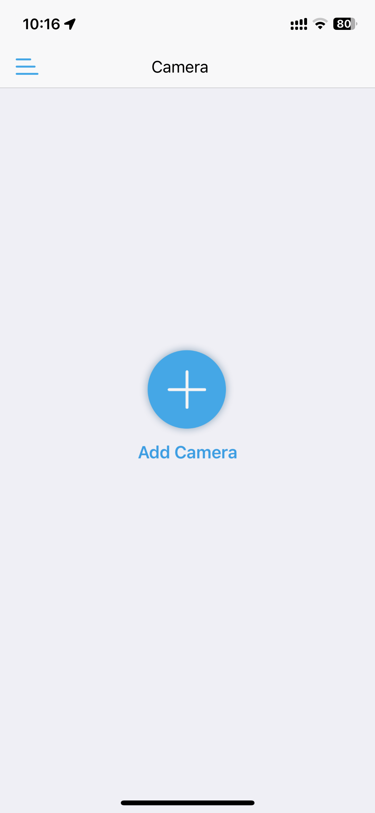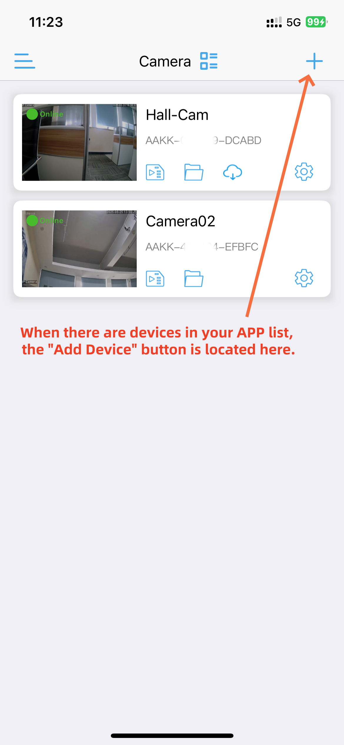

Step 2: Searching for Bluetooth Devices
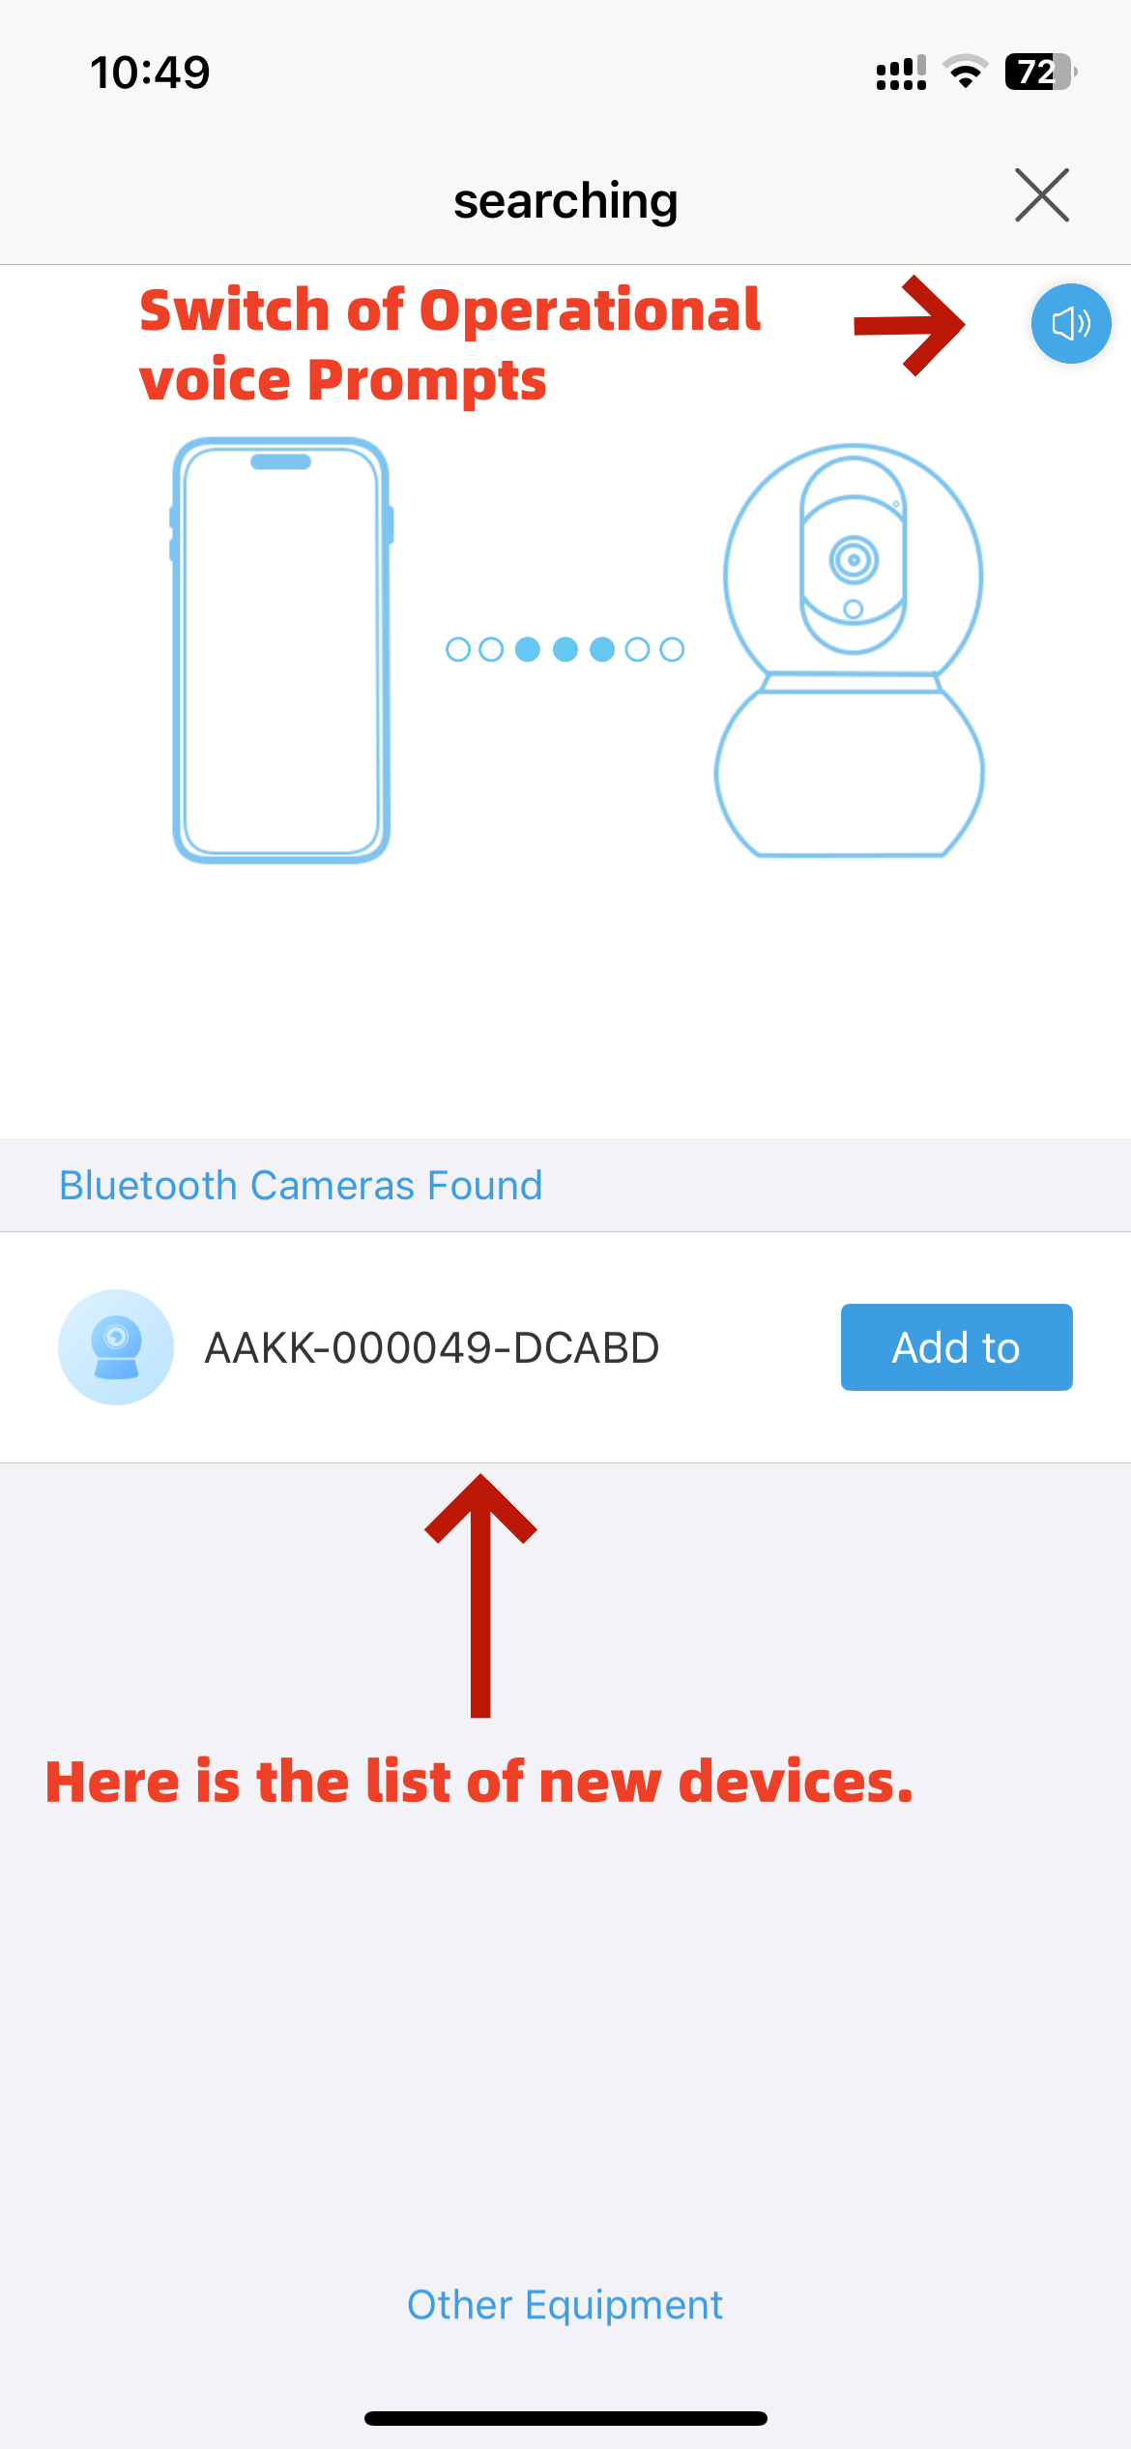
After you click the "Add Device" button, the app will search and detect new devices, then the new devices will be displayed in the new device list.
The app supports voice operation prompts and automatically matches the voice prompts according to the corresponding language settings.

Step 3: Wireless configuration
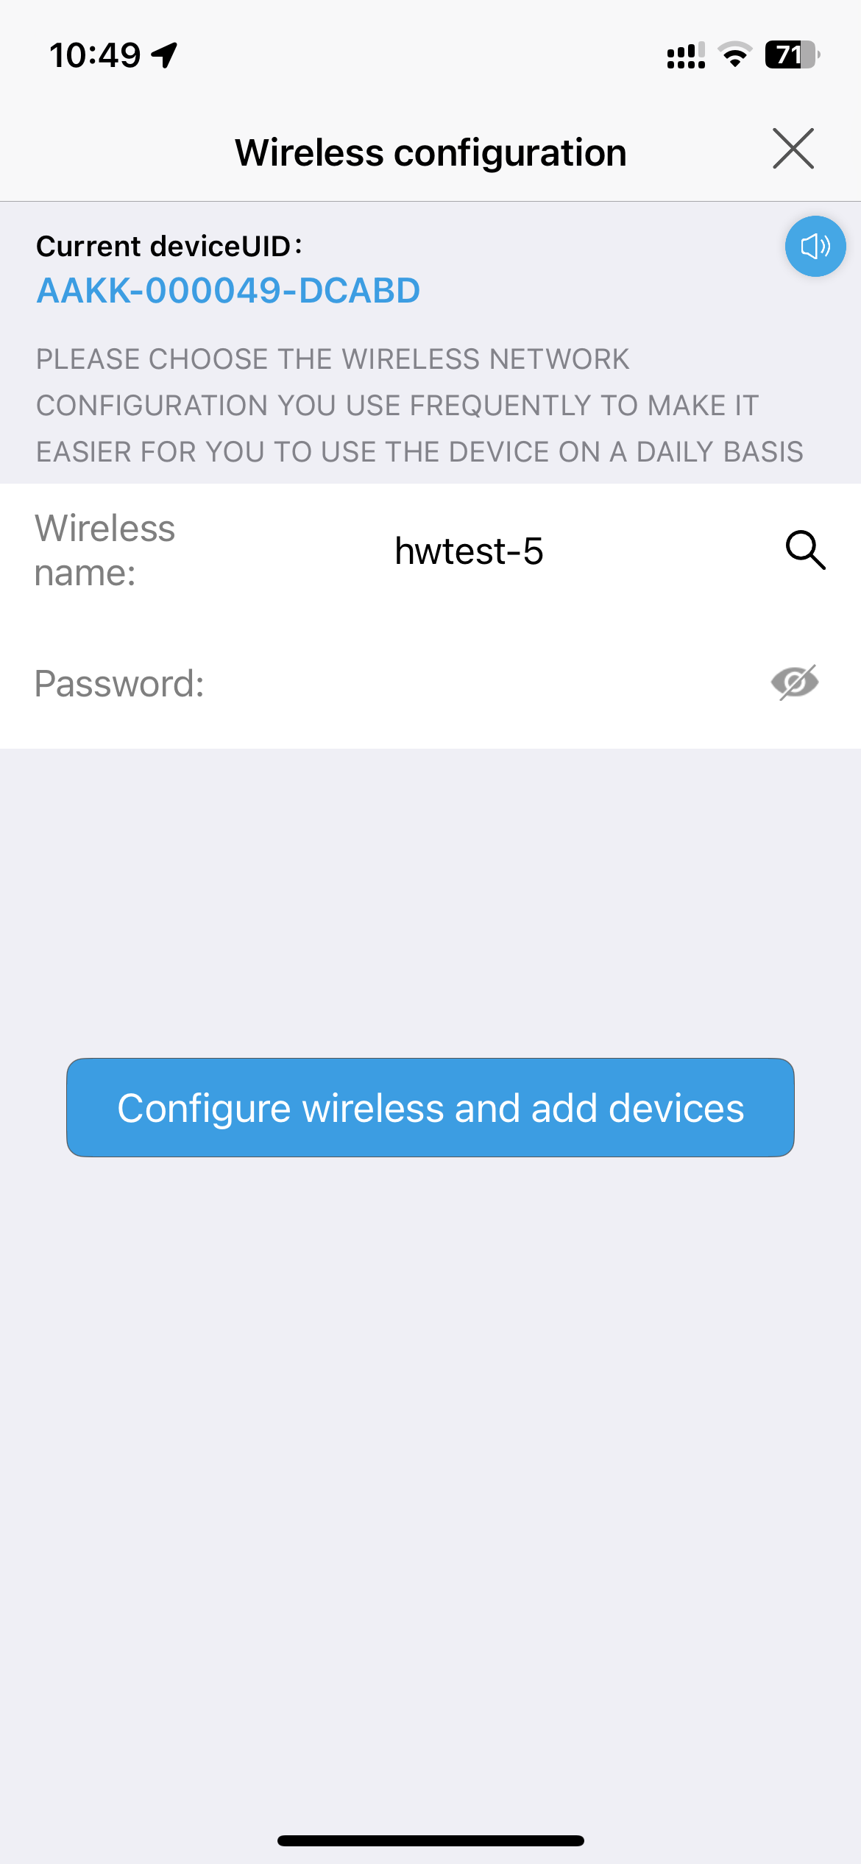After selecting the device that has been searched, press the "Add to" button to proceed to the next step, where you will configure the wireless network.
If your mobile phone is already connected to a Wi-Fi network, the app will automatically recognize and display the phone's Wi-Fi network.
You can also click the search button to find nearby Wi-Fi networks. Then, enter the corresponding Wi-Fi password and click "Configure wireless and add devices".

Then, the tips will pop up, asking you to confirm whether the Wi-Fi network and password are correct. If yes, click "determine" to proceed.

Step 4: Successfully added
Follow the prompts to operate until the device is successfully added.

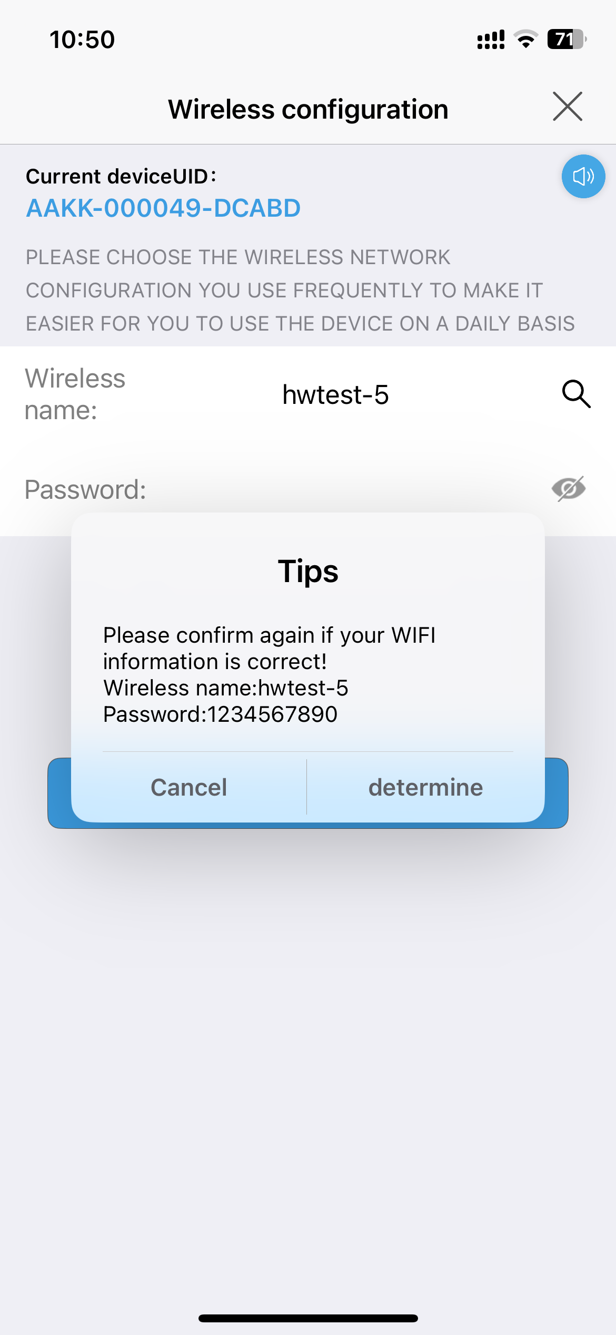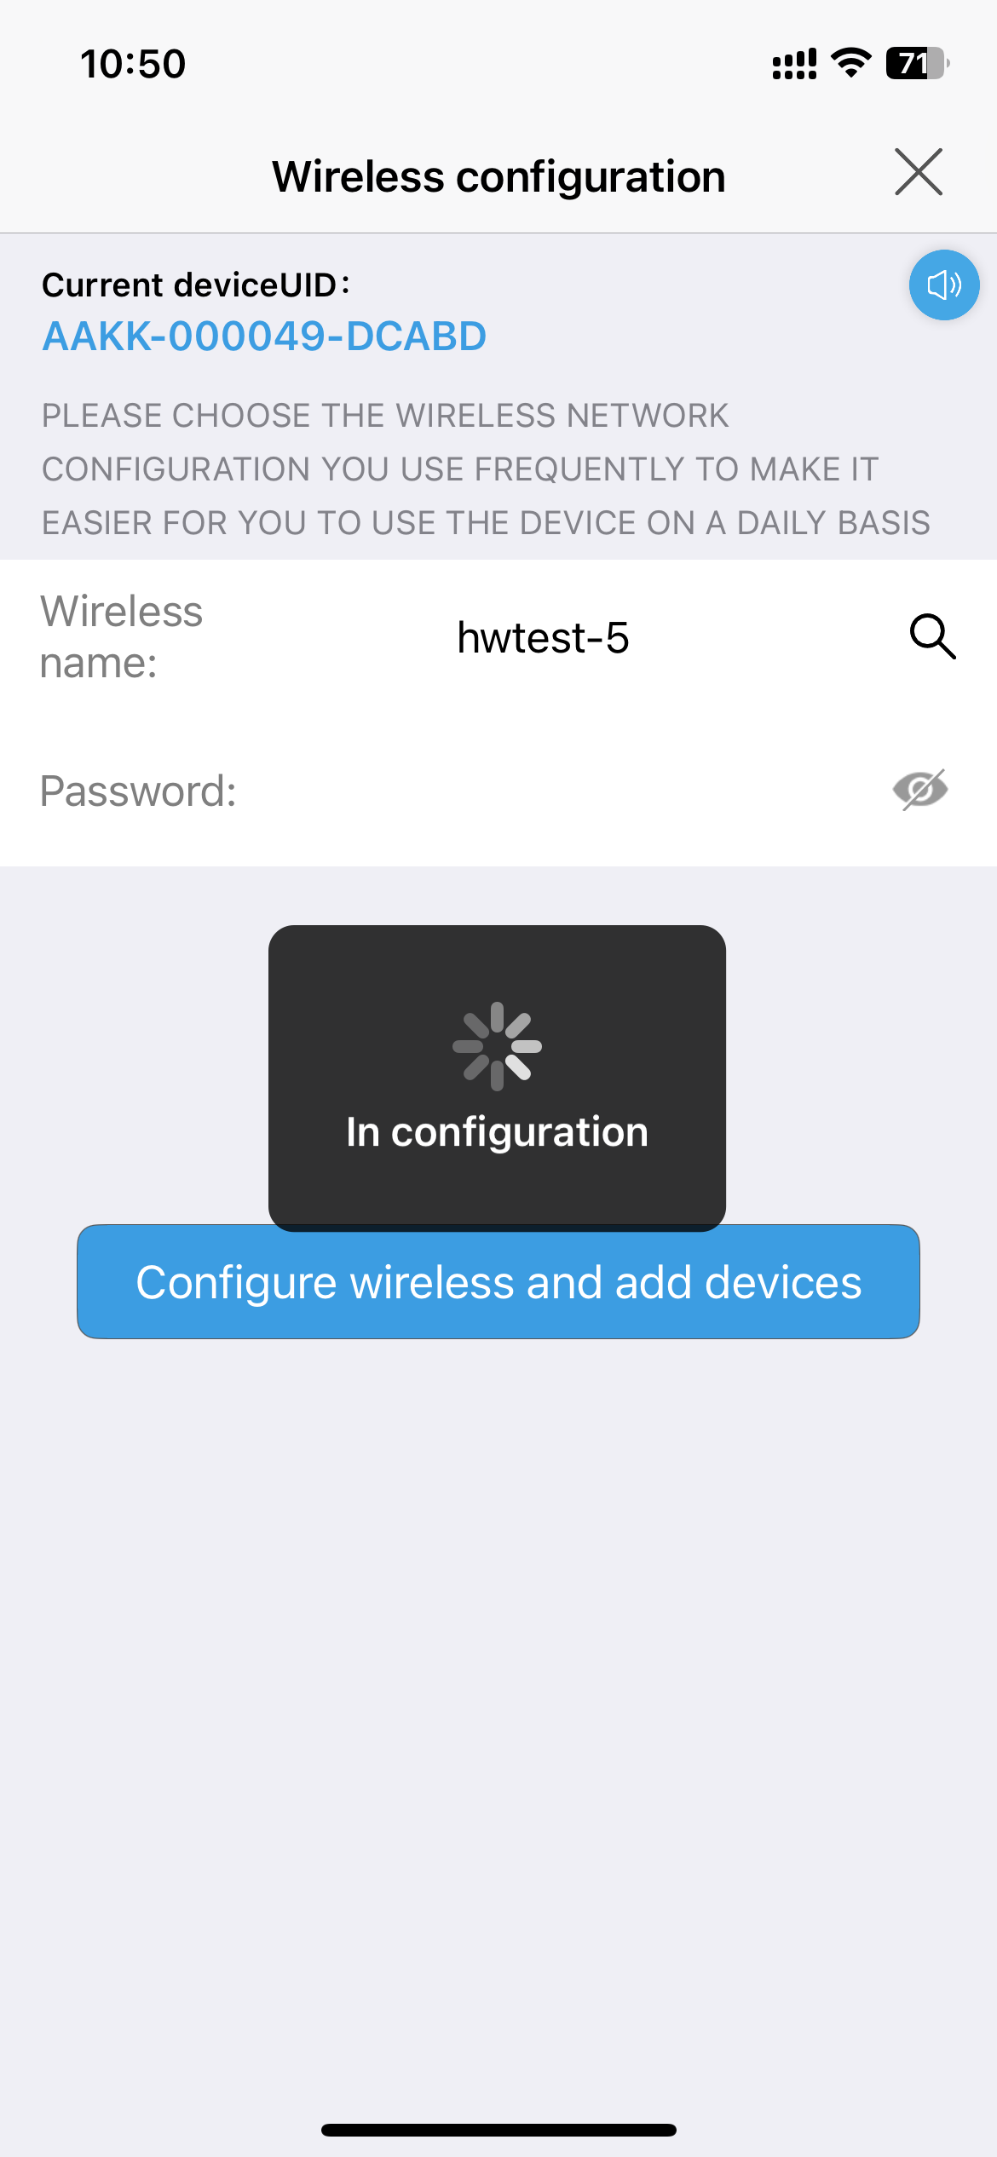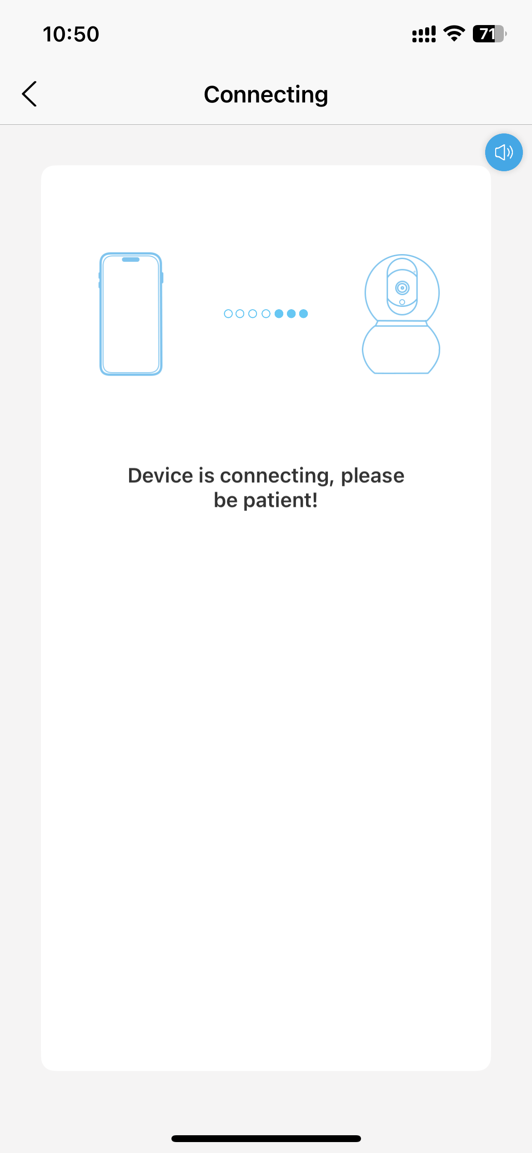

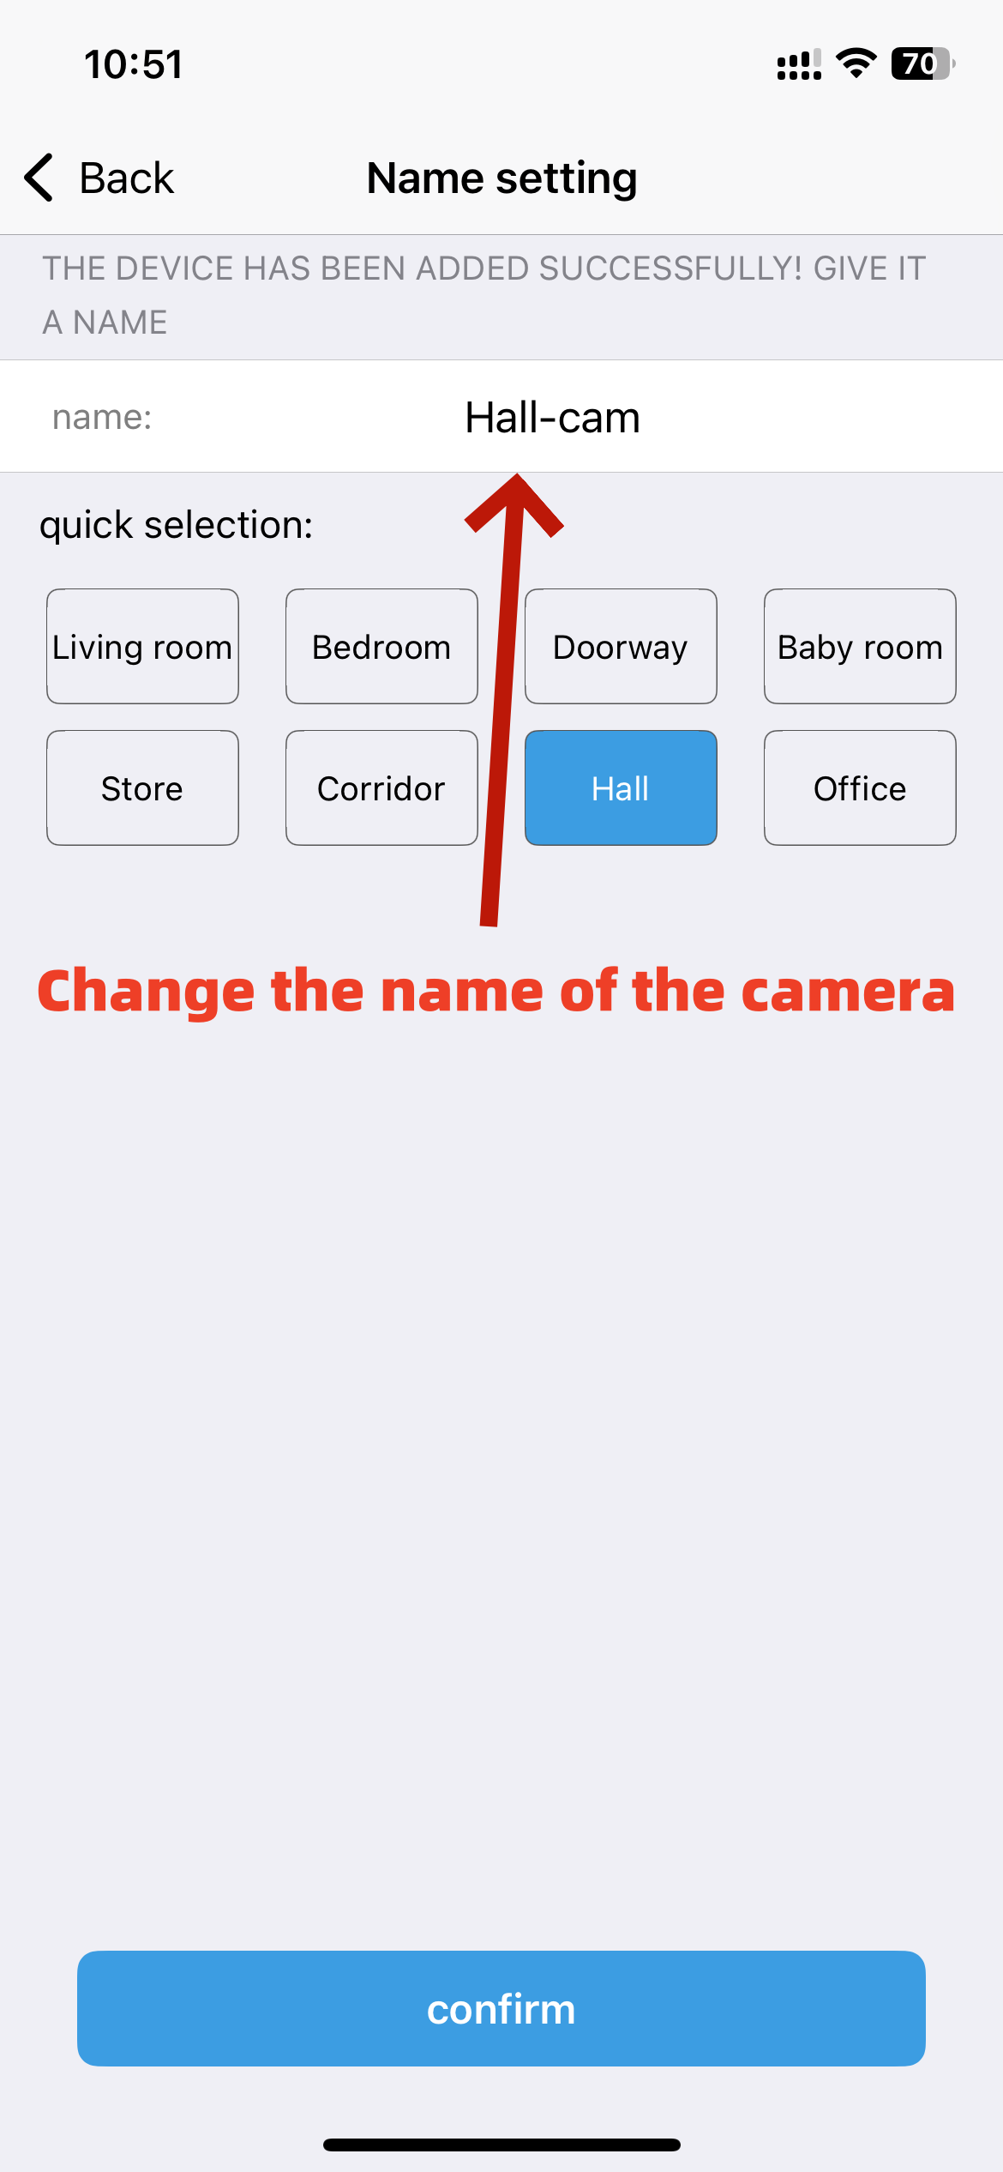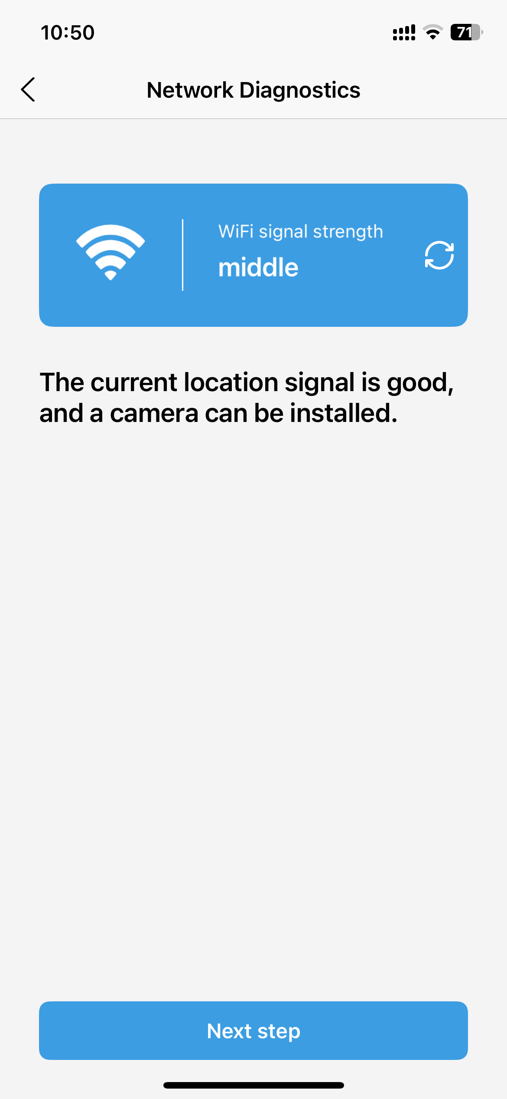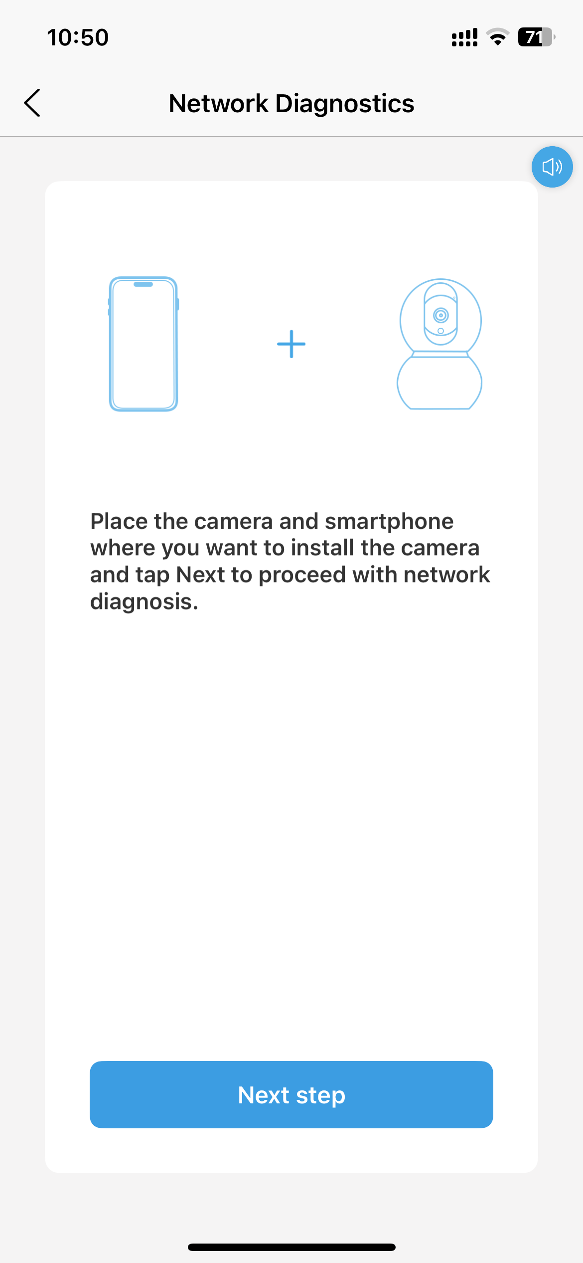

Step5: Device added successfully. Start using it.
To protect the security of your device, you need to reset the login password for the device when using it for the first time. It's extremely important to remember this password. If you lose it, you won't be able to use the device normally.
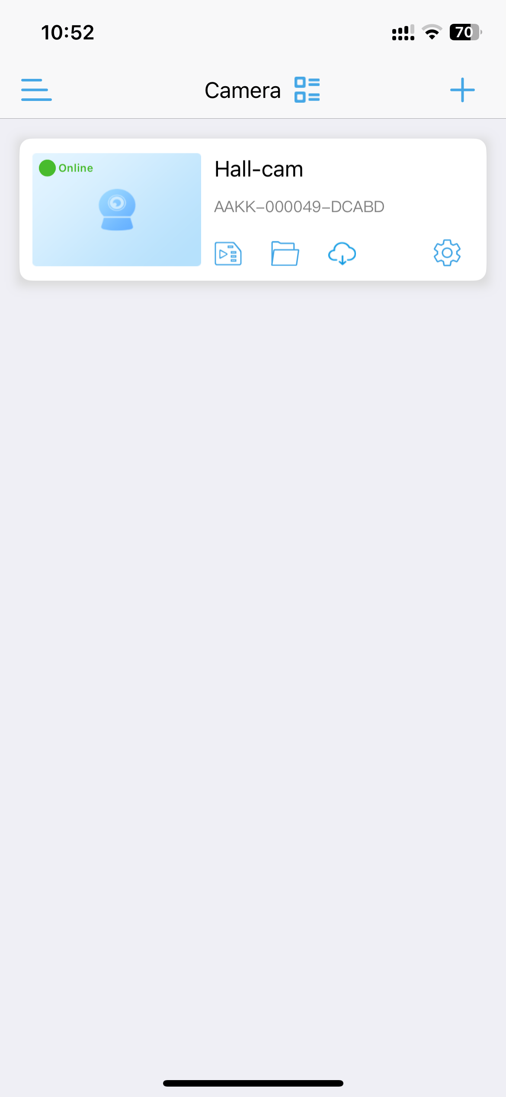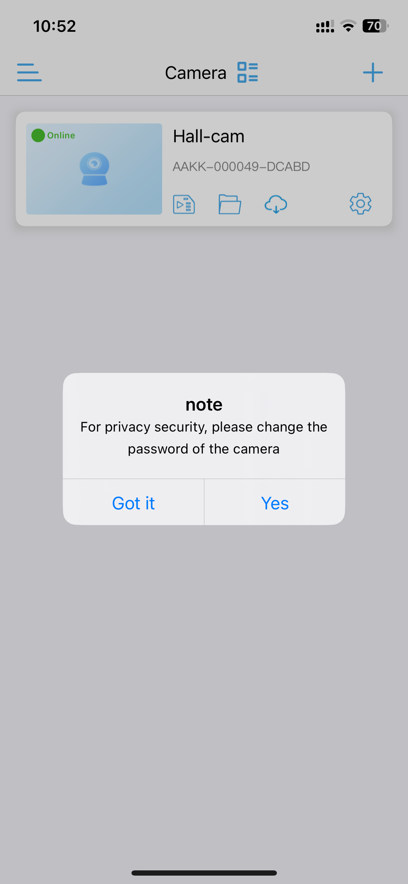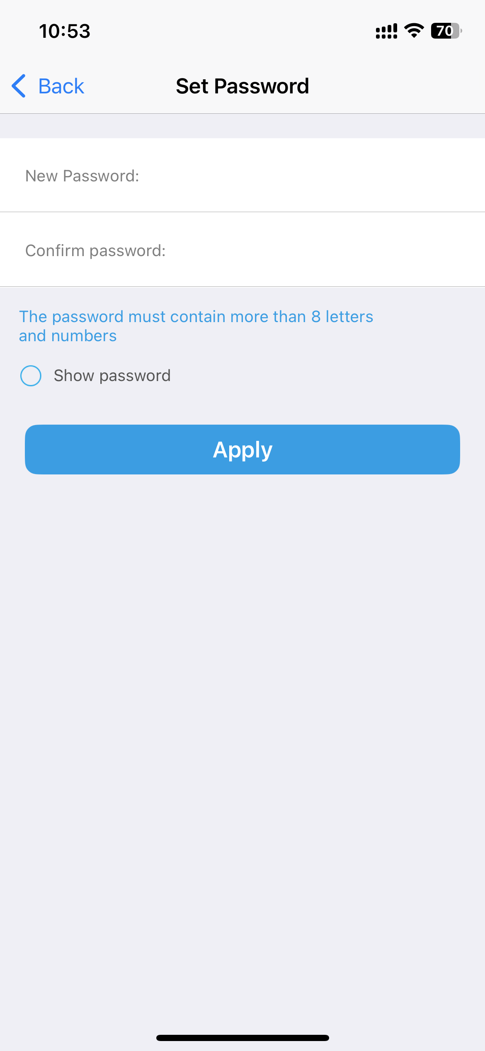

2.2 Add Device via QR Code

Step 1: Add Camera and Select the device type
If you want to add a device using other methods, you can select the "Other Equipment" button.Then, you need to select the device type;
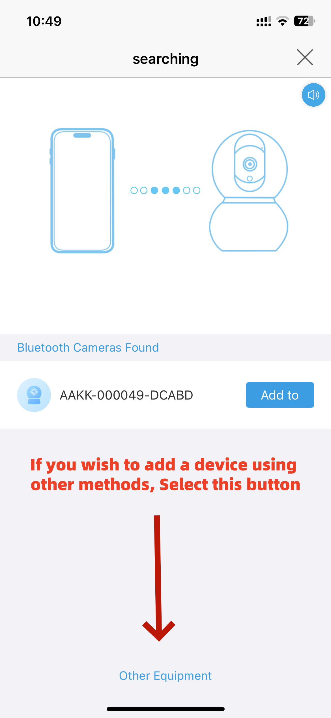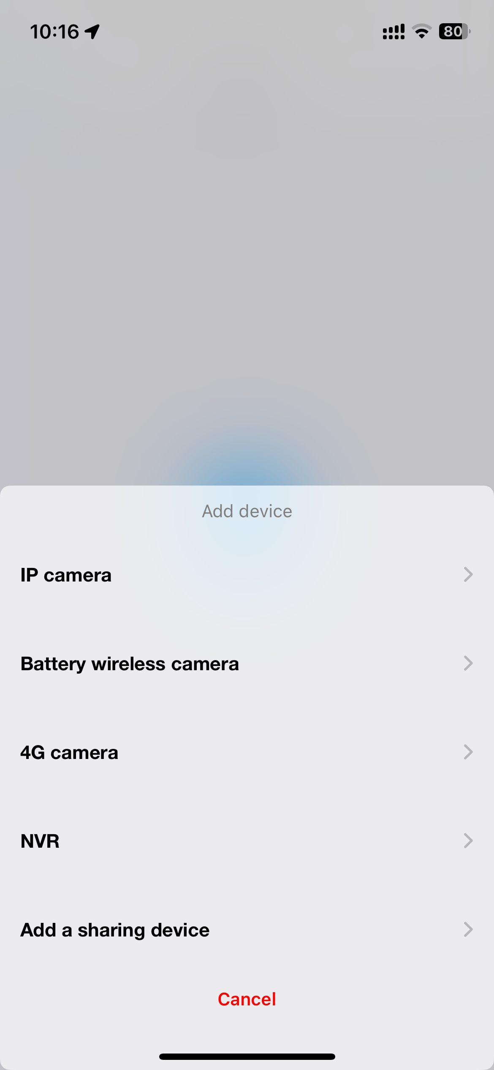
If the device does not support Bluetooth networking functionality, then after selecting the "Add Device" button, the window for selecting the device type will be displayed directly
There are 5 types of devices:
IP Camera、Battery wireless camera、4G camera、NVR、Add a sharing device.You need to make a selection based on the actual type of the device.

Step2: Scan the QR code of the device
You can quickly add a device by scanning the QR code on it.
First, turn on your phone's Wi-Fi connection, and then power on the device, and wait for about 30 senconds to confirm the device is working.
And then, enter the “Power is on,next step”,to enter the page for connecting to the camera's Wi-Fi.The lan netword “IPCAM-XXXX” is the camera’s hostpot.You need to connect to the camera's hotspot network before you can configure the camera for network connectivity. Select “join”to next page.

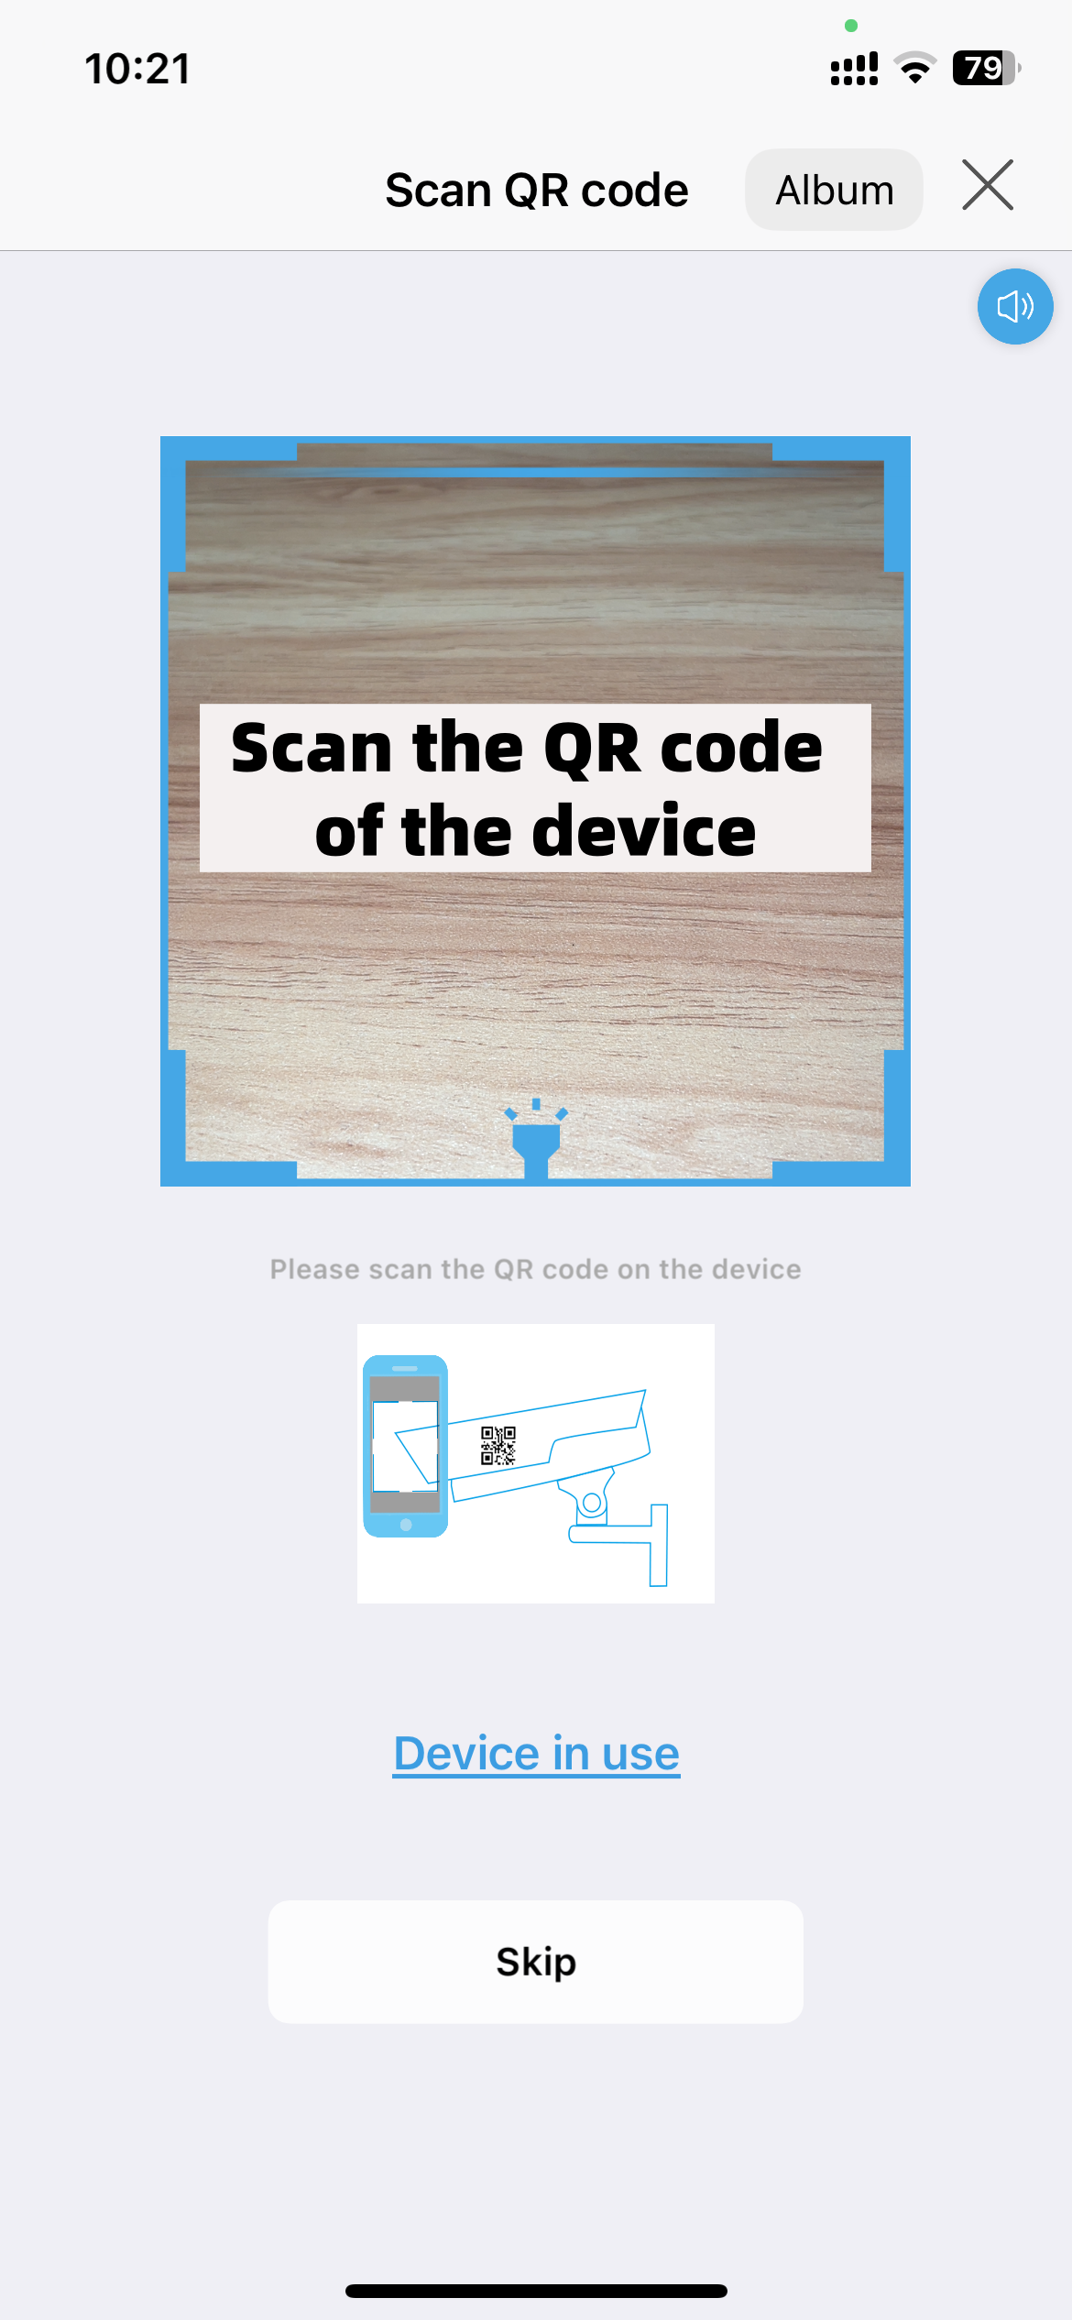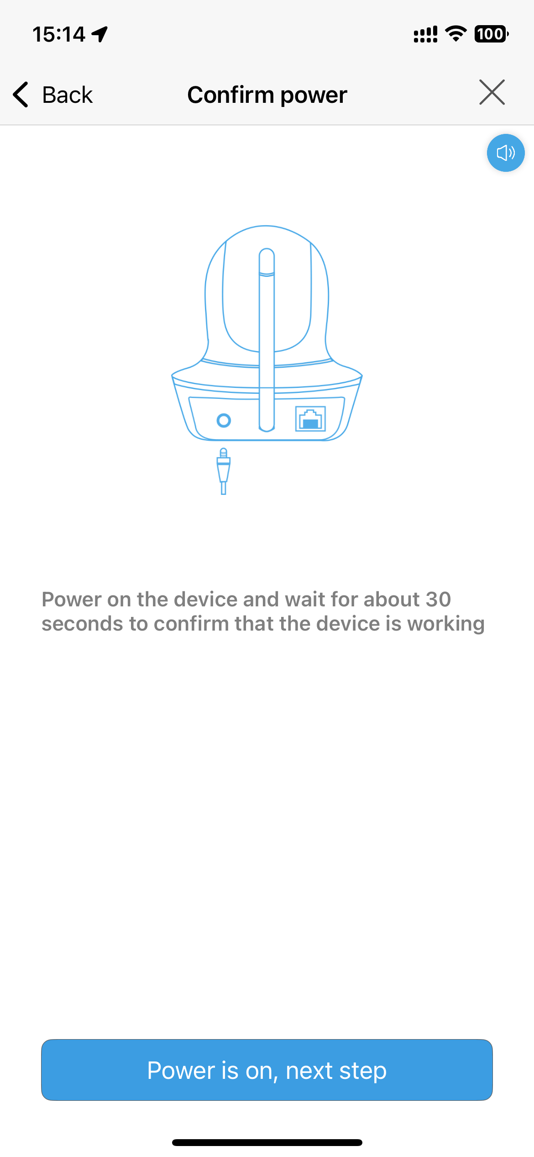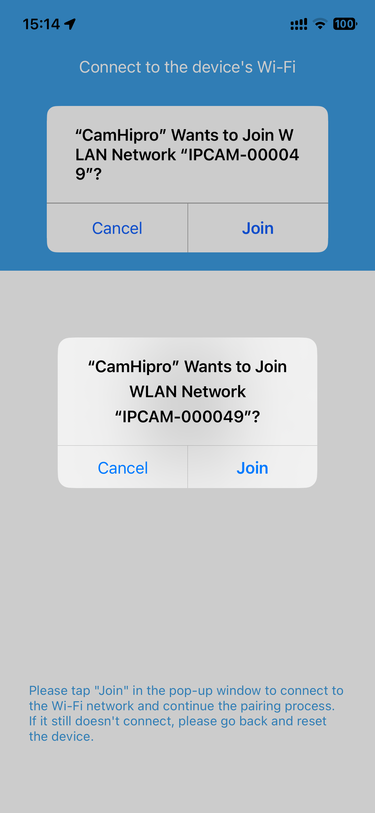
On the interface for scanning the QR code to add a device, if you select "Skip", you will be directed to a window for manually entering the device's UID.And then, after entering the correct device UID, you will proceed to the “Power is on,next step”interface.

If you want to add a device that is currently in use, you can select "Device in use" on the interface for scanning the QR code, You can add the device simply by manually entering the device's UID along with the username and password.
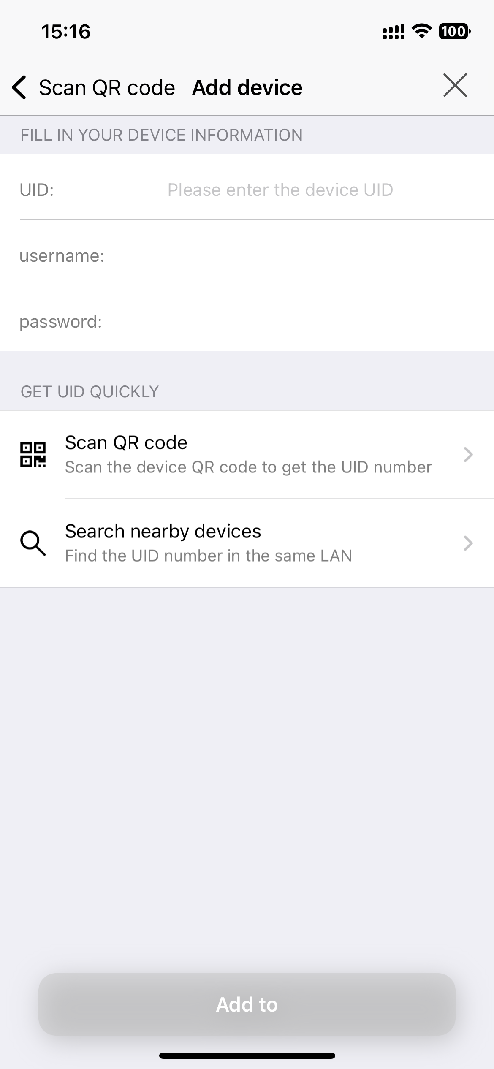
Reminder: Please ensure that the device can connect to the internet normally. Otherwise, it will be unusable after being added.
If you select “Search nearby devices”, the APP will scan and display nearby devices in a list.

Step 3: Wireless configuration
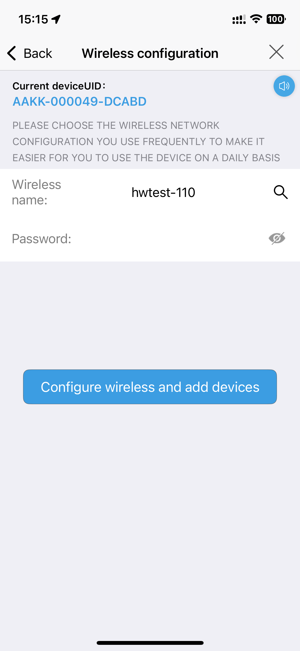
If your mobile phone is already connected to a Wi-Fi network, the app will automatically recognize and display the phone's Wi-Fi network. You can also click the search button to find nearby Wi-Fi networks. Then, enter the corresponding Wi-Fi password and click "Configure wireless and add devices".

Step 4: Successfully added
Follow the prompts to operate until the device is successfully added.

Step5: Device added successfully. Start using it.
To protect the security of your device, you need to reset the login password for the device when using it for the first time. It's extremely important to remember this password. If you lose it, you won't be able to use the device normally.

2.2.1 scanning code link device is abnormal
When scanning the QR code to add the device, failed to connected the device. You can try the operation according to the type of device.
1）IP Camera
If failed to connect to the AP hotspot of the device, the APP will redirect to the failure interface.you can choose ‘other methods’ to add device.
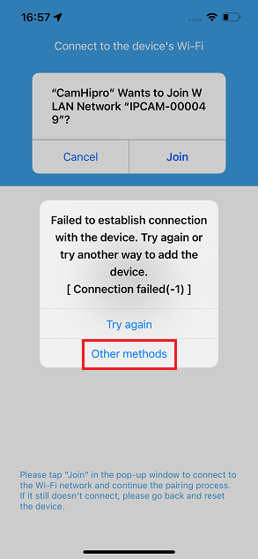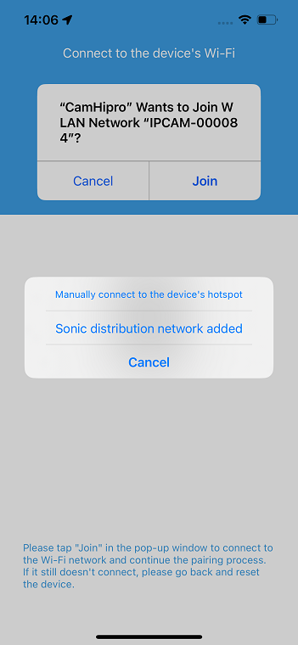
1.1）Manually connect to the device's hotspot
(You can refer to:2.3 Add Device via Access Point(AP))
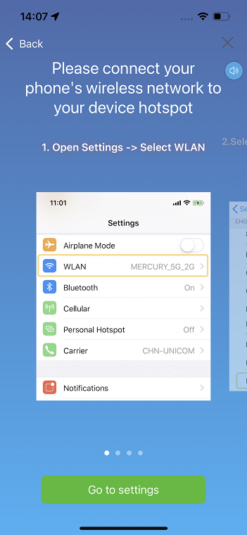 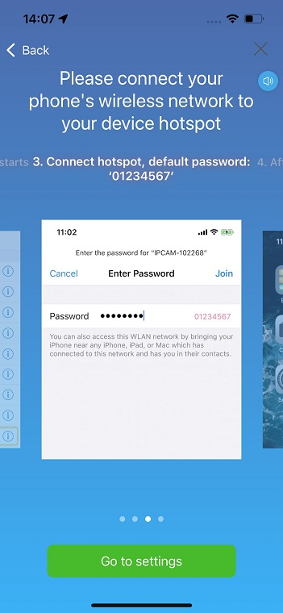 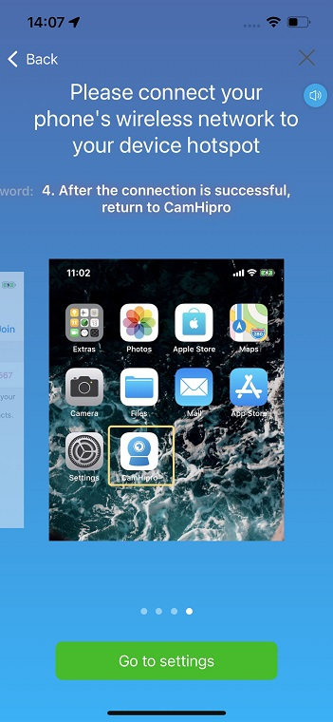\

2.2）Sonic distribution network added
(Acoustic wave device: When the power is connected but not connected to the network cable, the device may make a "ding-dong" sound)
Step1: Wireless configuration
Select the WiFi that needs to be configured ,enter the correct WiFi password-->click ‘Next ’
Step2:sound wave configuration
adjust the volume of the phone to the maximum and try to be close to the camera.
After device receive the sonic information pairing successfully,it will issue a ‘configuration sucess’ prompt music.
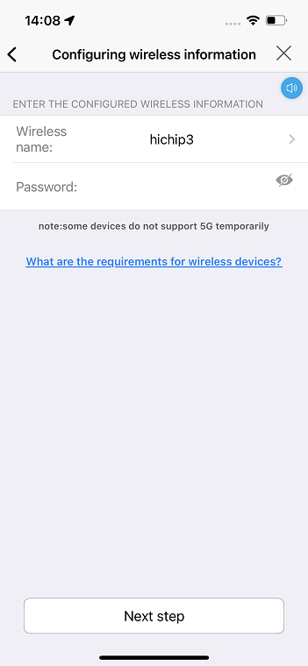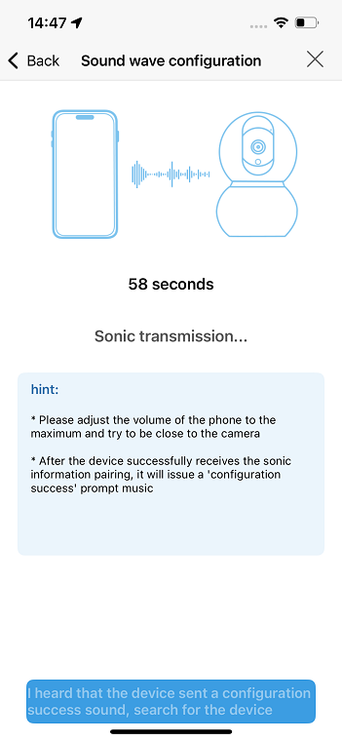
Step3:receive the device information
1) returned the device information successfully, jump to the page to confirm the device information. then add the device follow the steps.

2) heard the device sent a configuration suncess sound, if not returned the device information,click’search for the device ’, find the device in the search list. then add the device follow the steps.
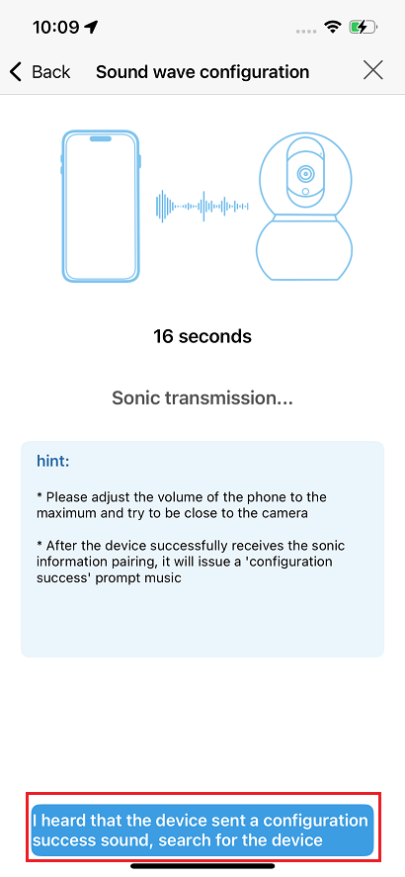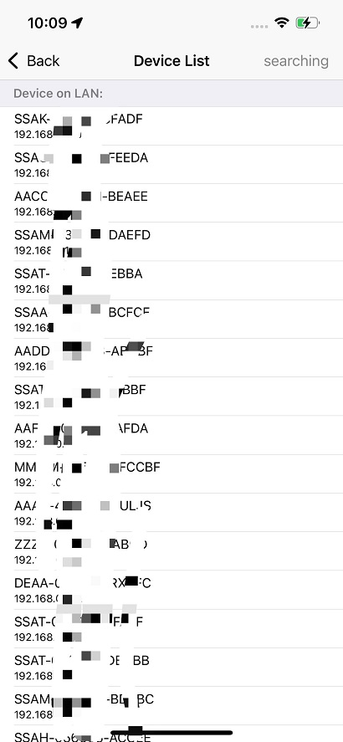
2) Battery wireless camera
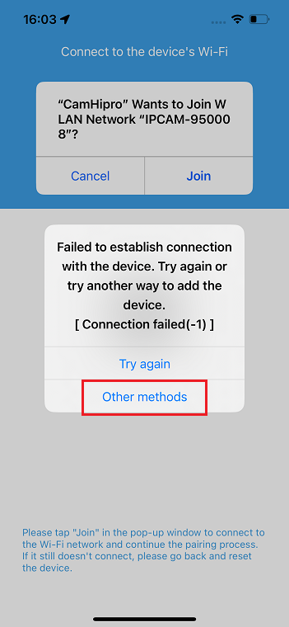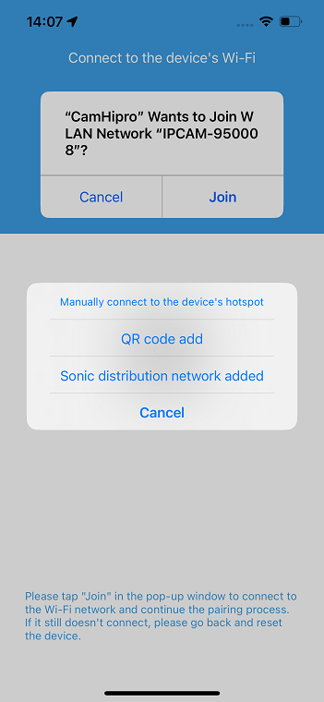

2.1)Manually connect to the device's hotspot
(You can refer to:2.3 Add Device via Access Point(AP))
2.2) QR code add
Step1: Wireless configuration
Select the WiFi that needs to be configured ,enter the correct WiFi password
-->click ‘Next step ’
Step2:scan the QR code
Please place the QR code 15~35cm in front of the camera lens, and wait for the camera to recognize it. Do not switch the mobile phone network during the recognition process
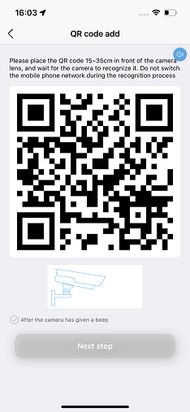
Step3: receive the device information
returned the device information successfully, jump to the page to confirm the device information. then add the device follow the steps.
2.3) Sonic distribution network added
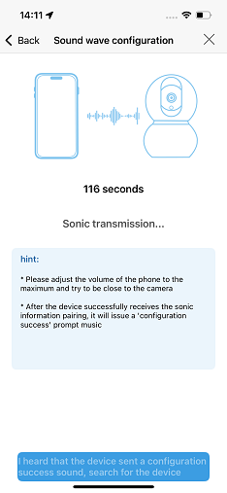
Step1: Wireless configuration
Select the WiFi that needs to be configured ,enter the correct WiFi password
-->click ‘Next step ’

Step2:sound wave configuration
adjust the volume of the phone to the maximum and try to be close to the camera.
After device receive the sonic information pairing successfully,it will issue a
‘configuration sucess’ prompt music.
Step3: receive the device information
1) returned the device information successfully, jump to the page to confirm the
device information. then add the device follow the steps.

2) heard the device sent a configuration suncess sound, if not returned the device
information,click’search for the device ’, find the device in the search list. then add the
device follow the steps.
3) 4G camera
When the red and the blue indicator flash alternately, it is possible that camera
network anomaly. You can try to set the correct APN information for the device.
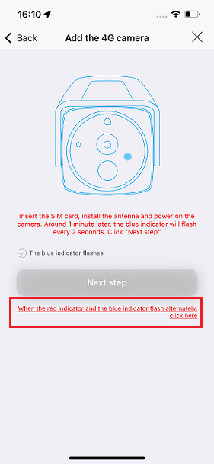
3.1) Set the APN via the QR code
(when there is an ‘Network abnormal’ prompt tone)
Step1: Setting of APN
Click’Setting of APN’-->learn ‘How to acquire the APN?’--> return to the Settings interface
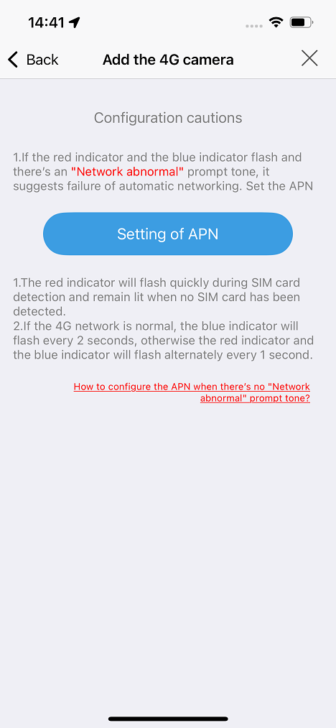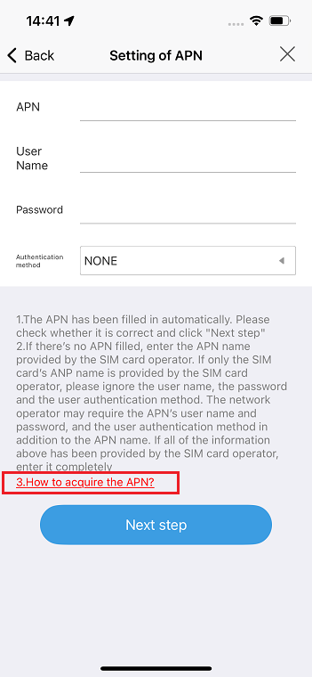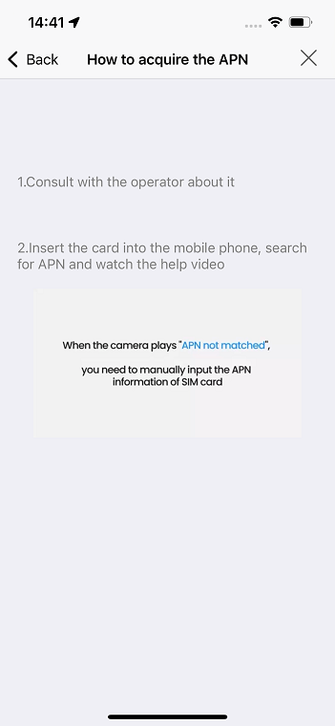

Step2: scan QR code
Set parameters-->click ‘Next step’-->Put the QR code 15cm to 35cm in front of the lens and wait for identification by the camera

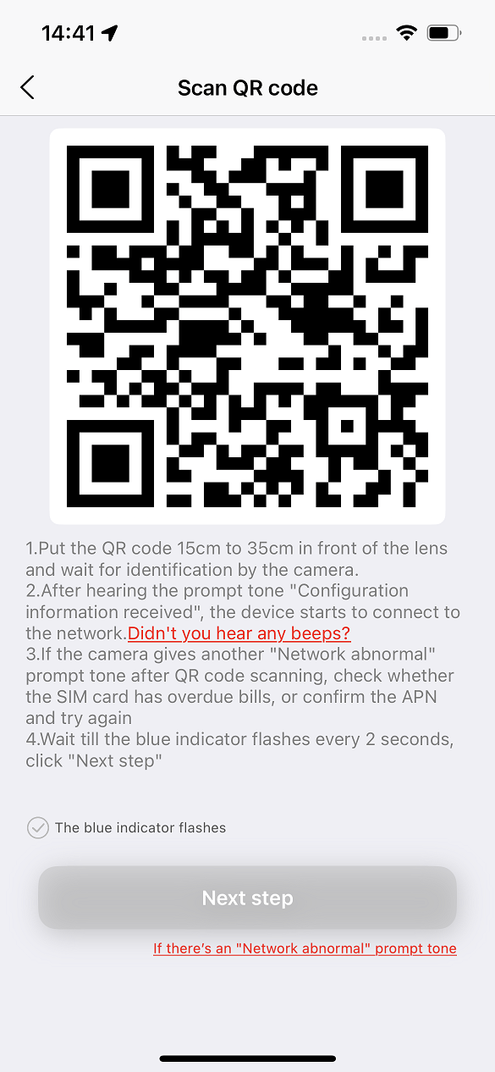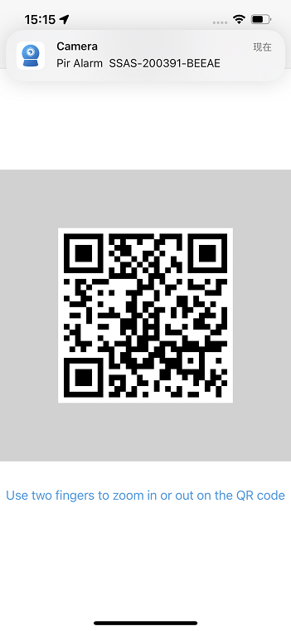
You can click the picture then use two fingers to set the display size of the picture
Step3: receive configuration information
After hearing the prompt tone "Configuration information received", the device starts to
connect to the network. then add the device follow the steps.
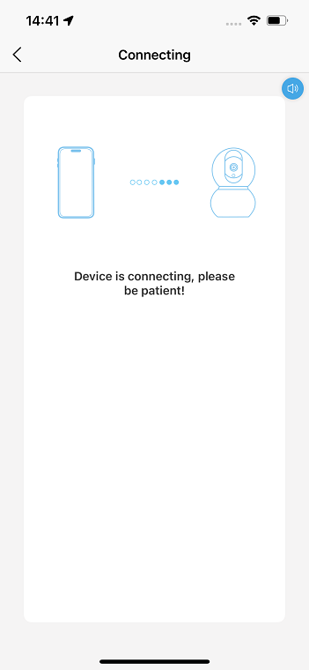
3.2) Set the APN using a TF card
(when there is no ‘Network abnormal’ prompt tone)
Path1: Just click on the abnormal prompt at the bottom of the interface

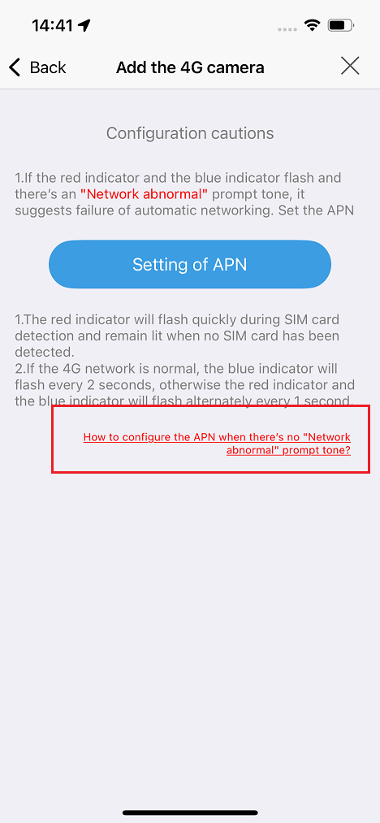

Path2: The QR code sets the APN interface, click on the abnormal prompt at the bottom ‘Didn't you hear any beeps?’--> ‘Another method’

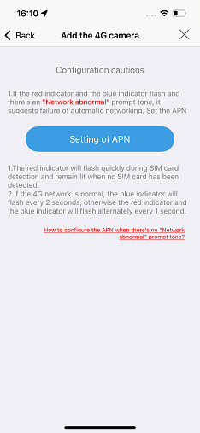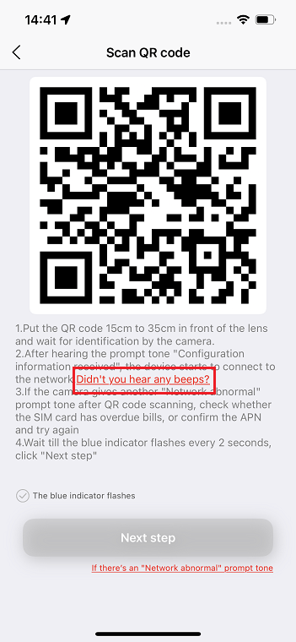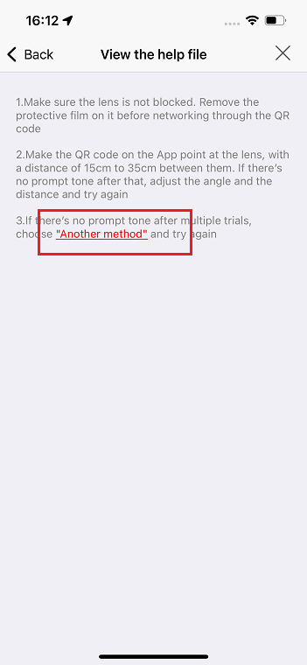
Step1: save the document to the TF
Enter the correct information, then share or copy it. Save the document to the TF card in
any way
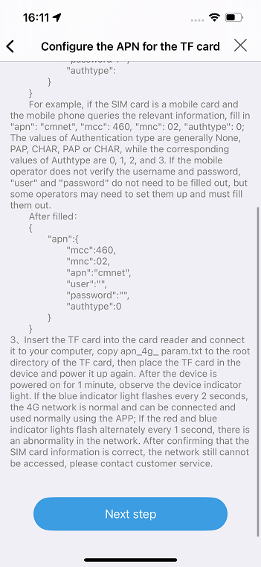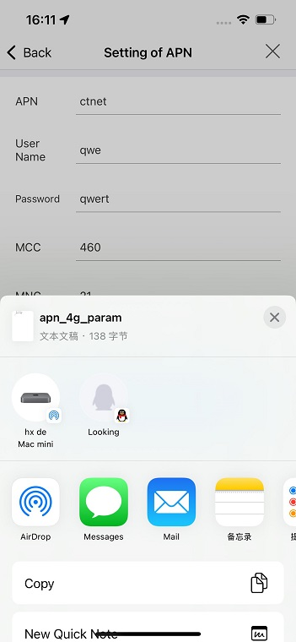

Step2: Configuration the APN
Place the TF card in the device and power it up again.After the device is powered on for 1 minute, observe the device indicator light. If the blue indicator light flashes every 2 seconds the 4G network is normal and can be connected and used normally using the APP.

Other abnormal situations:
If the red and blue indicator lights flash alternately every 1 second, there is an abnormality in the network. After confirming that the SIM card information is correct, the network still cannot be accessed, please contact customer service.

2.3 Add Device via Access Point(AP)
In camera systems, the AP function refers to the built-in Wi-Fi hotspot feature of the camera. After a mobile phone connects to this Wi-Fi hotspot, it can perform camera addition and configuration operations within the local area network (LAN). This approach enables rapid device connection and configuration without the need for complex network settings.

Step 1: Connect the camera's AP
To add a camera using the AP method, you must first connect your mobile phone to the camera's AP network and maintain the connection throughout the entire process..
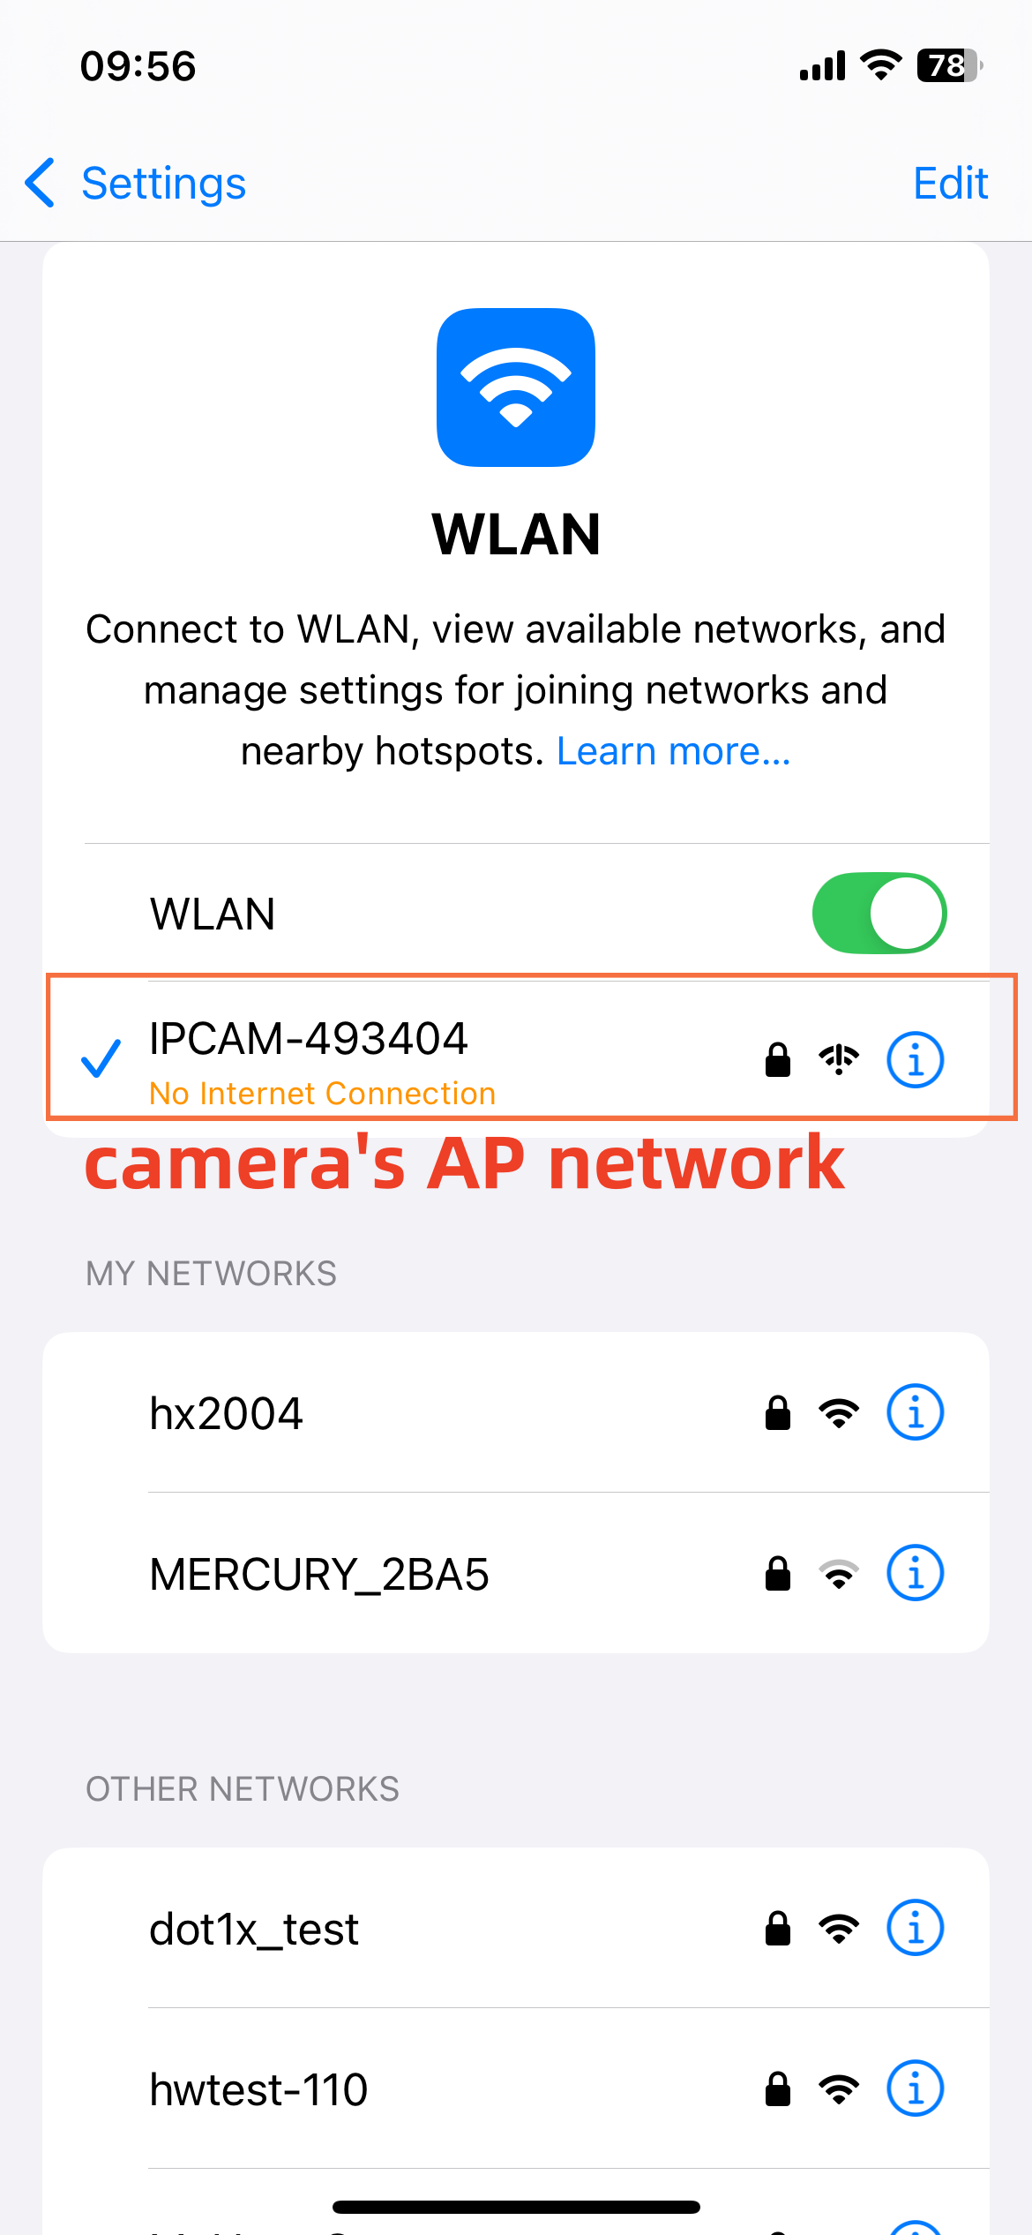
Find your phone's settings, and to the WLAN configuration, find the network starting with "IPCAM," and select to connect. The default password is 01234567.
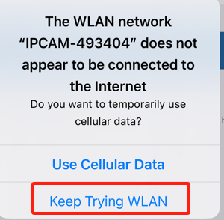After successful connection, the camera's AP network cannot access the internet, your phone will prompt that the current network cannot provide internet access and ask whether to switch networks. Be sure to select "Do not switch networks," otherwise, you will not be able to configure the camera subsequently.

Step 2: Add Camera in the CamHiPro
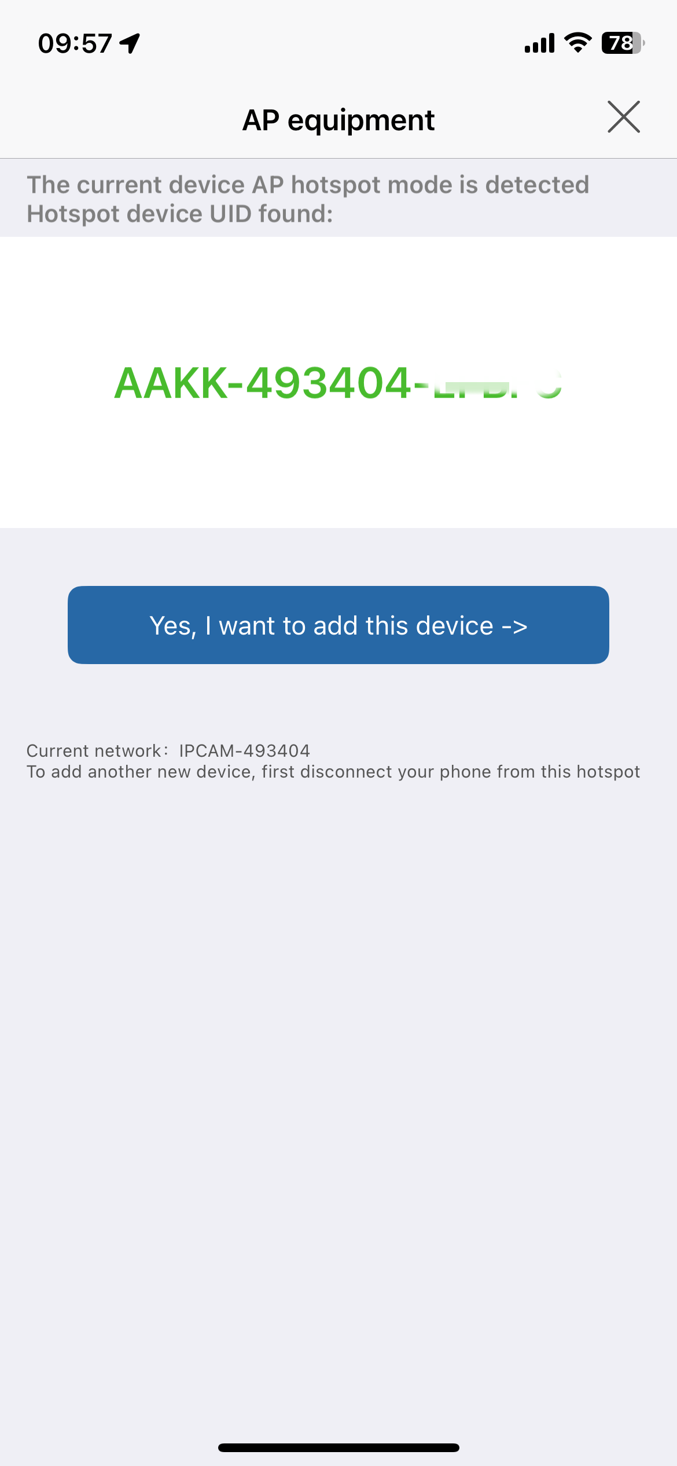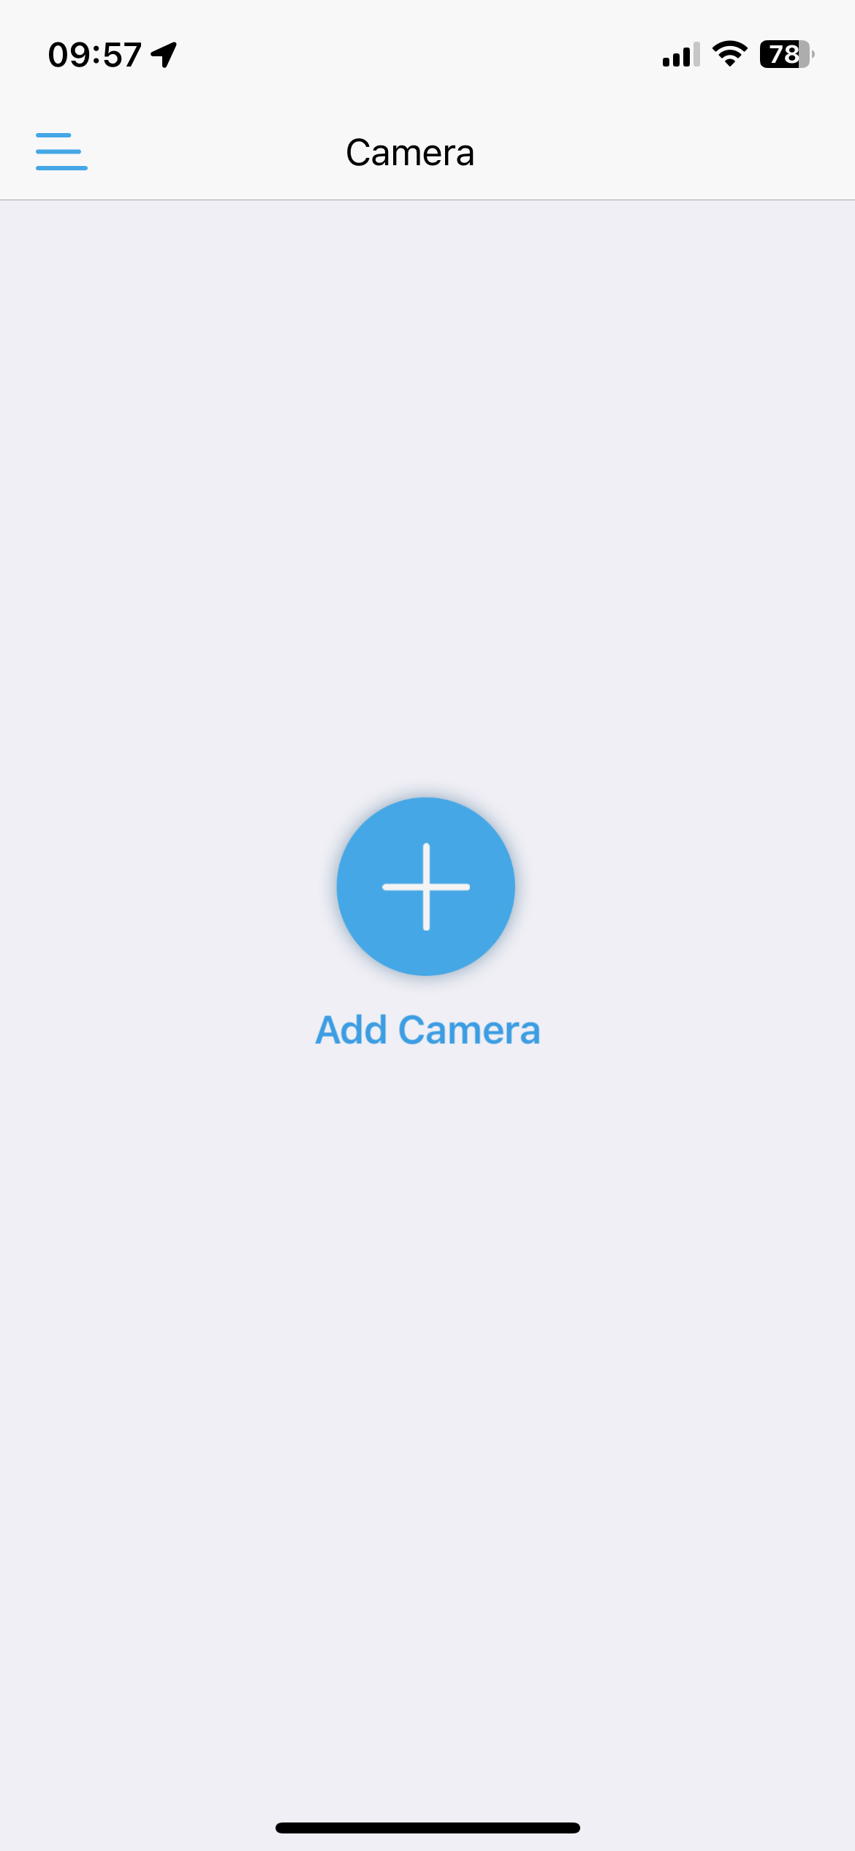

Step 3:Wireless configuration
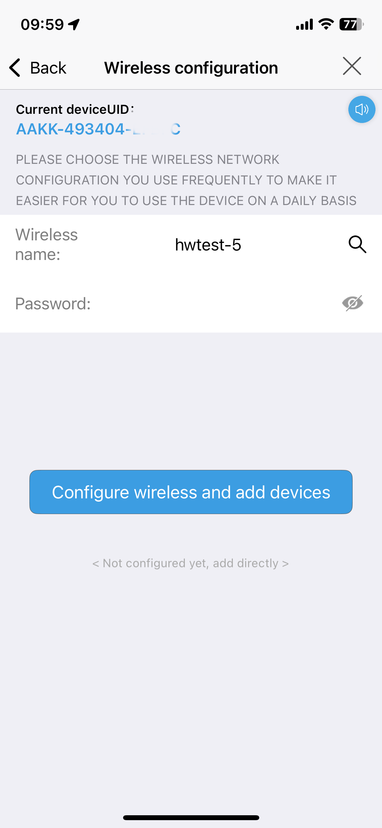After selecting the device that has been searched, press the "Add to" button to proceed to the next step, where you will configure the wireless network.
If your mobile phone is already connected to a Wi-Fi network, the app will automatically recognize and display the phone's Wi-Fi network.
You can also click the search button to find nearby Wi-Fi networks. Then, enter the corresponding Wi-Fi password and click "Configure wireless and add devices".

Then, the tips will pop up, asking you to confirm whether the Wi-Fi network and password are correct. If yes, click "determine" to proceed.

Step 4: Successfully added
Follow the prompts to operate until the device is successfully added.
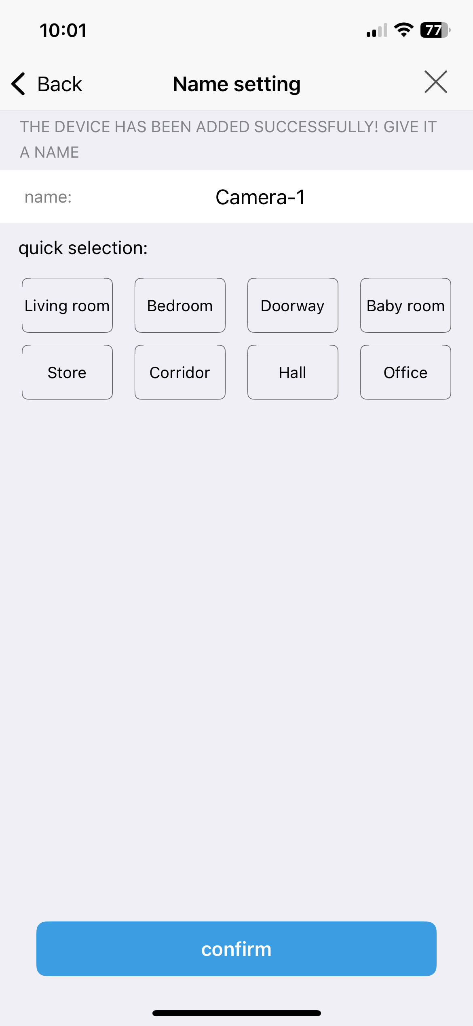

Step 5: Device added successfully. Start using it.
To protect the security of your device, you need to reset the login password for the device when using it for the first time. It's extremely important to remember this password. If you lose it, you won't be able to use the device normally.

3. Delete camera
In the device list interface, click the button “setting” to enter the camera setting interface, click the button “delete device” to delete the added camera.
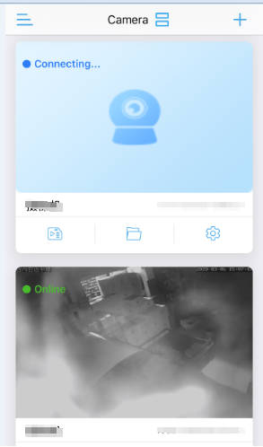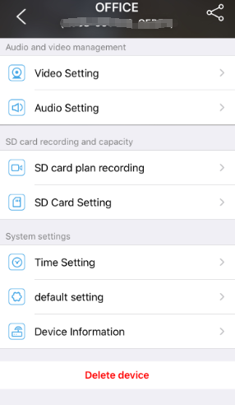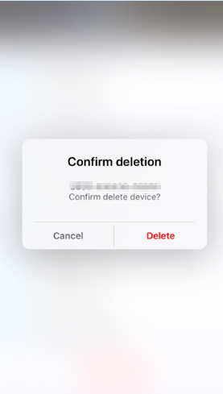

In addition, you can also delete it by swiping left on the device in the device list.

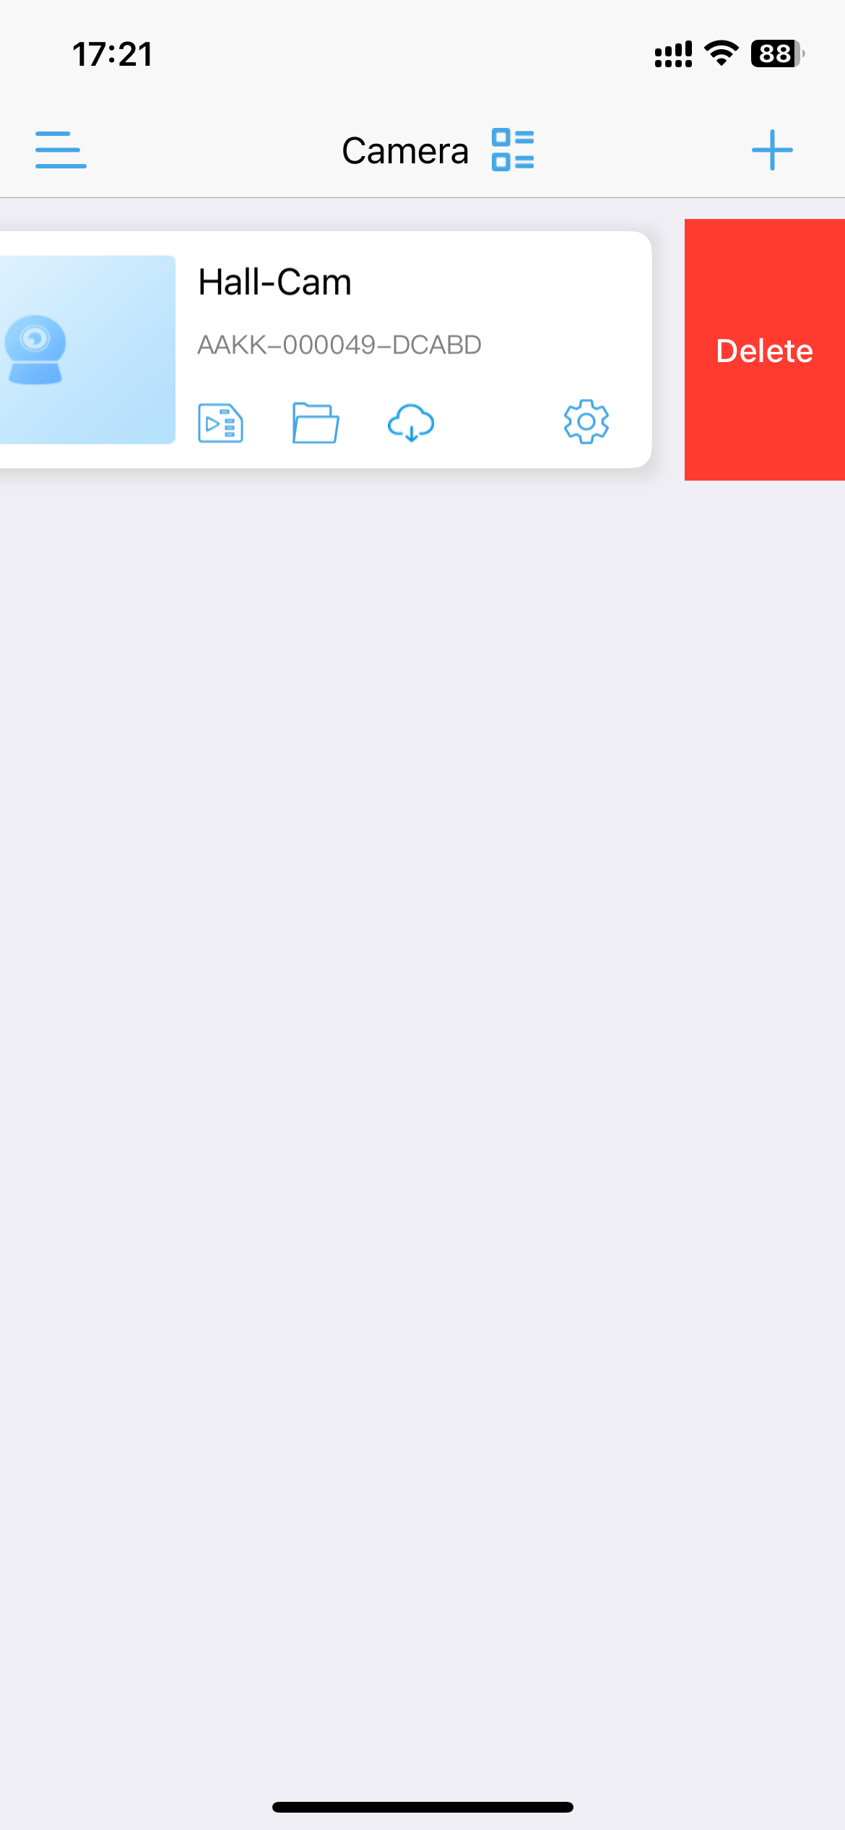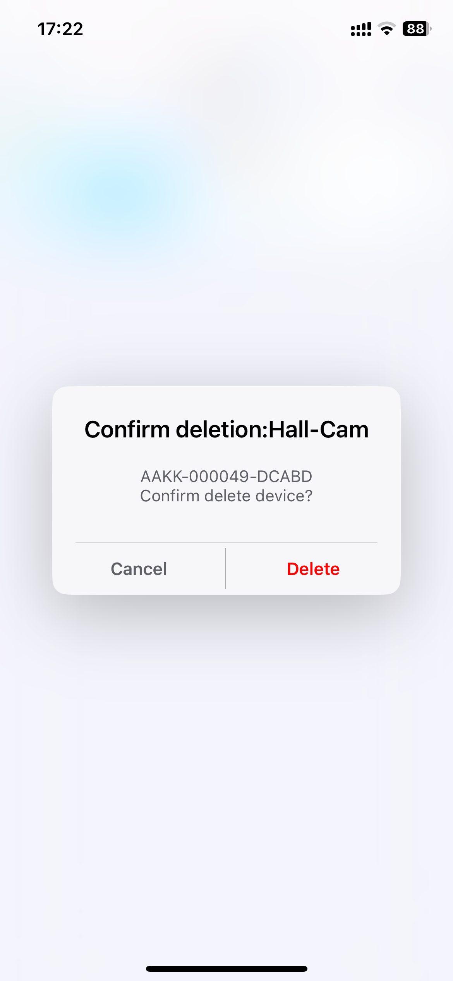
After deleting a device, if you want to re-add it, there are two methods: First, in the device addition window, select "Device in use" and refer to Section 2.2 for details. Second, you can also reset the device and add it following the procedure for a new device.

4. View the camera
After adding the camera for a few seconds, wait for the camera to connect to the automatically, prompt the online description to view the camera video, click on the camera that displays online to enter the camera live interface.
Camera status description:
Connecting: At this time, the camera is establishing a connection with the network camera. According to different networks, the connection time is different.
Online: This status indicates that the device is connected properly; click to view the video;
Disconnected: This status indicates that the device is offline
Password error: This status indicates that the camera login password is wrong. Clicking on the camera in this state will pop up the Change Password dialog box.

5. Function description

5.1 Ordinary camera interface
The ordinary camera monitoring interface is displayed in the small screen mode by default. The function selection button is displayed at the bottom of the screen. More function keys can be called to slide to the left in the blank space. The function description of the buttons is shown in the figure below.

 | Monitoring |  | Intercom
 | Snapshot |  | Local record
 | Mirror/Flip |  | Focus
 | Preset Position |  | Volume adjustment
 | Image adjustment |  | Night Vision mode
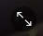 | Full screen |  | Resolution switching
 | Back |  | Toolbar
 | Intelligenttracking |  | Setting
Note: Some functions require device support

5.2 function button
On the video browsing interface of the camera, there are three groups of commonly used function buttons:

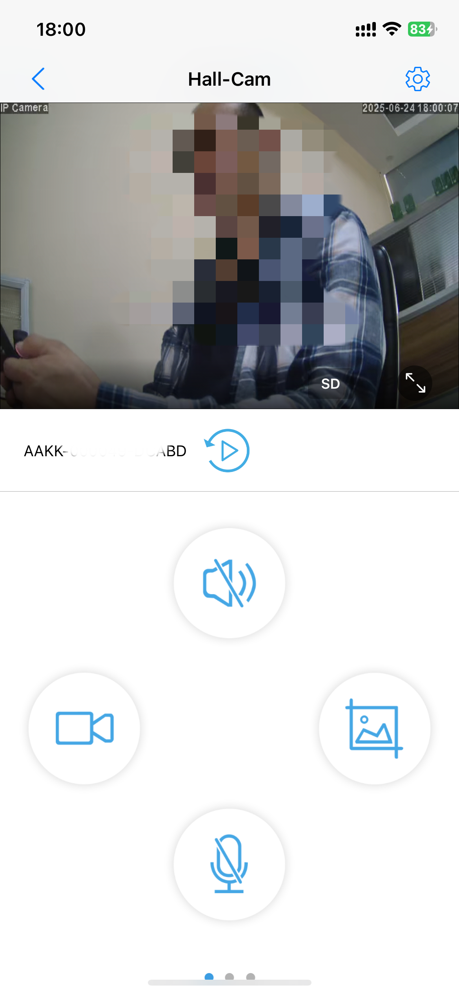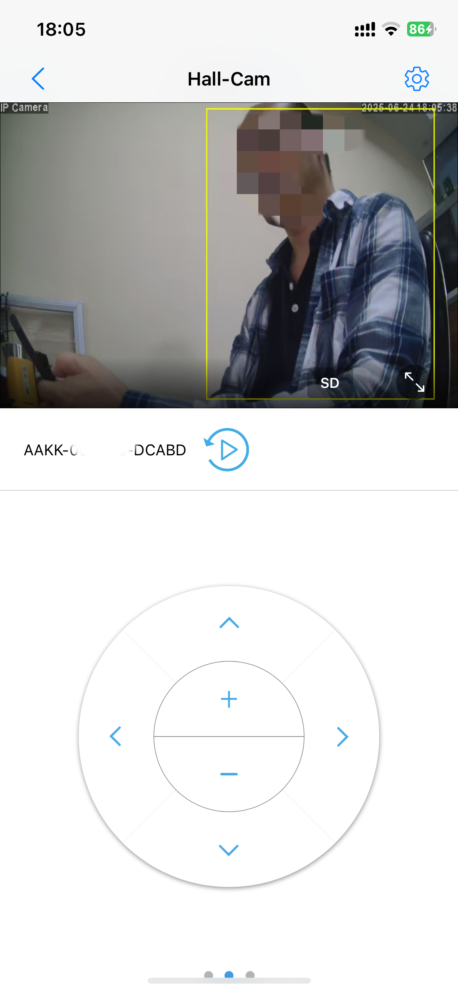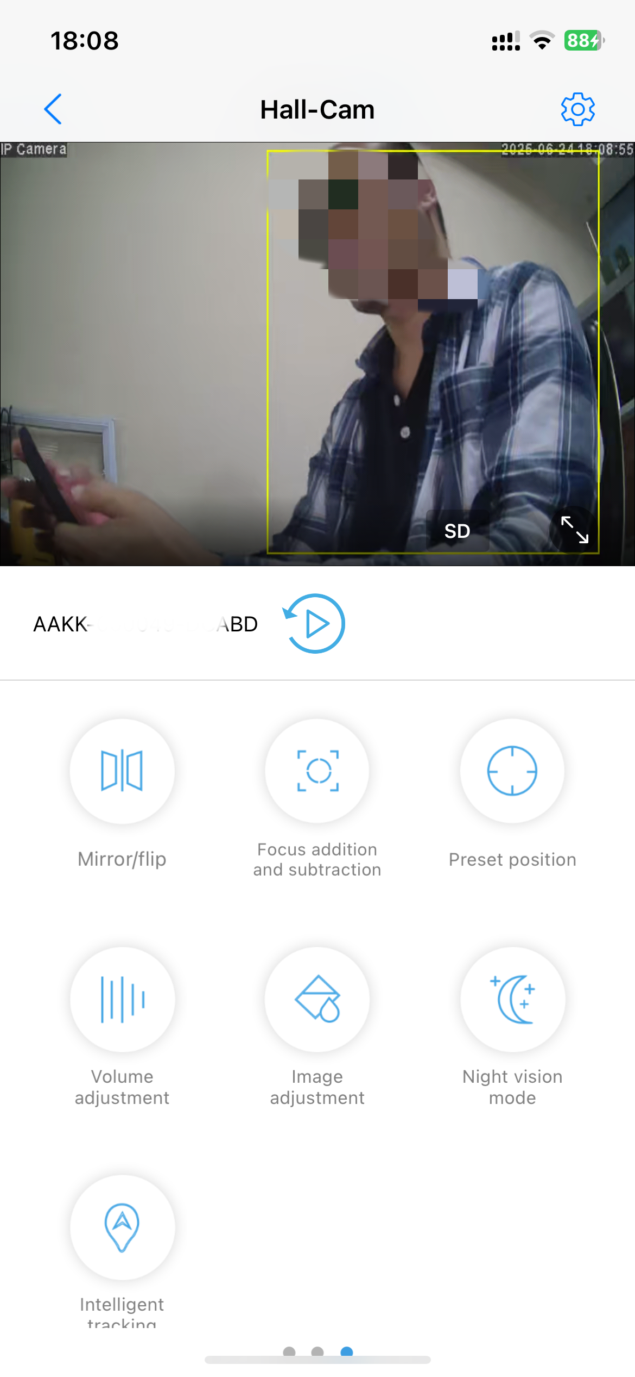

Monitoring：After enabling the Monitoring feature, CamHipro will be able to hear the audio from the network camera. After disabling it, CamHipro will no longer be able to hear the audio from the network camera.
Intercom：After enabling the Intercom feature, CamHipro can initiate two-way voice communication with the network camera, allowing audio from the CamHipro device to be played through the camera's speaker. Disabling the Intercom feature will terminate the voice communication functionality."
Local Record：Records video and stores it within the APP. Users can view and download the recorded videos to their mobile device through the CamHiPro app
Snapshot：Captures a single image and stores it within the CamHiPro app. Users can view the snapshot in the app and download it to their phone's gallery
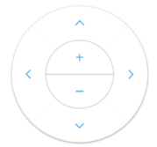PTZ ：For devices with PTZ function, use your finger to swipe the live video, the camera will rotate according to the direction of the finger.
Mirror/Flip：Functions for adjusting image orientation
Mirror: Reverses the image horizontally, creating a mirrored effect.When the camera’s installation position causes the left-right orientation of the video to appear opposite to the actual scene, the Mirror function can be used to adjust the image, ensuring it aligns with the viewer’s perspective.
Flip: Flips the image vertically, inverting it upside down. When the camera is installed upside down (e.g., mounted on a ceiling), the Flip function can restore the image to its correct orientation.

Focus：Adjusts the camera's focal length to ensure clear imaging.The Focus function includes four operations: Zoom In, Zoom Out, Focus Near, and Focus Far.

Preset Position：A preset position refers to a specific camera view that users can pre-configure and quickly recall. By setting and calling preset positions, users can easily switch between monitoring areas, thereby enhancing surveillance efficiency.

Volume adjustment:Volume adjustment: Quickly adjust the microphone and speaker levels.

Image adjustment:Modify image parameters, including brightness, contrast, and saturation settings.

Night Vision mode:The camera’s supplemental lighting mode when it is nighttime or the lighting is dim: Infrared mode/Full color mode/Intelligent mode

Intelligenttracking: The camera’s intelligent tracking automatically follows intruders.

Setting: When the camera is online, click the camera list interface or the live interface icon to enter the camera parameter setting interface

6. Camera parameters
When the camera is online, click the camera list interface or the live interface icon to enter the camera parameter setting interface.
In the parameter settings window, there are a total of 14 configurable parameter items.
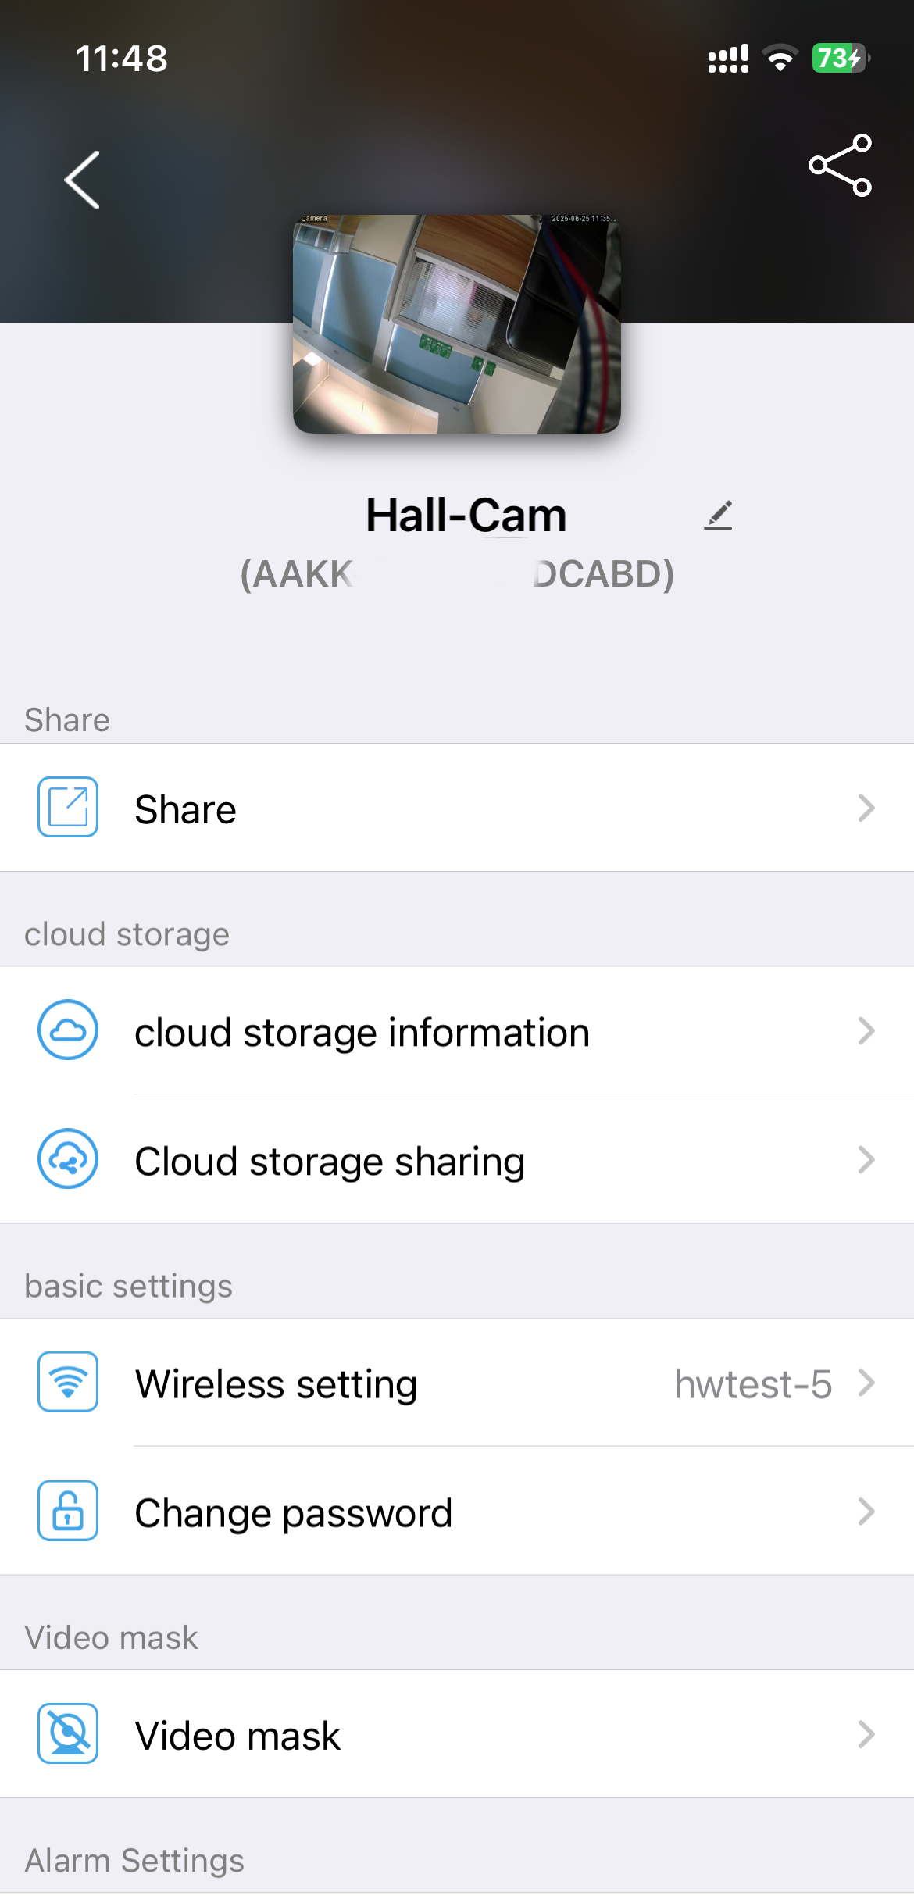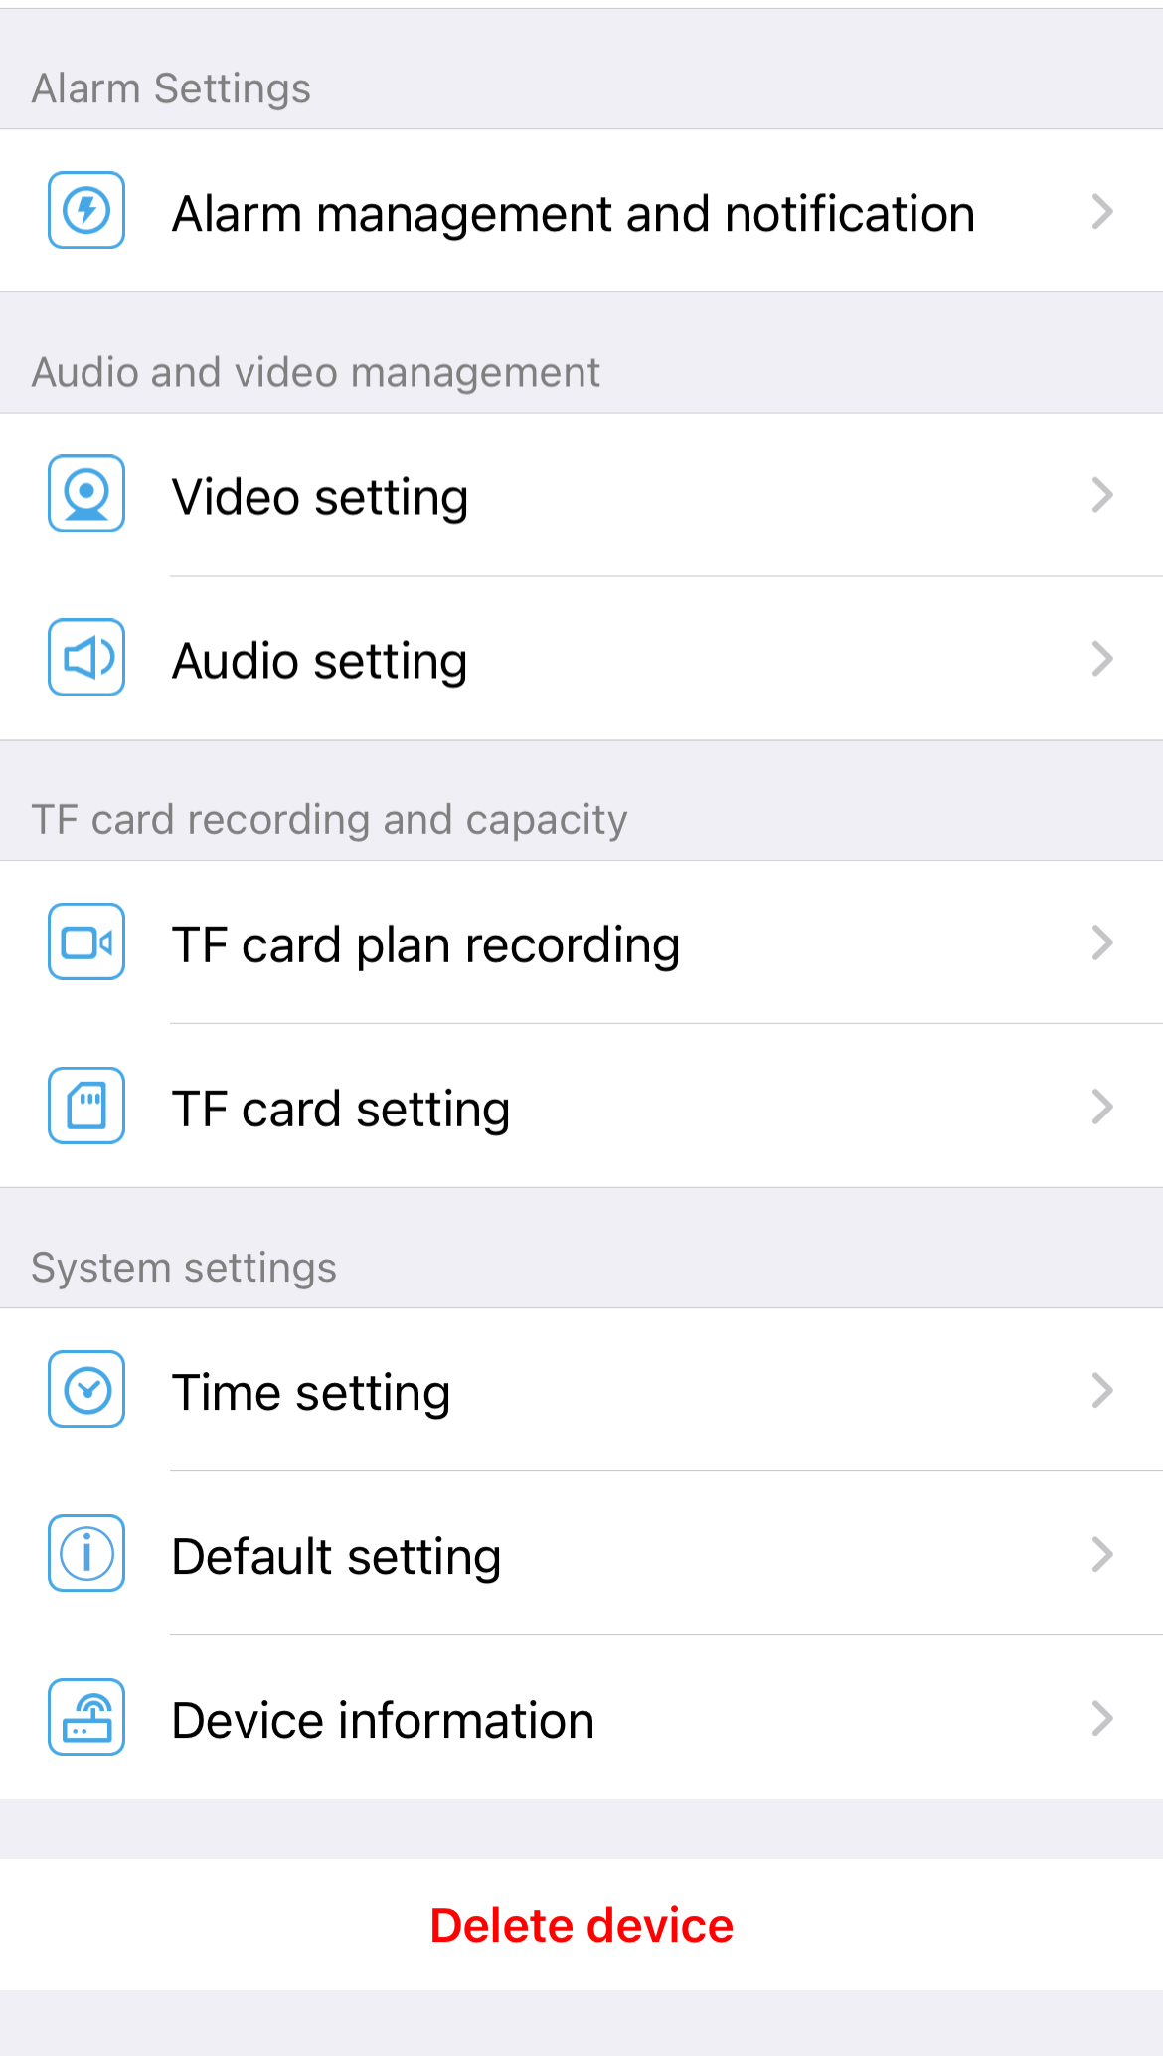

6.1 Share device
The sharing function allows the camera owner to grant browsing and operational permissions to other users. Once shared, the recipients can normally view the camera's video footage.Two roles are involved in the sharing process: the Sharing User and the Recipient User。
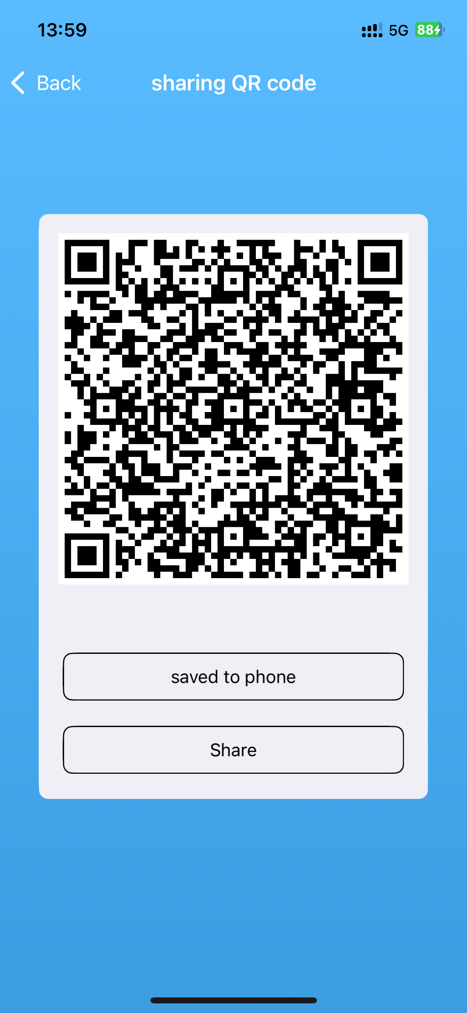Sharing User (the camera owner):
After clicking the "Share" button, the CamHiPro app generates a QR code. The sharing user can either save this QR code to their device’s photo gallery or share it to the recipient via third-party messaging apps (e.g., WhatsApp, WeChat, email).

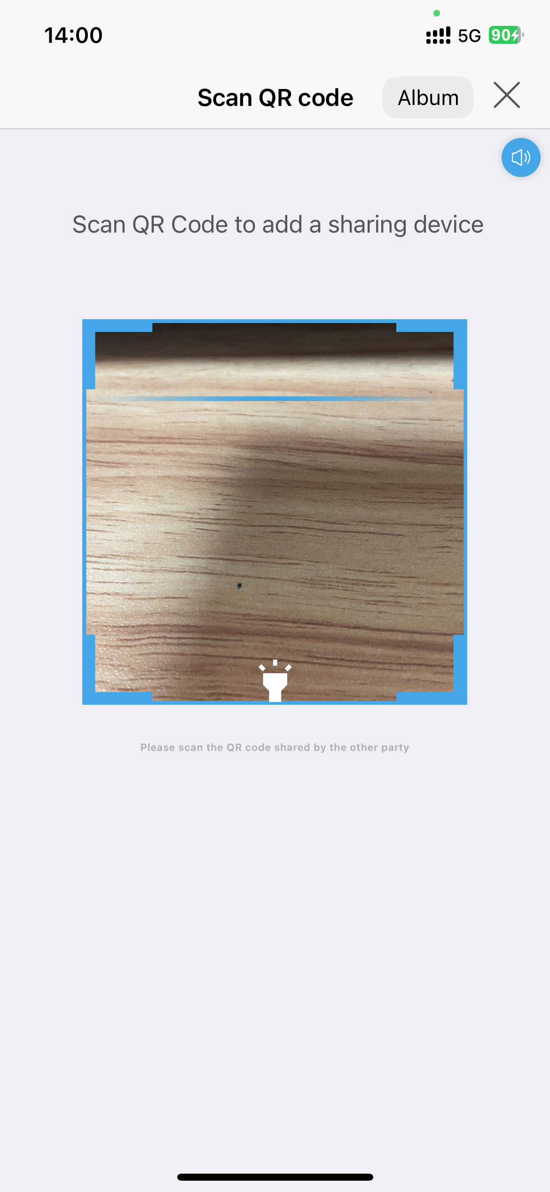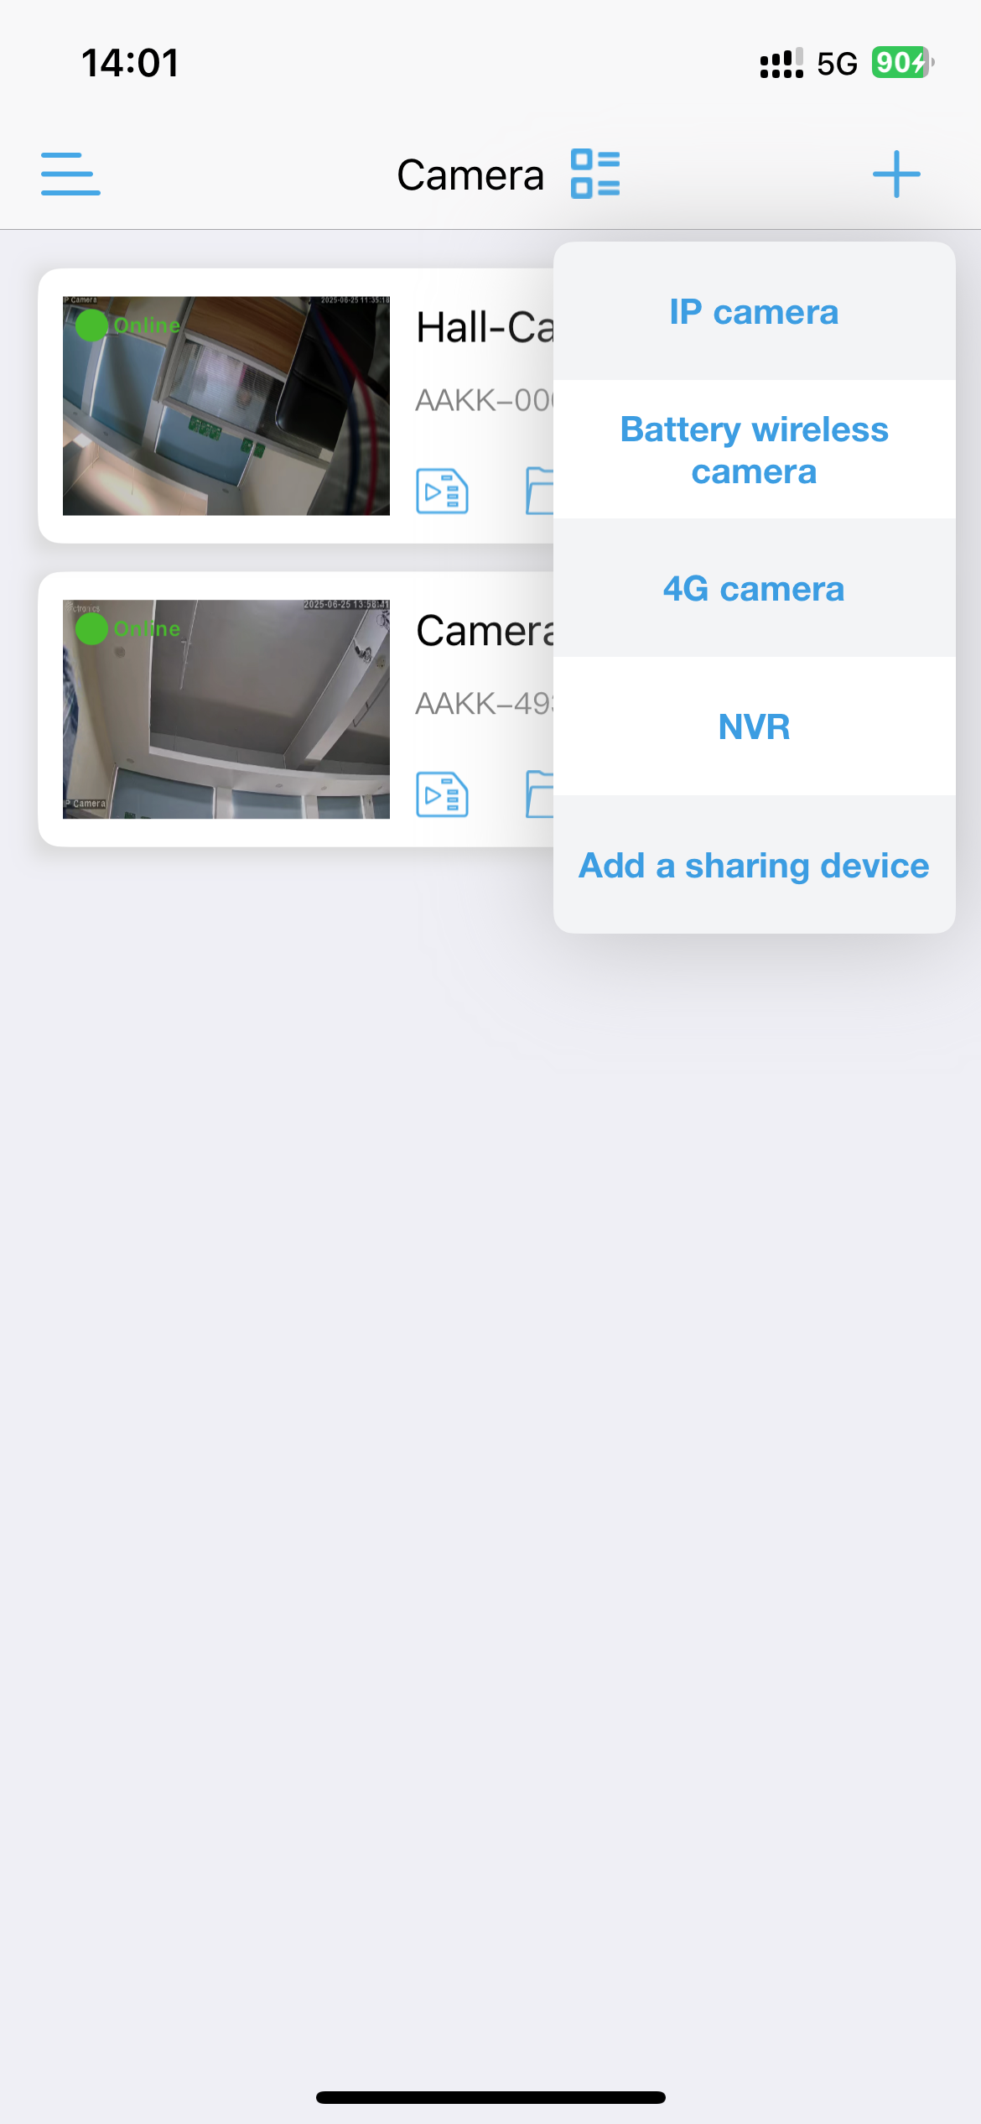Recipient User:
When adding the camera in the app, the recipient selects "Add a Sharing Device" and scans the QR code provided by the sharing user.
Once scanned, the camera is successfully added to their account.

6.2 Cloud storage information
You need to register an account using your email.After logging into the cloud storage management interface, users can directly select and purchase cloud storage packages tailored to their needs or manage existing cloud storage data. Here's a structured breakdown:

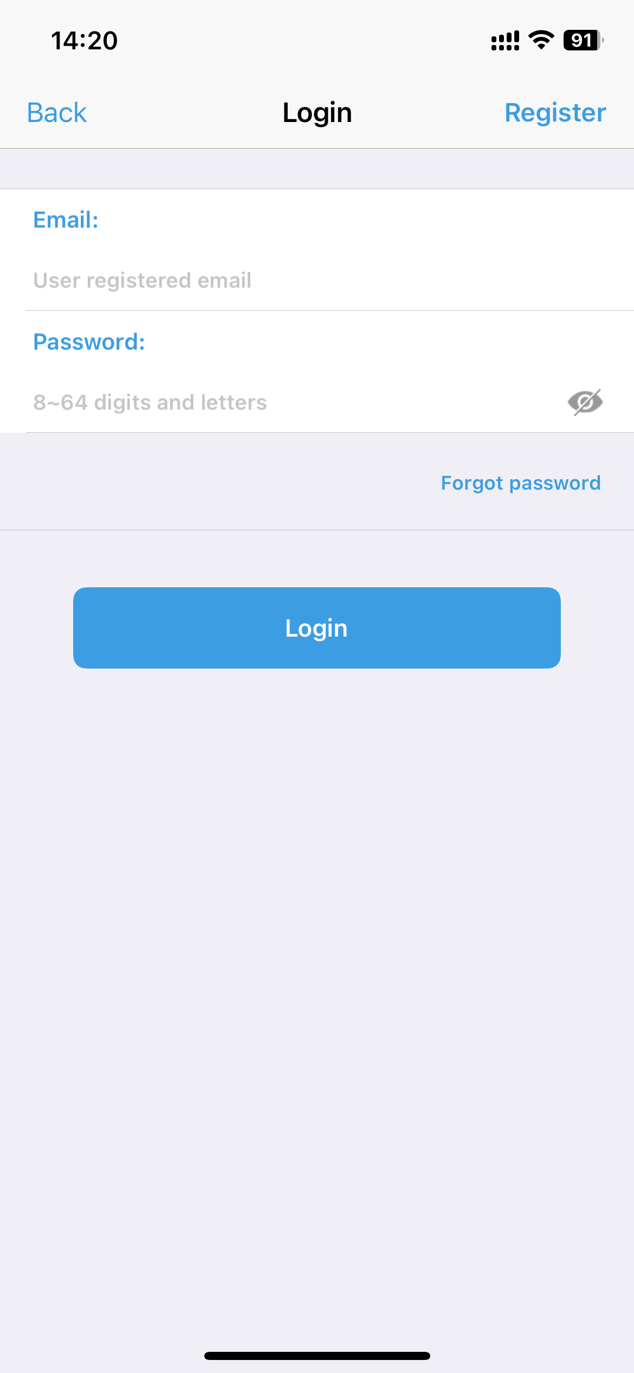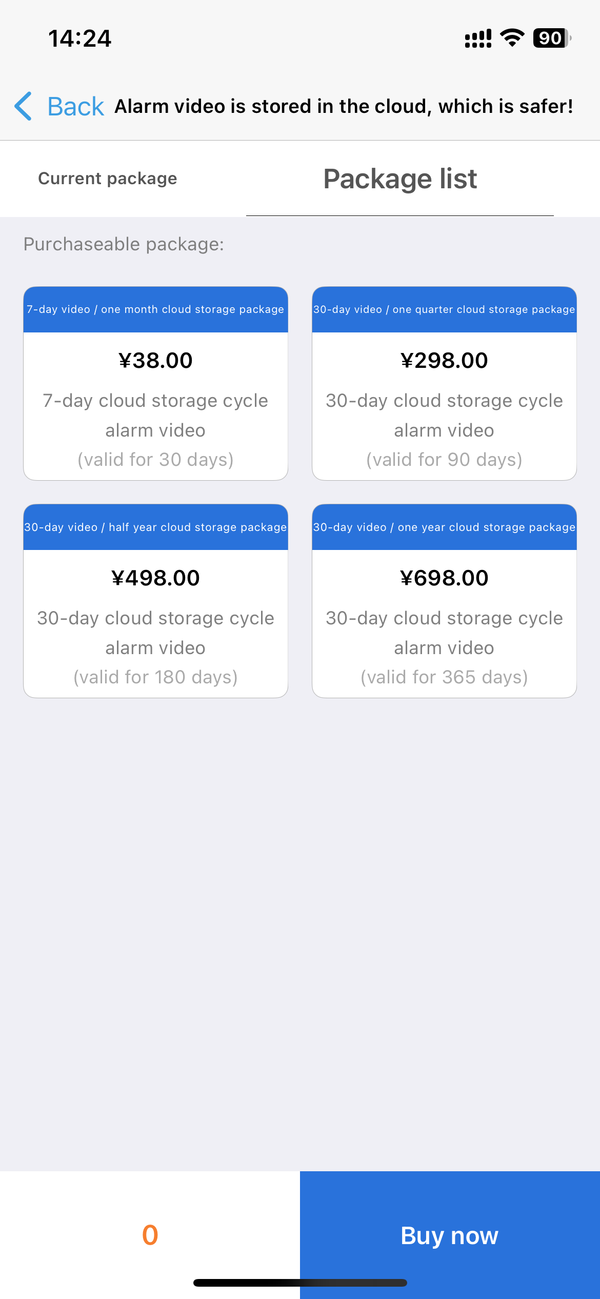

NOTE：The cloud storage only accepts alarm-triggered recordings.

6.3 Cloud storage sharing

Cloud storage sharing allows you to share your purchased cloud storage space with other users, enabling them to view the recorded video files stored in that shared space.
Before sharing the cloud storage, you must first share the associated device with the user.

6.4 Wireless setting

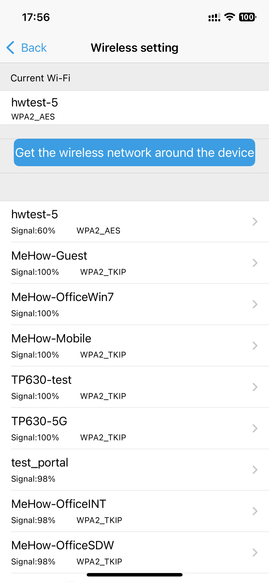Display the WIFI network connected to the current device
Click to get the wireless network around the device, the device will search for the WIFI network in the current environment automatically; select the password to configure the WIFI of the current device.

6.5 Change password

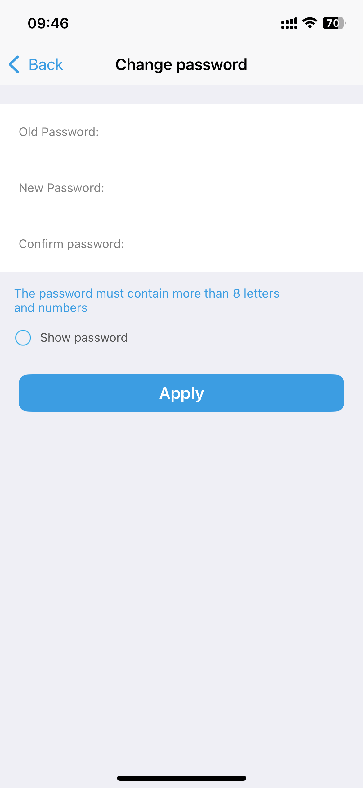
Changing the password refers to modifying the password used for logging into the camera. You need to first enter the old password, followed by entering the new password twice. Click "Apply" to complete the modification. The passwords will be displayed as asterisks (*) after input. If you want to verify whether the input is correct, you can click "show password" to display the plain text of the password.

6.6 Video mask
The "video mask" function refers to covering selected areas in the video frame with black to protect privacy.

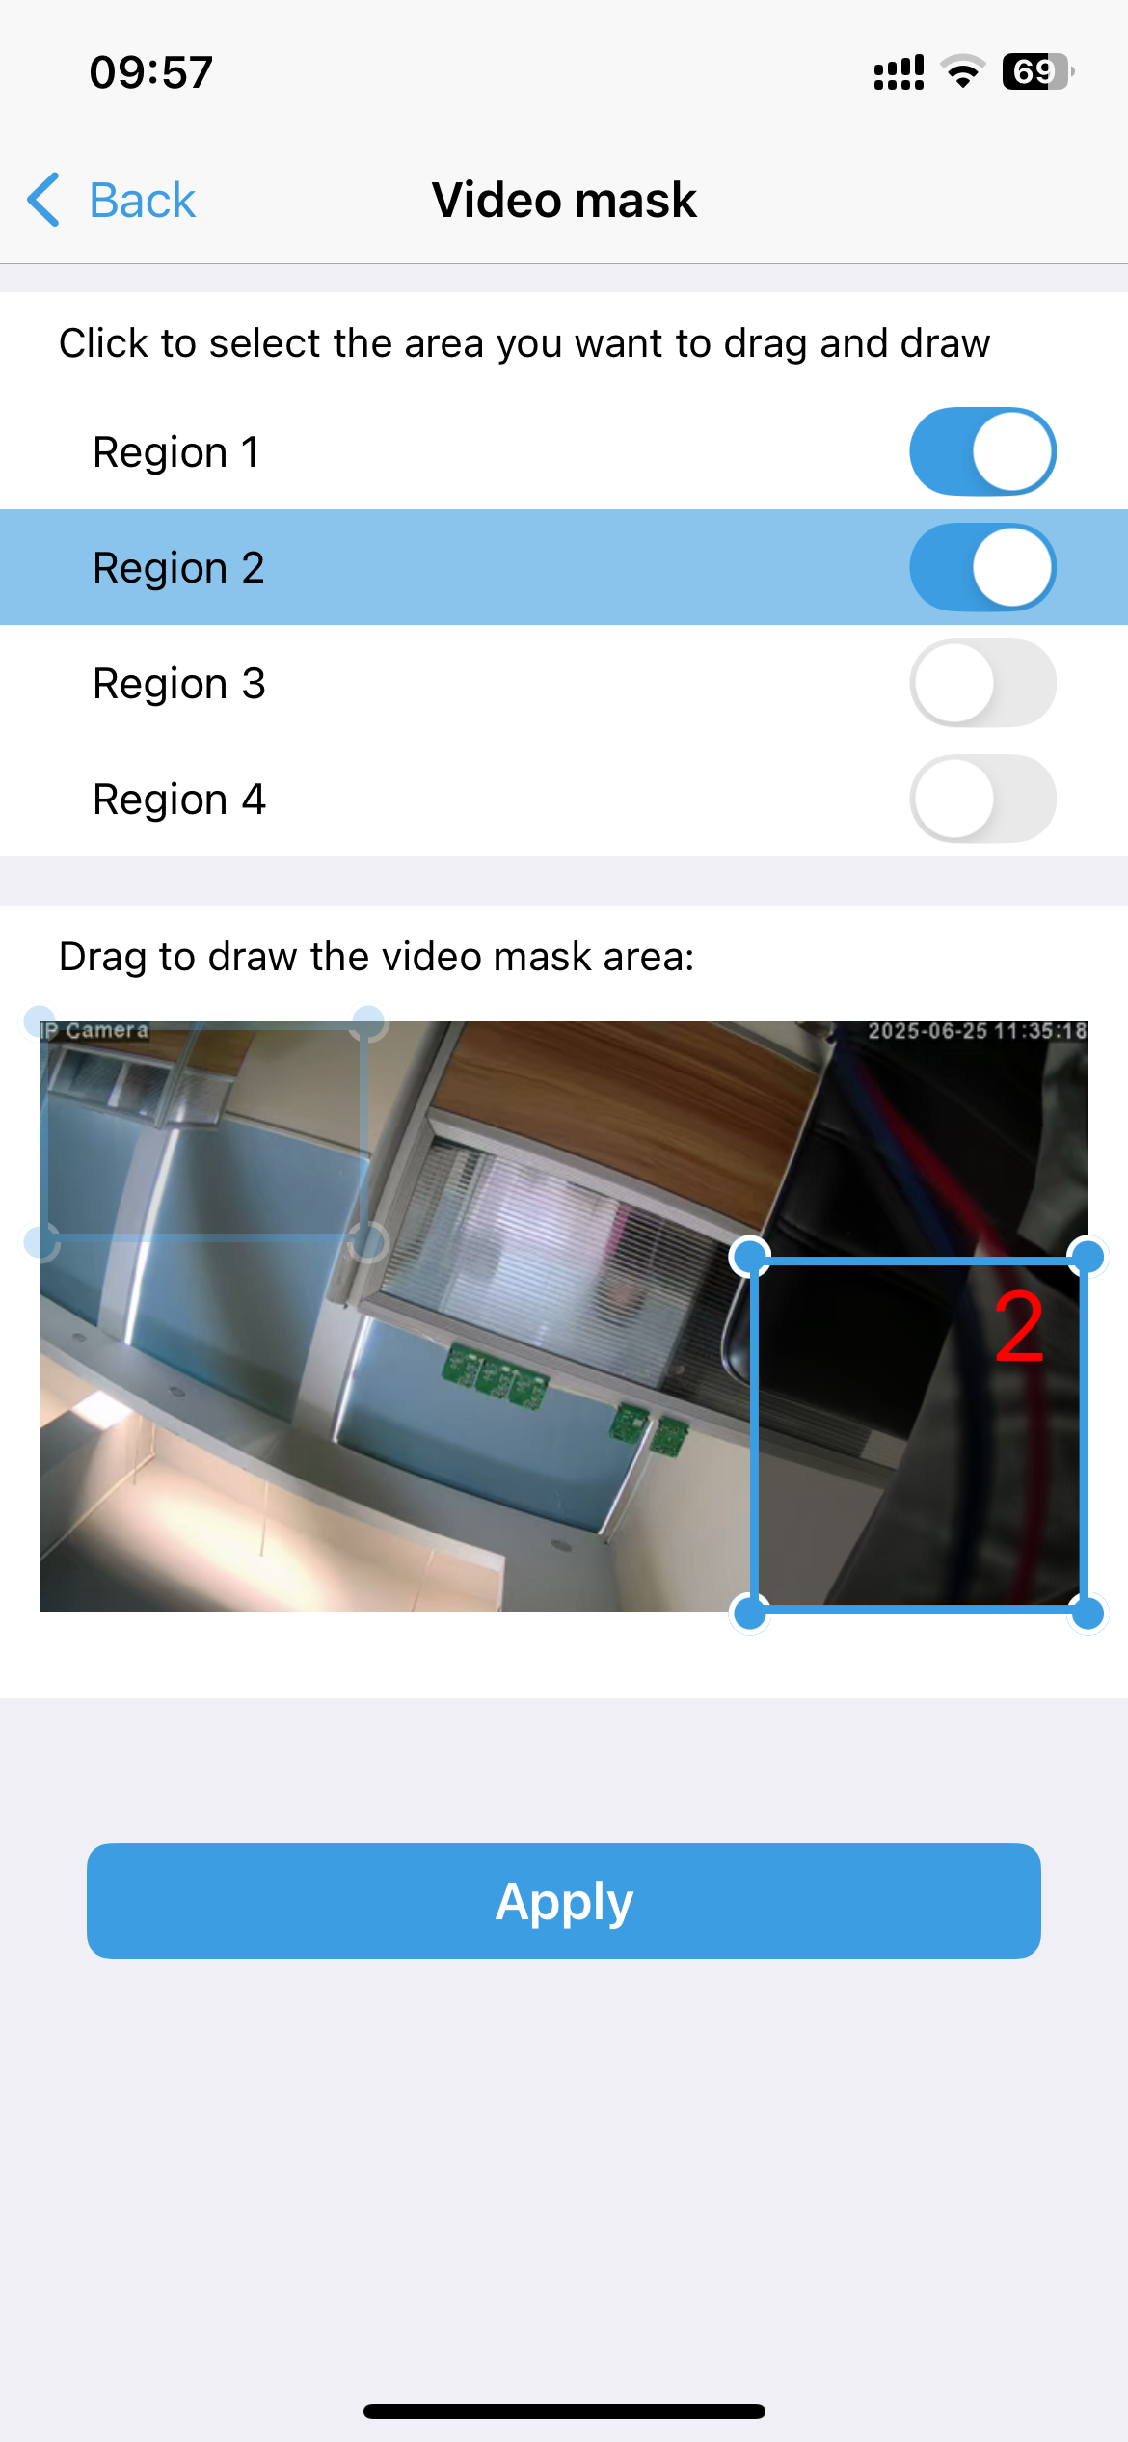
In CamHiPro, you can set up four masking areas. After enabling the feature by clicking the switch on the right, corresponding rectangular boxes will appear in the video window below. Drag the rectangular boxes with your finger to adjust the size and position of the video mask areas. Finally, click "apply" to complete the setup.

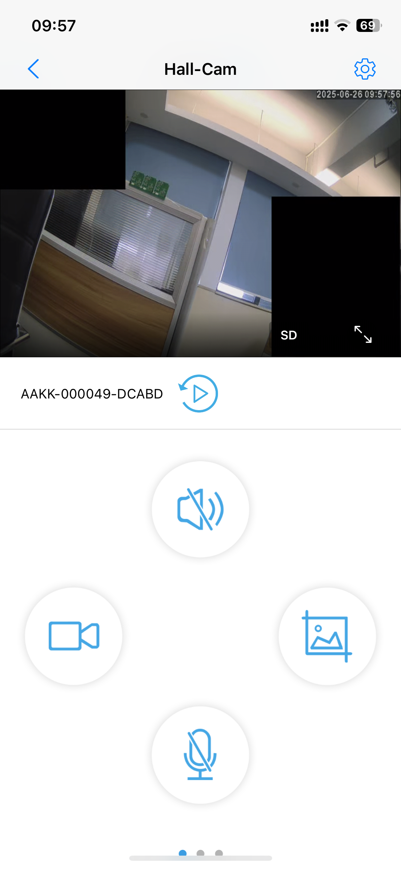
After completing the setup, you can check the effect. You'll see that in the live video feed, the two areas you just set up are covered by a black rectangular box.

6.7 Alarm management and notification
"Alarm management and notification" refers to the processes and systems involved in handling and communicating alerts or alarms generated by Camera devices.
Here, you can set up the alarm triggering methods and alarm push notification messages for the camera.

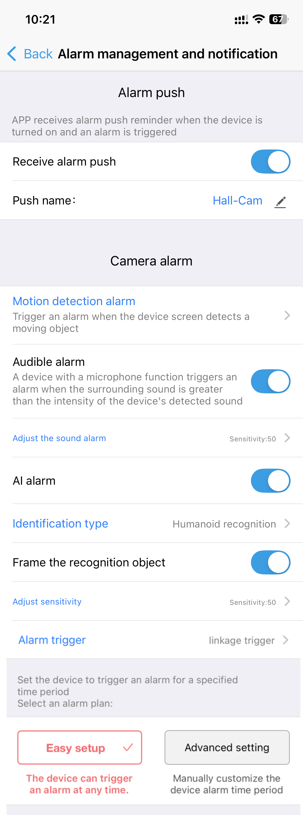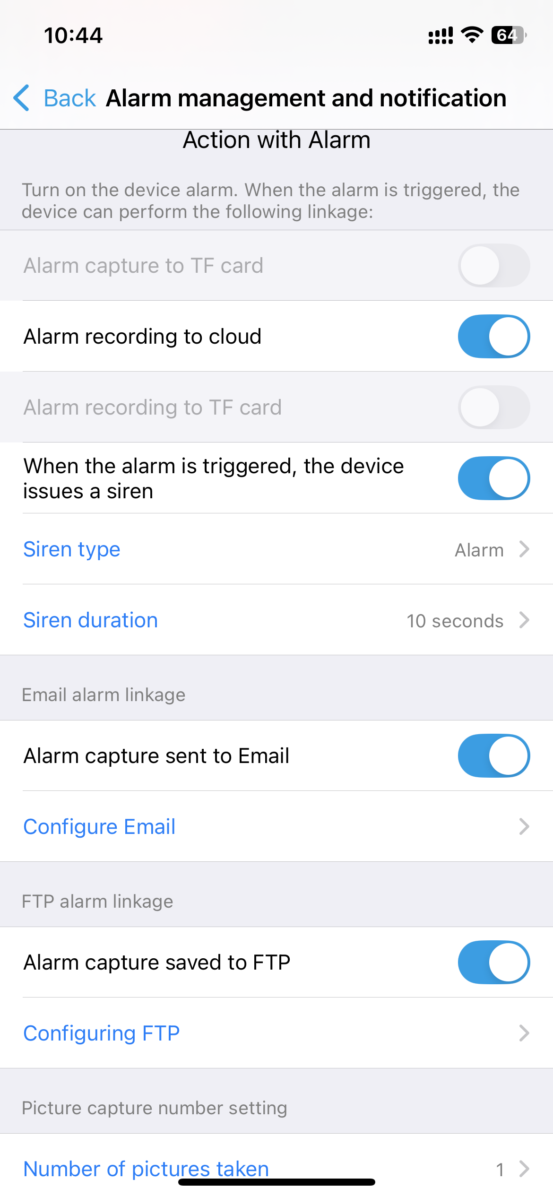

6.7.1Alarm push
1）Receive alarm push
After turning on the alarm push notification switch, when the camera generates an alarm, the mobile app will receive an alarm message.

2）Push Name
When the APP receives an alarm message, it will display the name set in the "Push Name" field at the top of the notification bar. You can modify this name to anything you prefer.

6.7.2Camera Alarm
1）Motion Detection alarm
When changes occur in the monitored footage, an alarm signal is generated. The camera can push alarm messages to a mobile phone according to the settings or execute preset alarm actions, such as activating an audible and visual alarm or initiating alarm recording.
Select On to indicate that the device has enabled motion detection. Clicking adjust motion detection, it can draw motion detection area and adjust motion detection sensitivity (This function is suitable for some models.)

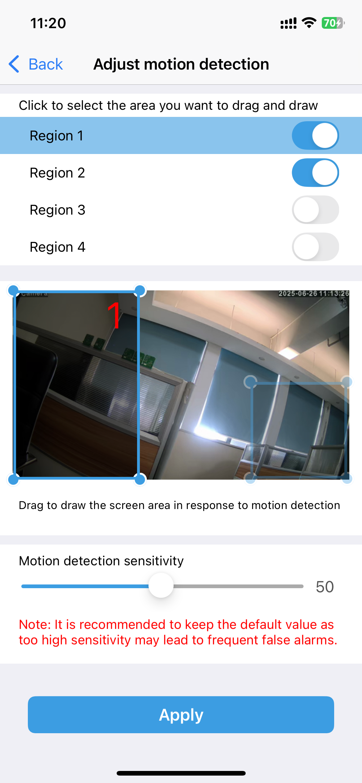
CamHipro supports setting up to 4 motion detection zones.
After clicking the button on the right to enable the motion detection zone, a rectangular frame will appear in the video window.
You can adjust the size and position of the rectangular frame with your fingers.
An alarm will be triggered when changes occur within the videoscene framed by the rectangle, but no alarm will be triggered when changes occur outside the rectangular frame.
You can adjust the alarm sensitivity for motion detection below, with a range from 1 to 100.
The higher the number, the more sensitive the detection will be, but this also increases the likelihood of false alarms.

It is recommended to use the default setting.

2）Audible alarm& Adjust the sound alarm
A device with a microphone function triggers analarm when the surrounding sound is greaterthan the intensity of the device's detected sound.
The option to "Adjust the sound alarm" can only be set after the audible alarm is enabled.

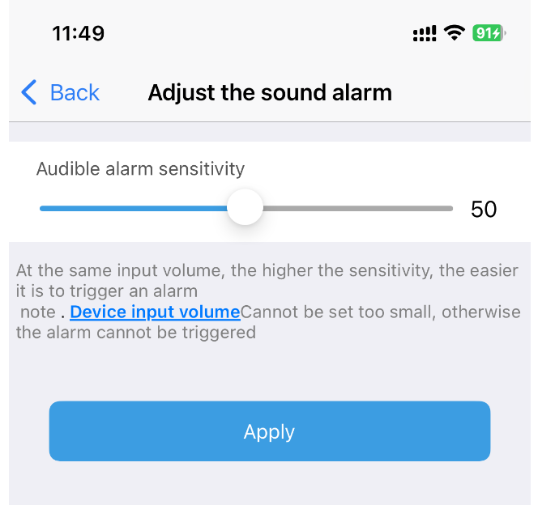
At the same input volume, the higher the sensitivity, the easierit is to trigger an alarmnote.
Device input volumecan’t be set too small, otherwisethe alarm can’t be triggered.

When using audible alarms, it is necessary to set the trigger threshold for the alarms reasonably based on the actual ambient noise level. This ensures that the alarms are not triggered under normal ambient noise conditions but can respond promptly when abnormal sounds occur.

3）AI alarm& Identification type
The AI alarm is an intelligent alarm function integrated with artificial intelligence (AI) technology. It conducts real-time analysis and recognition of human, vehicle shapes, and pets within surveillance footage through AI algorithms, automatically triggering an alarm when abnormal situations are detected.

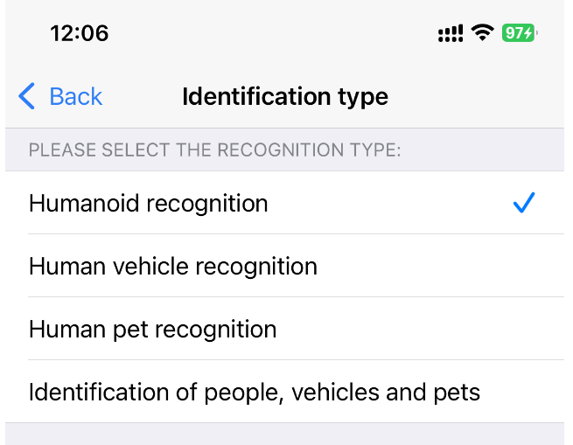
Humanoid recognition: When a human appears within the video range, the system will issue an alarm signal.
Human Vehicle recognition: When a human or a vehicle appears within the video range, the system will issue an alarm signal.
Human Pet recognition: When a human or a pet appears within the video range, the system will issue an alarm signal.
Indentification of people,vehichles and pets: When a human or a vehicle or a pet appears within the video range, the system will issue an alarm signal.

When the "Frame the recognition object" function is enabled, upon triggering an alarm for detected targets such as human, vehicle shapes, or pets, the system will enclose the recognized objects with a bounding box.

4）Alarm trigger

There are two types of alarm triggers: Alone trigger and Linkage trigger.
Alone trigger means that AI alarms and other alarm settings are triggered independently of each other.
Linkage trigger, on the other hand, means that an alarm is only generated when both the AI alarm settings and the motion detection alarm settings are satisfied simultaneously. For example, if a motion detection alarm is set up with a specific alarm area, and an AI alarm is also configured (such as for human recognition + vehicle recognition), then an alarm will only be generated when either a human or a vehicle appears within that designated area. If only one of them (either a human or a vehicle) appears in the area without the other being detected, no alarm will be triggered.

5）Easy Setup & Advanced setting
Easy setup ：The device can trigger an alarm at any time.
Advance setting:Manually customize thedevice alarm time period.

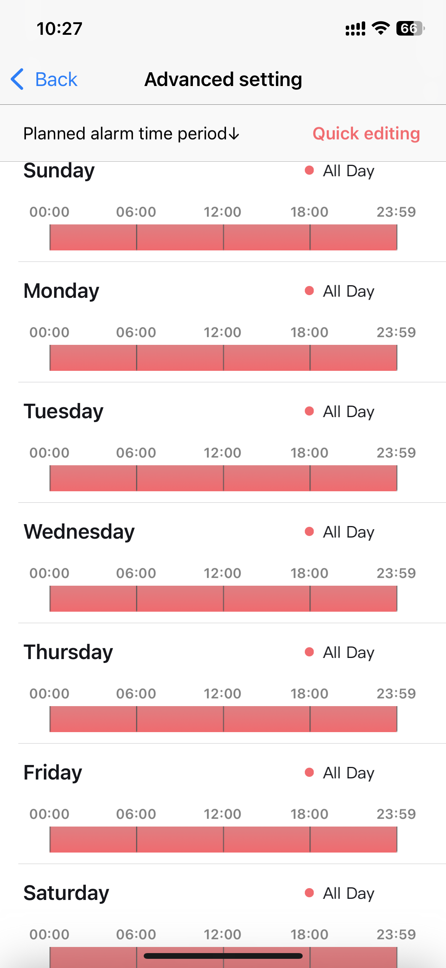

6.7.3 Action with Alarm
Turn on the device alarm. When the alarm is triggered, thedevice can perform the following linkage:

1)Alarm capture to TF card:
When an alarm is triggered, capture an image and save it to the TF card.

2) Alarm recording to cloud
When an alarm is triggered, initiate alarm video recording and save it to cloud storage.

3) Alarm recording to TF card
When an alarm is triggered, initiate alarm video recording and save it to TF card.

4) When the alarm is triggered,the device issues a siren
If this function is enabled, the device will issue a siren after an alarm is triggered.
The types of alarm sounds include: Alarm/Canine bark/Custom recording;

5) Alarm capture sent to Email
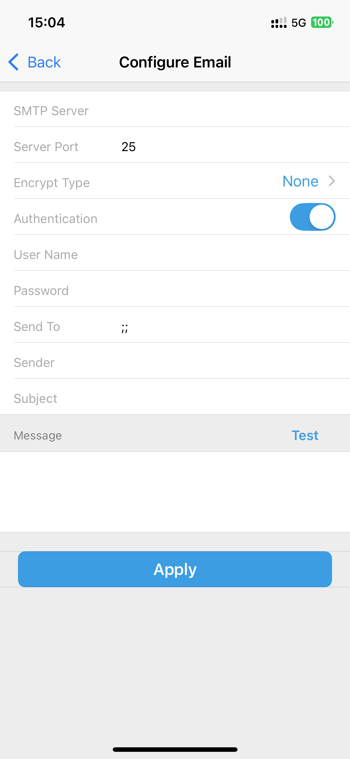
Select On to indicate that the device will trigger the alarm and send a picture to the mailbox. Click Configure Email to set the mailbox information.
Send an email to the QQ mailbox as an example:
Smtp server: smtp.qq.com
Port: 465
Secure connection: SSL
Username: QQ number of the outbox
Password: Authorization code of the outbox QQ mailbox
Receiving address: the mailbox that receives the alarm picture
Sender address: sender email address, here is the QQ mailbox as an example, you need to fill in the QQ email address (consistent with the user name). Subjects and content can be filled in casually. After filling out, click the Apply button, then click the Test button to check if you can send an alarm email.

5) Alarm capture saved to FTP
The alarm images can also be saved on an FTP server.
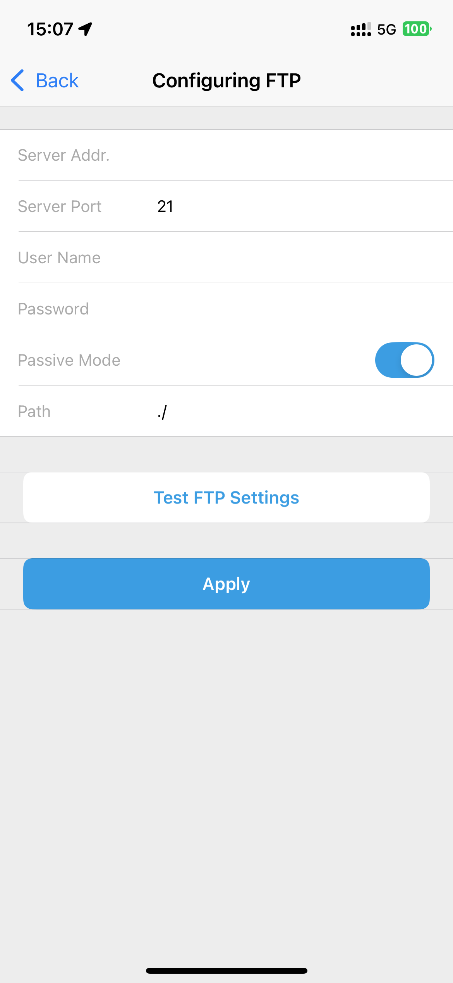
Select On to indicate that the alarm capture image is saved to FTP.
Click Configure FTP to set FTP information.
Server address: Fill in the erected FTP address
Port: Fill in the FTP port
Username and password: Fill in the username and password set in FTP
After filling in, click the Apply button, then click the Test button to check if you can send an alarm picture to FTP.

6.8 Video setting
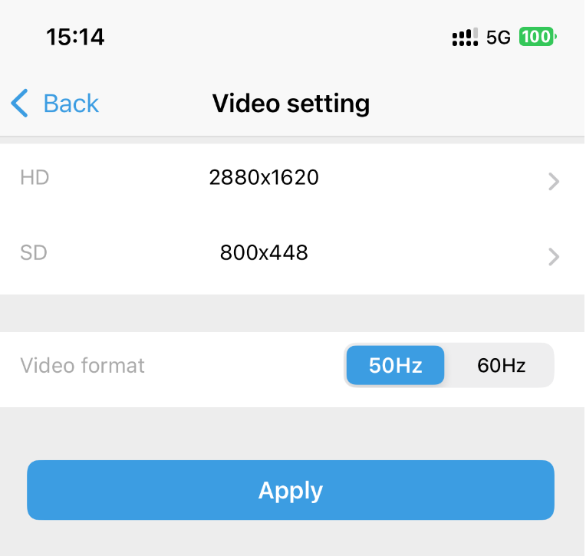
You can configure the resolutions for the main stream and sub-stream.
The resolutions supported by the device are automatically recognized based on the device model.
Additionally, you can set the video standard (either 50Hz or 60Hz).

6.9 Audio setting
Input volume: Adjust the input volume of the device
Output volume: Adjust the output volume of the device

6.10 TF card plan recording
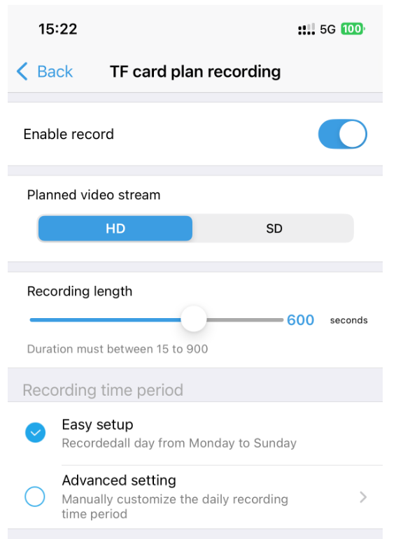
After enabling this feature, the camera will continuously record video during the set time period and save the recorded files onto the TF card.
You can choose to record the main stream (HD) or the sub-stream (SD).
Additionally, you can set the recording length, with the default being 600 seconds per file.

6.11 TF card setting

In the TF card settings, you can view the total capacity and available capacity of the TF card, and you can also format the TF card.

NOTE :Format command will erase all date TF card.

6.12 Time setting

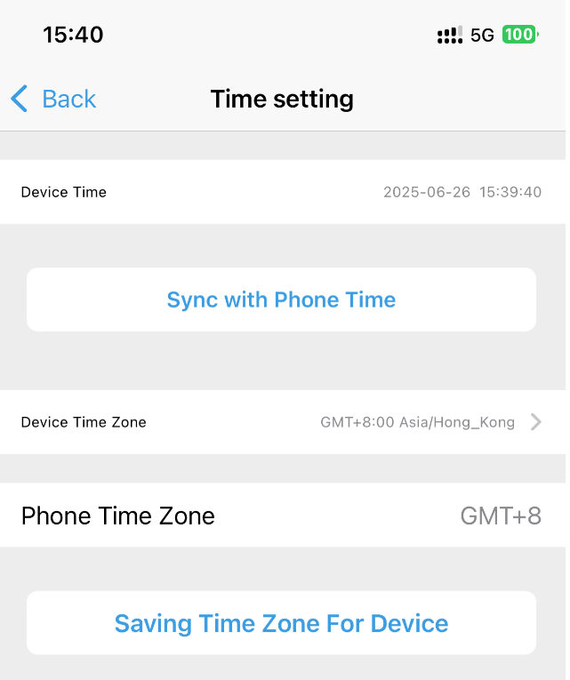
1、Synchronize device time to phone time
2、The device time zone can be set. After the time zone is set successfully, the device will restart automatically.

6.13 Default setting
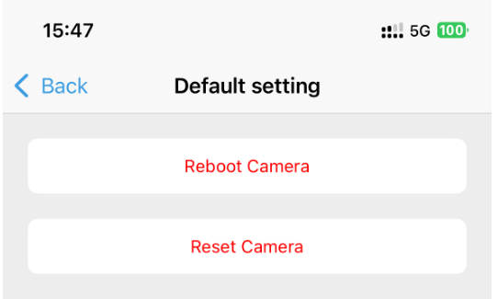
Reboot Camera: The camera will restart after clicking.
After rebooting, the network camera will reload its operating system and applications while retaining all user-defined settings and configurations.

Reset Camera: The camera will reset after clicking.
After resetting, the network camera will revert to its factory default settings, including network configurations, user accounts, video parameters, etc. All user-defined settings and configurations will be erased, and the device will need to be reconfigured as if it were a new device.

6.14 Device information

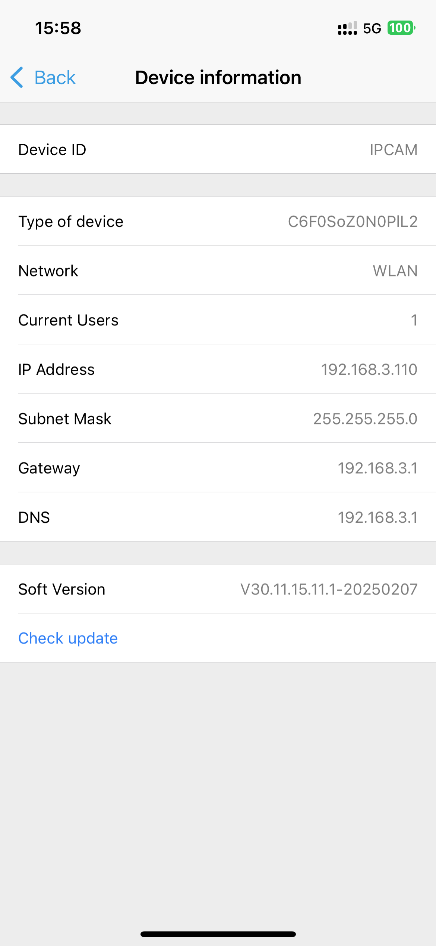
Here, you can view the basic information of the device, including the device type, IP address, and firmware version number.
When the device encounters a malfunction, you need to provide the device's UID and firmware version number to the manufacturer's technical support personnel.

Additionally, when a firmware update for the device is available, you can manually upgrade it here.

================================0626======================

7. Video/Image search and view

7.1 Local recording playback and download
Find the camera to be viewed in the camera list interface, click the icon, select the recording page, the recording file will be displayed, you can sort according to the size and length of the video file, click the button, you can save the video file to the mobile phone album. Click the edit button; it can delete the selected video file.

7.2 View local snapshot images
Click on the image page in the local file interface, the local snapshot images will be displayed, the images will be sorted according to the capture time, click the preview thumbnail to view the image, click the button, you can delete or save the image to the album.

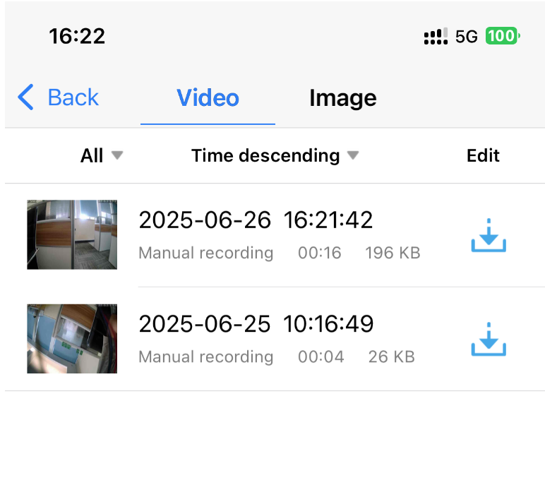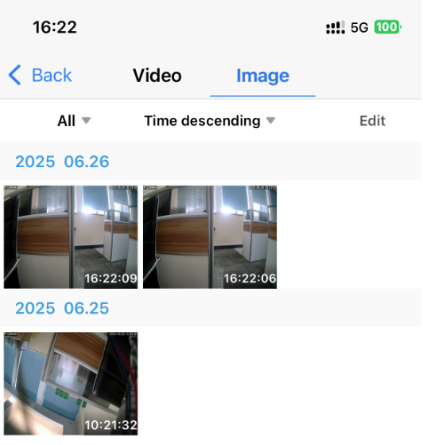

7.3 Remote video playback and download

7.3.1 Remote video playback
Click the button“camera list interface” to enter the remote recording list interface. The APP searches for the last 6 hours of video files by default. You can customize the sorting according to the recording time, click the video file, and then click play to playback the video files in the SD card of the device.
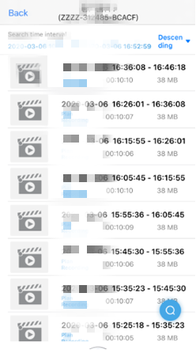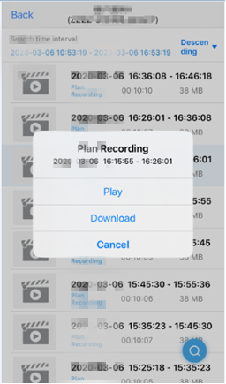

7.3.2 Remote video download
Click on the video file in the recording list interface, and then click Download, the video file will be downloaded automatically. The downloaded video file will be saved in the local recording interface. After the video download is completed, you can click continue download, continue to download other video files, or clickview, will jump to the local recording interface automatically.

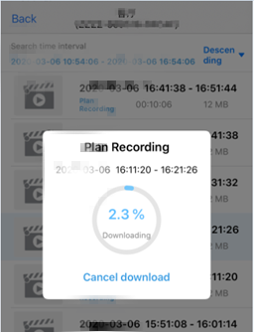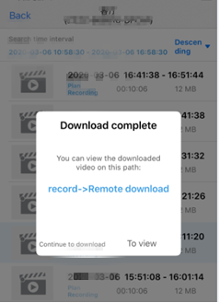

8. Other functions

7.3.3 Remote video search
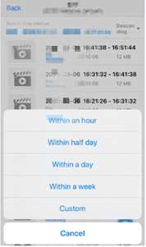
Click the button on the recording list interface, the search option appears, you can select the recording search range as needed.
Search time range is optional

7.3.4 Timeline replay
Slide the timeline to view file playback
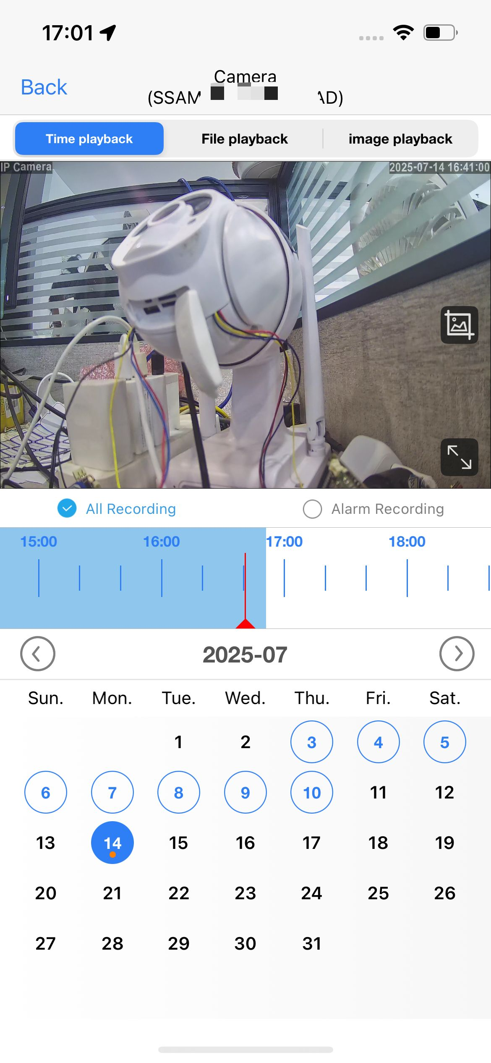
7.3.5 Picture replay
Quickly view the alarm image
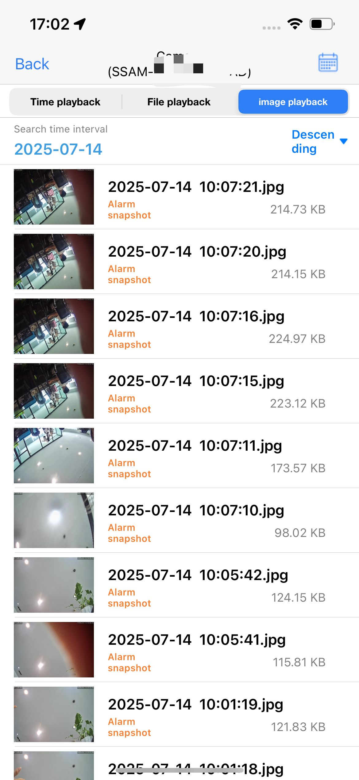

8.1 Camera list display mode
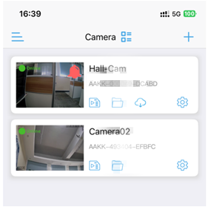
Click the camera list interface icon to select the camera list in large or small image mode.

8.2 Four-screen display
Support simultaneous viewing of multi-screen live broadcasts
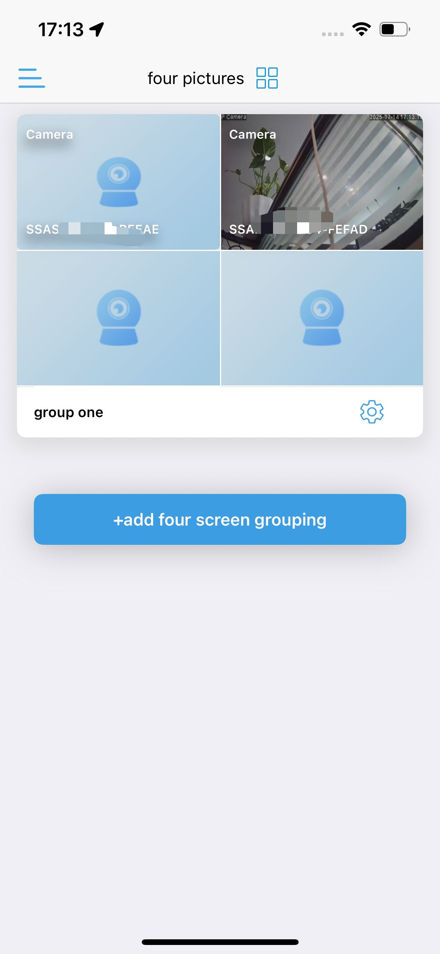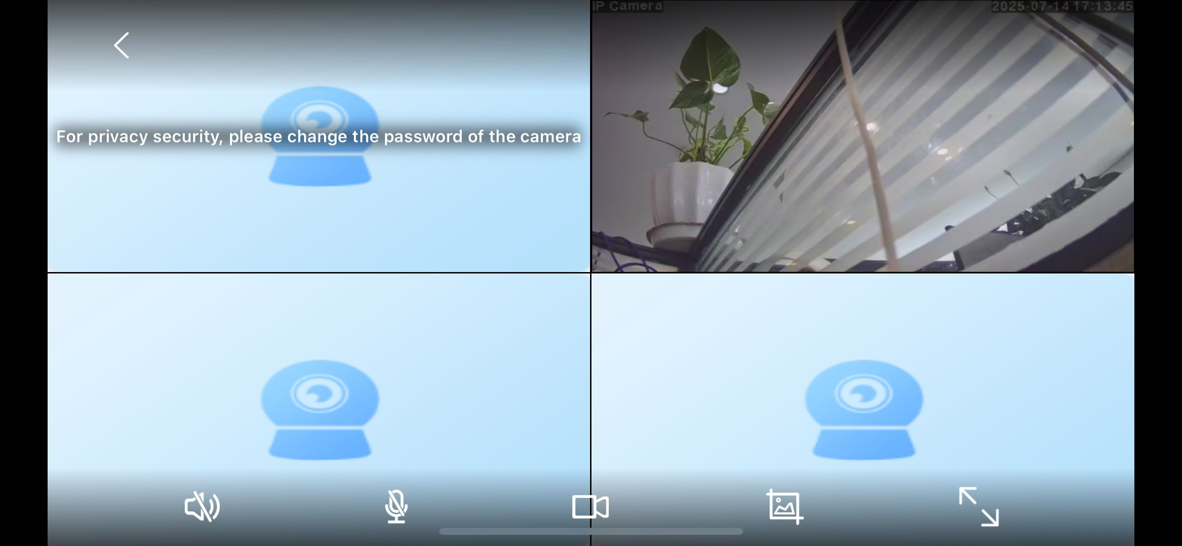

8.3 Sidebar settings
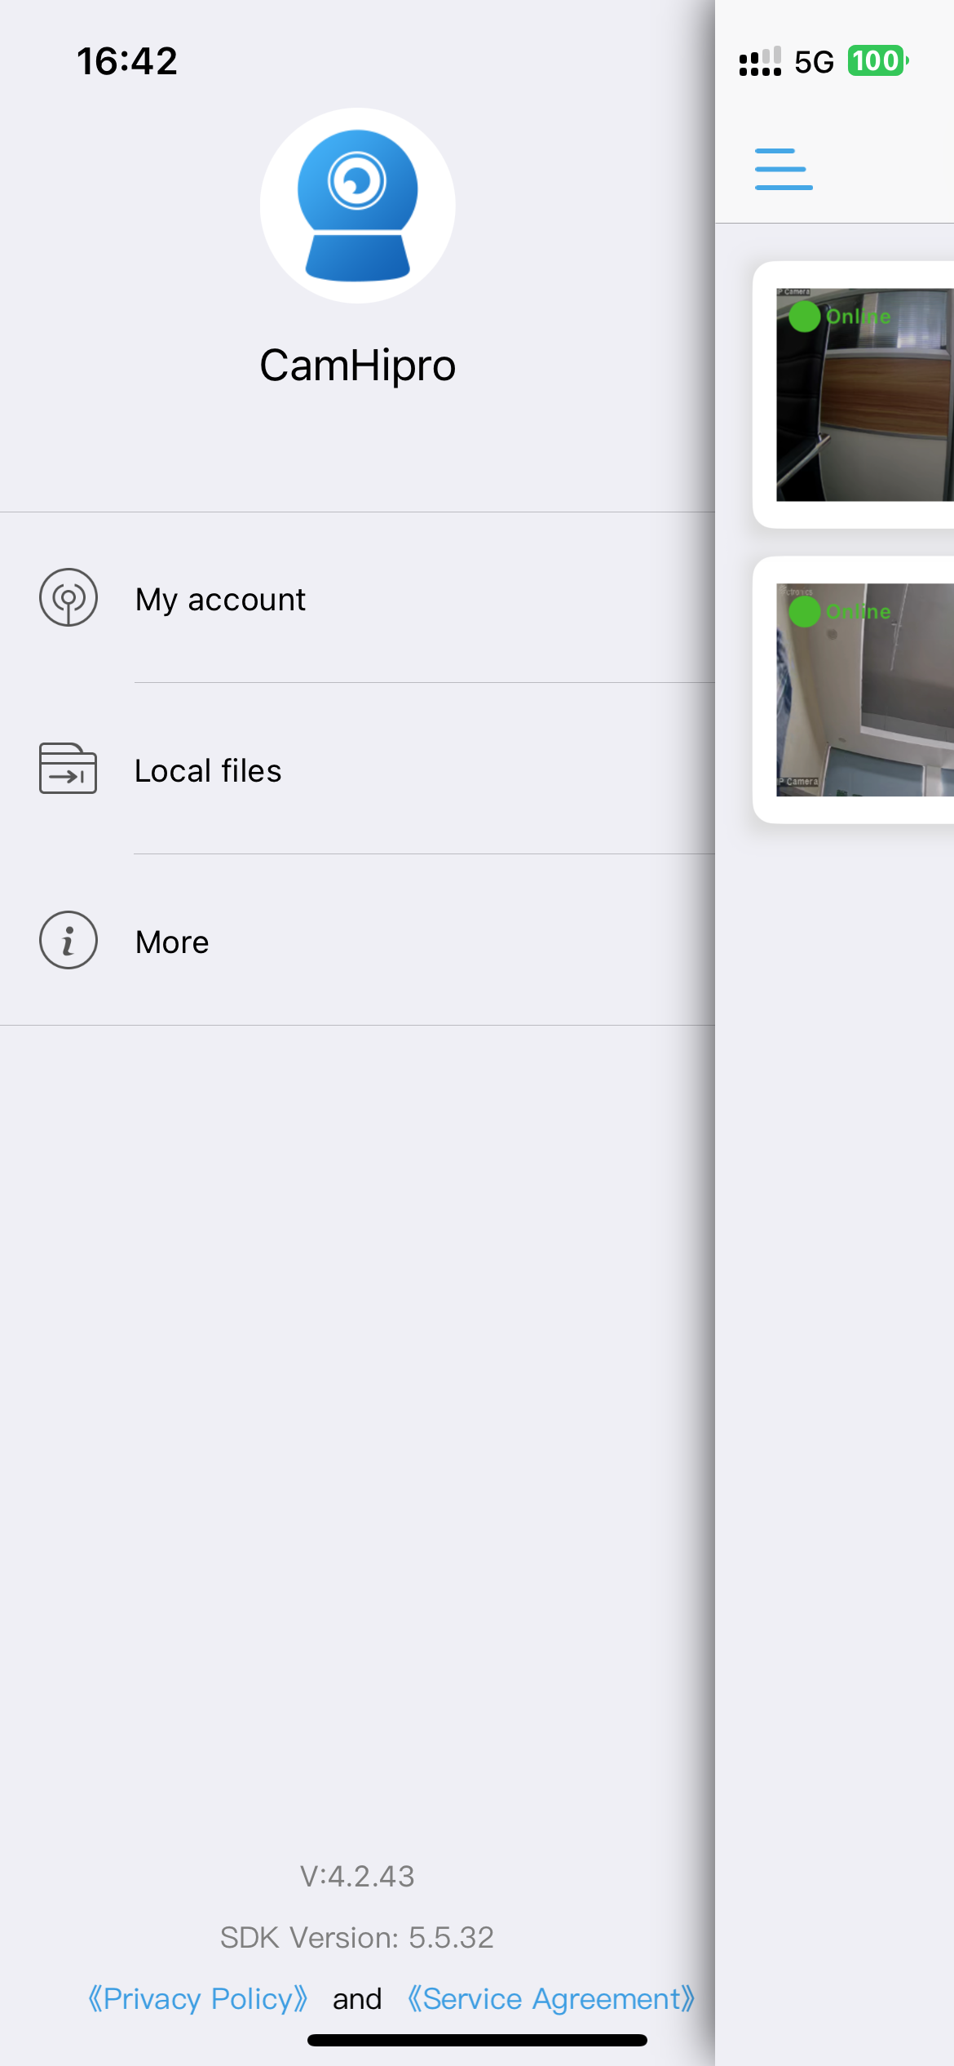Click the camera list interface button, or swipe the screen to the right in the camera list interface to enter the APP sidebar. The APP name is displayed on the sidebar. The below displays APP version.

1) My account:
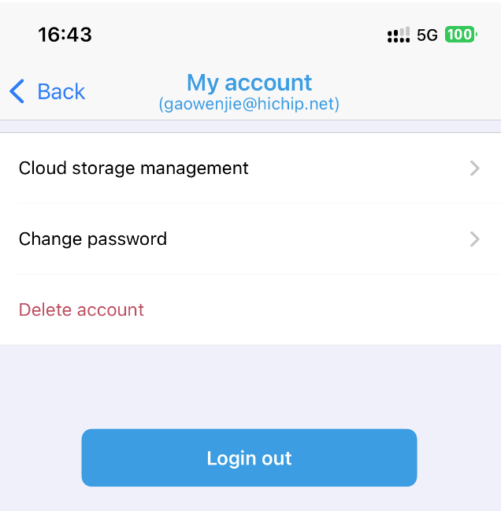In "My account", you can view your cloud storage account information, manage your cloud storage data, and also modify the login password for the APP. Additionally, you have the option to delete your account.

2) Local file
Click Local File to enter the local file interface. This interface displays all the local videos and pictures saved by this camera on this phone. Click on the file to playback the video file or view the local picture. Click the Edit button to delete the file.

3) More
Click the More buttons to check whether the APP has obtained the notification permission of the mobile phone. If the display is not enabled, the APP cannot send the alarm push message.
After the notification push is enabled, go to the device ‘Settings->Alarm Management and Notifications' toenable the 'Accept Alarm Push'switch to receive thecorresponding device push message when the devicetriggers an alarm

