IP Camera user manual

Product name:High definition IP Camera
Document version:4.2
The manual for: V6.1.6.2.1-20131128 and above editions
Editions suit for 720P IP Camera

Directory
1 Products overview 4
2 Technical Parameters 5
3 Appearance and interface 6
4 Equipment installation 8
4.1 Running environment 8
4.2 Device connect 8
5 Network Settings 9
5.1 Quick Setting Guide 9
5.2 System login 11
5.3 Configuration manufacturers DDNS 13
5.3.1 Port forwarding 13
5.3.2 DDNS 14
5.3.3 Manufacturers domain name visit 15
5.3.4 Third party dynamic domain name visit 15
5.4 Mobile Access 15
5.5 Mobile phone software visit 16
5.6 WIFI Setting 16
5.7 RTSP monitor 17
6 Function Setting 20
6.1 monitor 20
6.1.1 Main Menu 20
6.1.2 Video display area 20
6.1.3 Capture 21
6.1.4 Record 21
6.1.5 Playback 21
6.2 Video Setting Page 22
6.2.1 Image Setting 22
6.2.2 Video Setting 23
6.2.3 Audio Setting 25
6.3 Network Setting Page 26
6.3.1 Basic Network Setting 26
6.3.2 WIFI Setting 27
6.3.3 Remote Access Setting 28
6.3.4 Platform setting 29
6.3.5 ONVIF Setting 29
6.4 Alarm Setting Page 30
6.4.1 External Alarm Input 30
6.4.2 Motion Detection Setting 30
6.4.3 Alarm Mode Setting 30
6.4.4 Alarm Time Setting 31
6.5 Advance Setting 31
6.5.1 User Management 31
6.5.2 Auto Snap Setting 32
6.5.3 Email Setting 33
6.5.4 Timer record 33
6.5.5 FTP Setting 34
6.5.6 Terminal protocal 34
6.6 System Setting 35
6.6.1 Date and Time Setting 35
6.6.2 Initialize Setting 35
6.6.3 Device Information 36
7 FAQ 37

Products overview
IP Camera is designed as web server running on network it can transmit real-time video to anywhere through internet,and user can view real-time live video via web browser any time .It is available to large stores,schools,factories,houses,etc.
Basic function IPCAM can transmit real-time live video data to remote place through internet with hardware compression method H.264 which providing high-quality video image.
The IP Camera video data transmission is based on TCP/IP protocol,built-in web server supporting internet explore ,it make more easy to manage and maintain the devices to remotely configure ,start and upgrade firmware,etc.

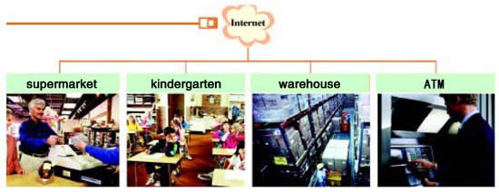
 | Please check if the items are all in before installation of IP camera ,if there is some missing,please contact seller.
List of articles：
IP camera…………………………………………………………………………………….1
Bracket (to be equipped by the model) ………………………………………………………1
WIFI antenna（for wireless model）………………………………………….…………….1
Power adapter ………………………………………………………………………………..1
Qualification certificate…………………………………………………………………........1
CD ……………………………………………………………………………………………1

Technical Parameters
- Adopt mega pixels CMOS sensor, support 1280*720/1920*1080 video resolution.
- Support H.264 Baseline profile video coding
- Support Dual video stream synchronous transmission
- Support Mobile monitoring
- Support WIFI/802．11b/g/n wireless network(Optional)
- Support ONVIF
- Support two-way voice intercom
- Support sending email, attaching picture
- Support DHCP
- Support DDNS
- Support Motion-Detection(multiple regions and sensitivity can be set) and sensor alarm
- Support remote alarm linkage, multiple alarm time can be set
- Support recording and snapshot in PC through live video
- Support up to 12 users browsing at the same time(Each stream supports four users)
- Support multiple network protocol, such as TCP/IP，HTTP，TCP，ICMP，UDP，ARP, IGMP，SMTP，FTP，DHCP，DNS，DDNS，NTP，UPNP and so on
- Only 1 network port is used for IE Browsing, stream transmiting a nd command access, convenient for router setting
- Support UPNP
- Can provide CMS (charge needed）

Appearance and interface

Device interface:

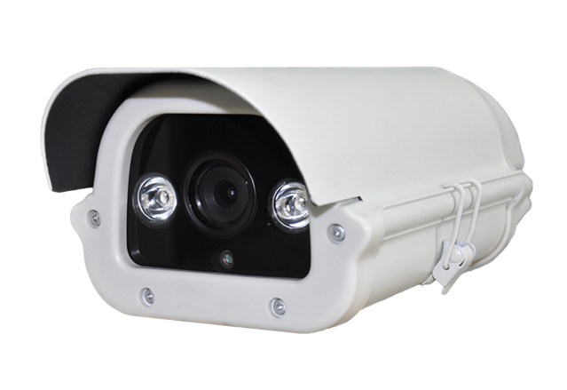
Multifunctional finish line:

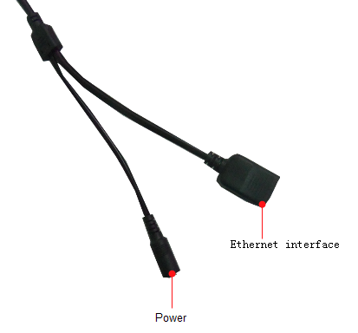
1.Enthernet interface
2.Power

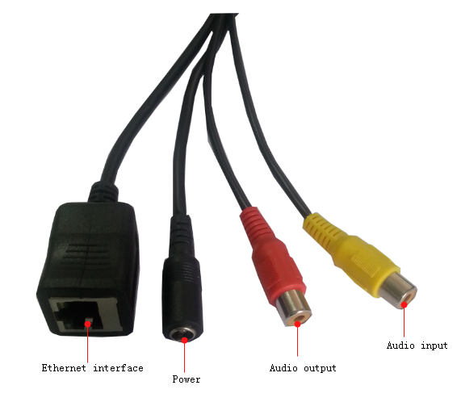
1.Enthernet interface
2.power
3.audio input interface
4.audio output interface

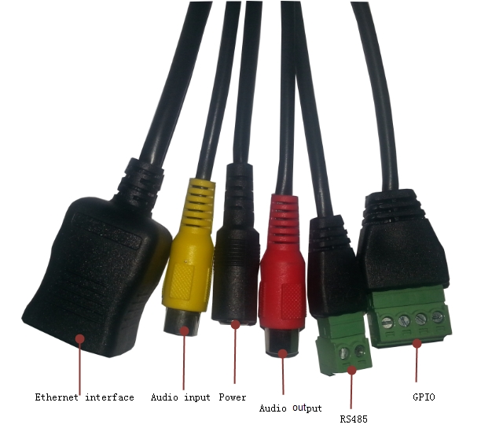
- Enthernet interface
- Audio input
- Power
- audio output
- RS485
- GPIO

1 Power
external power adapter DC 12V/1A
2 Ethernet interface
The network interface for 10/100 M adaptive Ethernet interface, through the interface can with all kinds of network equipment connection.
3 Audio input interface
Used for external microphone or linear audio input signals, such as pickup signal. If meet linear audio input signal, need to be installed where in the audio, choose linear input.
4 Audio output interface
Output audio signals, used for external sounds play equipment, like the headphones, sound box.
.

Equipment installation

Running environment
Operating system： Windows 2000/2003/XP/vista/7
Network protocol： TCP/IP

Device connect
1.Connect the crystal head of network cable to RJ45 interface of IP camera
2.Connect the power adapter to the electrical outlet of the IP camera and power on
3.The network connection normally in 5 seconds at the network connection of light (orange) will light up, data indicator light (green) shine, this time the network cameras physical connections to complete.

Network Settings

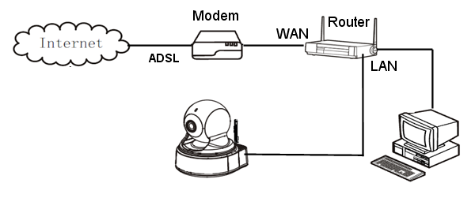
Network connection diagram

Quick Setting Guide
- Through the IP Camera connection to network (or PC), and then to the IP Camera electric start, pictured above.
Note: if IP Camera and PC connected directly, PC IP address to use manual distribution methods, and the IP address of the PC network segment and IP Camera keep the same segment.

- Operation in the CD :quick setting Guide program ：
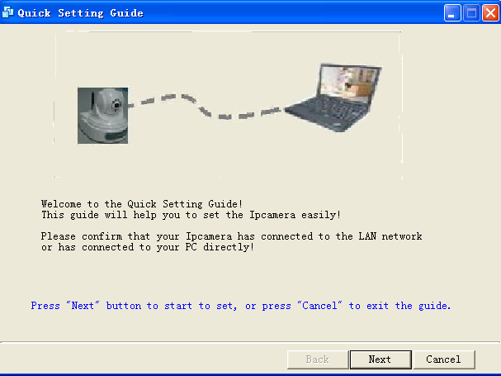
- press "Next" button, pop-up as below interface
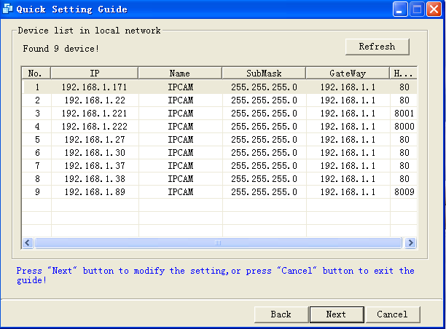
- Choose device after the click on the "next" , pop-up as below interface
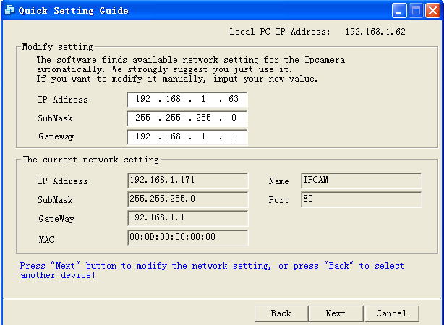
- press "Next" button, pop-up as below interface
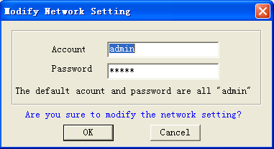
- Click OK IP Camera parameters configuration, POP up in the following figure after interface ,IP Camera parameters configuration succes,click finish exit Quick setting guide.
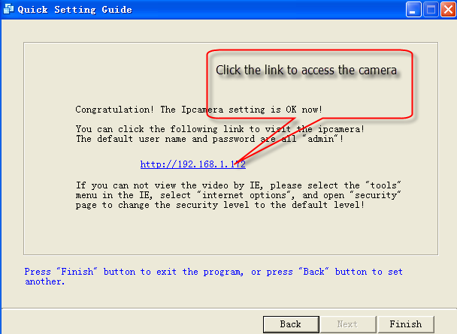

System login

- Open the web page,enter default IP address:http://192.168.1.88;
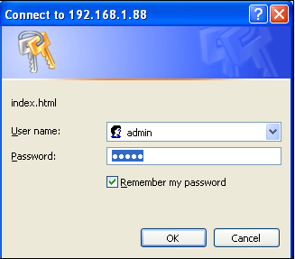
- Input the authorized user name and password ,the default user name of the camera is admin,password is admin,The following page will be shown after correct password authentication
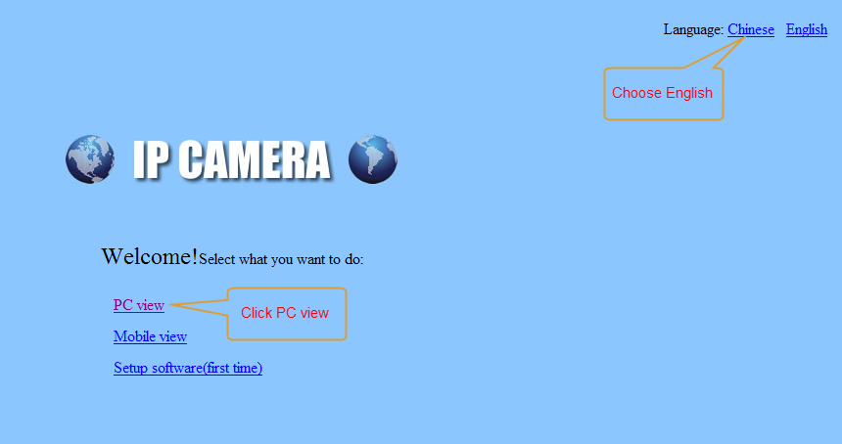
- Click the "PC view" into the web camera screen,
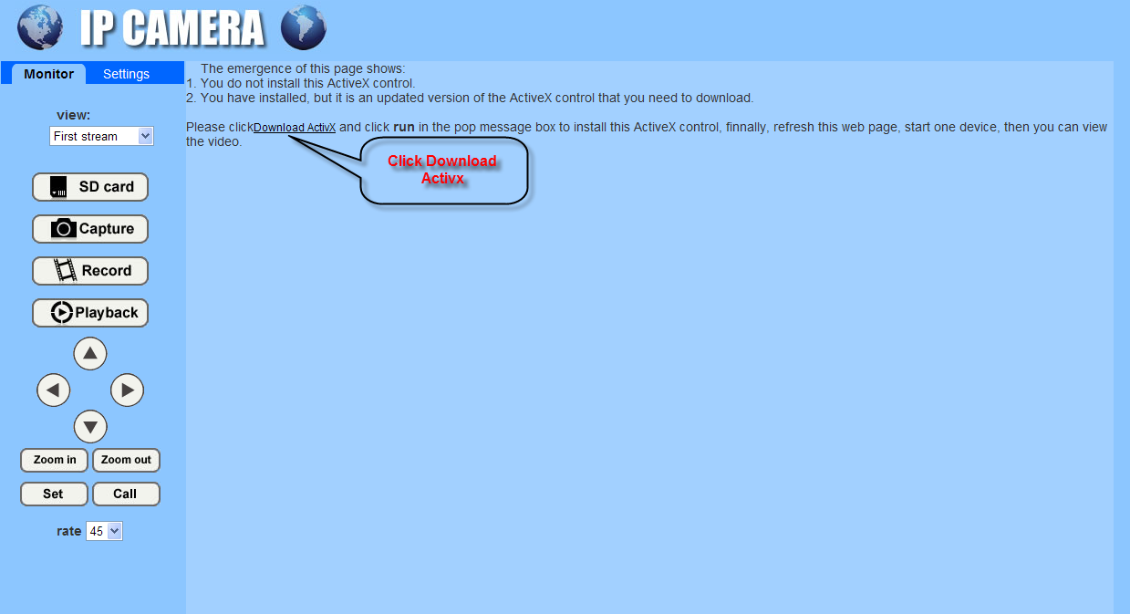

- Click the :"Download activx",POP-up as below,click run button,installation button;
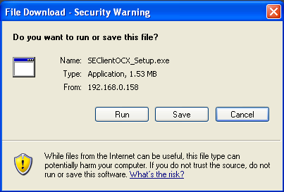
- Activx installation is completed, click "Monitor" can browse as below interface;
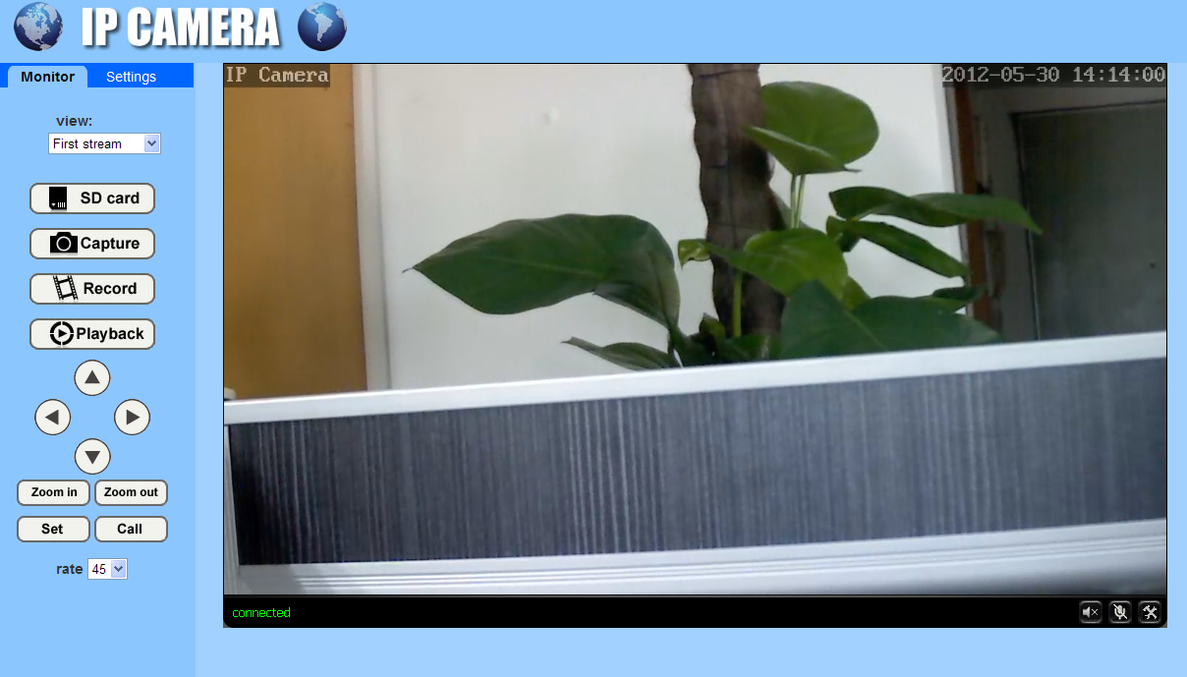

Configuration manufacturers DDNS

Port forwarding
If visit IP Camera from WAN, you must do port forwarding on the router. Take Netgear router for example.

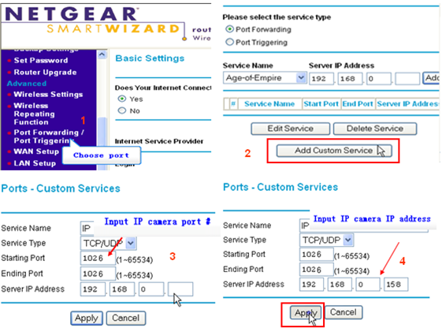

Operation Steps:
After login the interface of the router，choose “Port Forwarding”;
Choose “Add custom Service” ;
Input IP camera port;
Input IP camera IP address，click “Apply”（the http port and ip address should be the same as figure 4 which set by you own).

Note: Different router has different settings for port-forwarding; please kindly follow your router guide to do the port-forwarding.

After the port-forwarding is done, you could view the IP Camera from WAN now.

DDNS
Manufacturer's Domain name：
Device manufacturer has established a DDNS, and allotted a dynamic domain name to every device, the domain name has been integrated into devices when producing. For example, enter domain name , the browser will connect the device and display the IP address.
Note: dynamic domain name by manufacturer manufacturer provides the user name and password

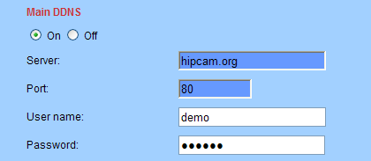
Third Part Domain Name:
User can also use third part DDNS, such as www.dyndns.com User must apply a free domain name from this website and fill the info into the below blanks (Figure 12) and save the settings. Then the domain name can be used.
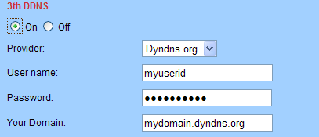

Manufacturers domain name visit

The router configuration parameters and camera parameters, in the browser to enter your user demo. Hipcam. org directly to the camera, such as manufacturers with user name: 99 a1234b, the domain name for 99 a1234b. Hipcam. Org
Note: use the manufacturer domain name visit camera, doesn't need an HTTP port, input domain name only can access

Third party dynamic domain name visit
the product also can support third party ddns, such as oray
Note:the third party ddns realizes the function by analytical methods,after inputting the ddns in browser,the characers would not change,if the port is not 80,need to add a colon and port behind the ddns such as：http://demo.dyndns.org:1024

Mobile Access
In the mobile phone browser input domain name:
http://viewipcam.dyndns.org/mobile.html或http://viewipcam.dyndns.org/wap.wml
If the camera HTTP port is changed, please input:
http://viewipcam.dyndns.org：端口/mobile.html或http://viewipcam.dyndns.org：端口/wap.wml

Mobile phone software visit
1.support android 、Iphone system
2.Go to the【AppStore】for Iphone, search “hi player”
Note: it is recommended that in "video parameters" page code of the time flow rate for 64 K code modify the following, frame rate set to 8 frames the following, if set too large, mobile phone decoding slow, can lead to phone the image to see a delay

WIFI Setting

- Through the local area network configuration IP Camera network parameters,makes a pc can access IP Camera;
- Configuration wireless parameters of the wireless router
- Configuration wireless parameters of the IP Camera
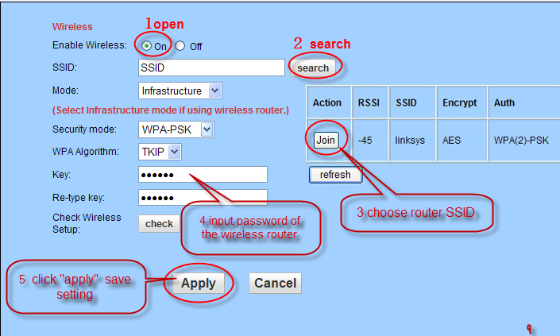

Note: if the router to wireless set not set password, it does not need to enter the password and click "check"
Pop-up is shown below, says WIFI is set correctly, click on the "application" save Settings, if tip connection, please enter a password, and then click on the "check"

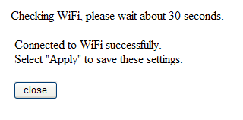
- Disconnect IP Camera after,power off to restart IP Camera,Can use WIFI connection
Note: after open WIFI function, if need to use wired connection way, must first network cameras connected to the Internet, and then to the web in cameras electric start, or network cameras into the wireless connection to state

RTSP monitor
TCP:
1.Open the vlc player,Click on the “Media” “Open Network stream or “Ctrl+N” ;

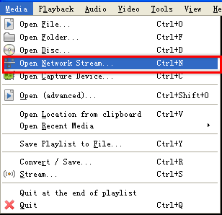
- Input URL addrdss:
First stream: RTSP://192.168.1.188/11
Second stream:rtsp://192.168.1.188/12
Third Stream:rtsp://192.168.1.188/13
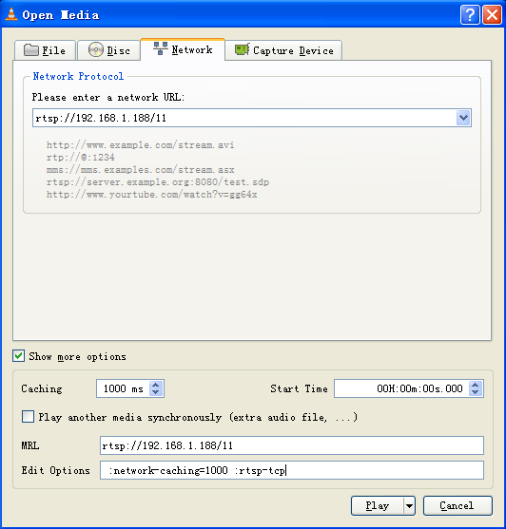

NOTE:
- IP is 192.168.1.188; Rtsp port is 554(omitted)
- RTSP using TCP connection needs to be input in the Show more options:
“:rtsp-tcp”

UDP:
1.Open the vlc player,Click on the “Media” “Open Network stream or “Ctrl+N” ;

- Input URL addrdss:
First stream: RTSP://192.168.1.188/11
Second stream:rtsp://192.168.1.188/12
Third Stream:rtsp://192.168.1.188/13
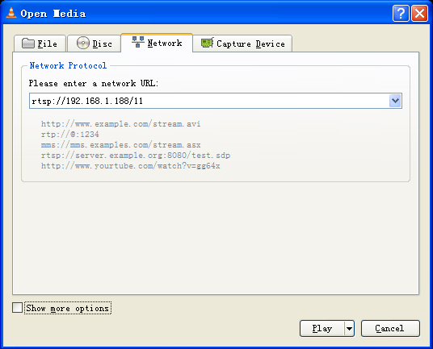

NOTE: if required by way of internet , we need to map the following ports:
TCP | 554 | RTSP port
UDP | 554 | RTSP port
UDP | 6600 | UDP port
UDP | 6602 | Audio port

Function Setting

monitor

Main Menu
Menu bar all pages are including two class in the Menu bar: including real-time parameter Settings and monitor; display of the camera is the prison see pictures and related operation function keys; Set the main parameters is set the camera related parameters.

Video display area
The video displaying area is correspond to the resolution, the higher the resolution is, larger the displaying area will be. If motion detection was set, when it has detected any movements of the certain area, it will show a pane to call user’s attention.
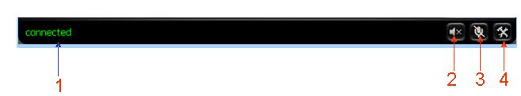
- Connection status display；
- Audio play button:it can play out the sound which collected by the equipment on the computer,click it again,it will stop playing.
- Talk-back button：it can transmit the sound which collected by the computer to the equipment,And played out by the speakers which was connected to the equipment,Click it again,it will stop playing;
- File saving location setting:you may set the location for recording and capturing,the default location is D:/record

Capture
Click the Capture button,which could take photos for the current video and store the image at the present path.

Record
Click “Record” button, which could record the video with audio and store it at the present path. When recording, there will be an indicated symbol in the status of video display area to show you it is recording. Click the “Record” button again, and then the record stops.

Playback
Click “Playback” button, it will pop up a player which could play the video stored on your PC disk.
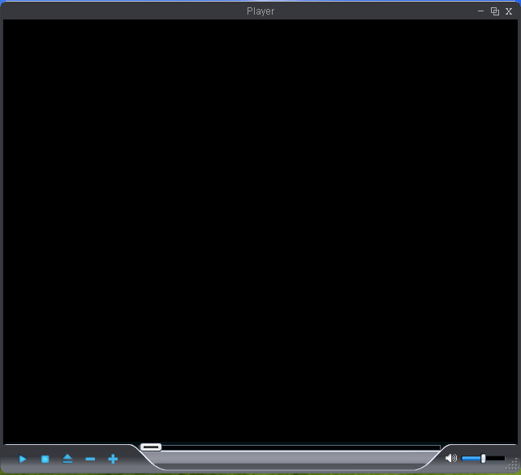

these buttons are for play, stop, the previous recorder, the next recorder, open the recorder file. Please click the button of “open the recorder file” first, and select the file you want to play, you can playback the recorder.

Video Setting Page

Image Setting
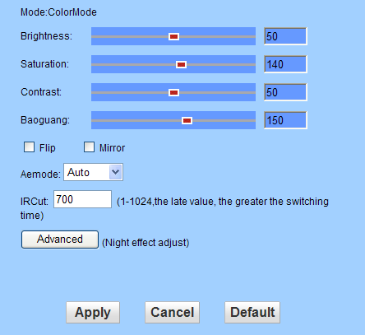
- Colour adjust
Drag the slider above, can adjust the brightness of the image, saturation, contrast, and meet their vision of user preferences;
- Sensitivity
Can drive through the slider setting color turn black camera time, the smaller the sensitivity, the image color the later turned black, sensitivity, the bigger the image color turned black more early;
- Flip and mirror
Image Flip and mirror
- IRCUT time
IRCUT threshold Settings, default is 250

Video Setting
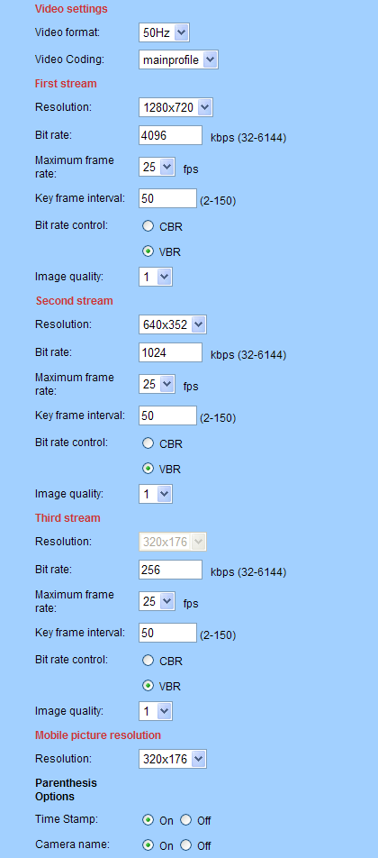
- Power Line Frequency: If the monitoring site adopting lighting elimination, user should set a corresponding frequency. If the two frequencies are different, the image will flick. There are two frequencies on the world, one is 50HZ, and the other is 60HZ. In China, adopt 50HZ.
- Video coding: setting Main profile and baseline coding, default coding is main profile;
- Resolution Adjustment: First Stream: There is 960P(1280*960)/720P(1280*720)、Second Stream is 640*352(for 720P)/640*480(for 960P)、Third Stream is 320*176(for 720P)/320*240(for 960P); The bigger the resolution is, more clear the image will be. On the other hand the bit rate is bigger and takes more bandwidth.
- Bit Rate Adjustment(First stream): User can choose a certain bit rate, generally speaking, the bigger the bit rate is, the more clear the image will be. Please choose the suitable bit rate according to your bandwidth. If you select a big bit rate, while the bandwidth is worse, it will cause the video stream can’t be transferred smoothly, the video quality will be not perfect too
- Max Frame Rate Adjustment: User can choose a certain frame rate, when the bandwidth is limited, suggest reducing the value. Generally, the video is fluency if the value is more 15 frames.default is 25 frames;
- Bit Rate Control: There are two modes for bit rate control, CBR and VBR. If user choose CBR mode, the video encoder will encode according to the bit rate you have selected. If user choose VBR mode, the video encoder will consider to the image quality and encode according to the bit rated have been selected, but not strictly according to this bit rate. Suggest VBR mode.
- Camera name: User can add the equipment’s name and the time on the video page thorough this setting.

Audio Setting
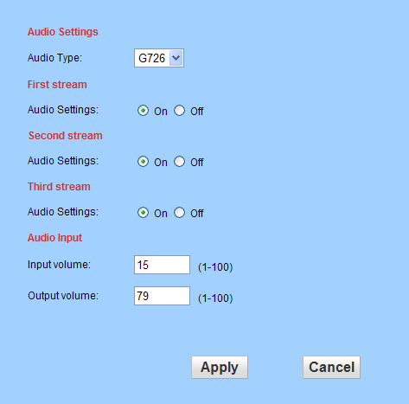

- Audio settings : Frist stream: Audio type G.726 and G.711
Second stream: Audio type G.726 and G.711
Third stream: Audio type G.726 and G.711
- Audio input:
Input volume: volume setting 1 to 100,default volume is 15;
Output volume: volume setting 1 to 100, default volume is 79;

NOTE: Audio input support pick-up only input, audio output support headset or power amplifier

Network Setting Page

Basic Network Setting
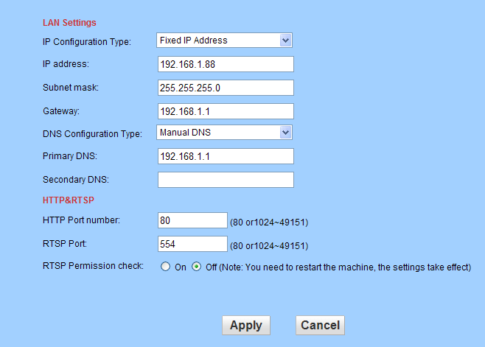

- LAN Settings
- Equipment default IP address for 192.168.1.88; The user can through the operation "Quick Setting Guide" configuration camera network parameters,user can change it according to your network environment.
- HTTP Port
HTTP Port: The IP address Identity one IP camera in the network, you can run several programs on this equipment, and every program will transfer the data through some port, in fact data is transferred from one port to another. The port setting of this page is asking user choose which port to transfer the data for the web server；Doing port mapping, need to maintain consistent with the port (equipment factory default port is 80)
- RTSP Port
IP camera support RTSP agreement, can use VLC tools such as direct broadcast（default rtsp port is 554)
- RTSP Permission
Choose "on" RTSP connection use need to input the camera login user name and password, choose "off" RTSP connection doesn't need input the camera user name and password can connect;

WIFI Setting

Please use the network cable to connect the device into Internet before doing settings of wireless connection. Please follow the above 1-4 steps to do the settings, then click “apply” to save the settings. You can also check the wireless network is connected successfully or not by clicking “Check” button. When the wireless is connected successfully, power off the device and reboot it, then the wireless network will work perfectly.
Description: when the equipment connected to the Internet, and also enable the WIFI, equipment, when activated, will be the first to choose cable connection mode, if can't connect, then choose WIFI connection. WIFI connection of the IP address and port to use with cable connection of the IP address and port use consistent

Remote Access Setting
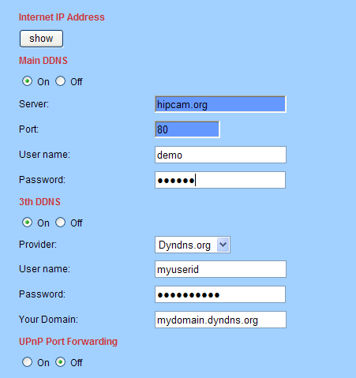
- Show Internet IP address
Click the “Show” button as above Figure , it will show you another new page displaying the WAN IP address when it is connected to the Internet.
- Dynamic domain names settings
Please refer to the content of the 5.3.2 DDNS.
- UPNP
UPNP stands for universal plug and play, if you started UPNP, once the IP camera was connected into the LAN, it will communicate with the router of the LAN. It will request the router to open a port to forward its own port. User doesn’t need to log in the router to set the port forwarding.

Note:
users in the use of the function, need to confirm a router also is enabled UPNP; Because many router model, not necessarily can very good support UPNP, testing and supporting the router is very good with, or suggest not start the function. At present test and TP-LINK router cooperate good.

Platform setting
As below picture,open platform after setting, need to input "login ID" and "password", "server address" (login ID and password and server address by platform service providers)
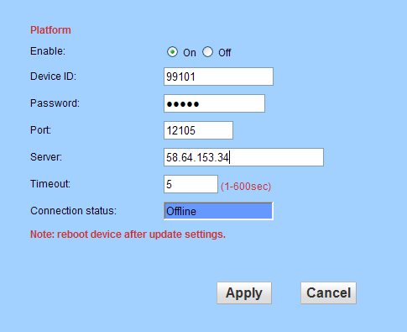
Note: when the camera and connected to the server platform, "connection" will show a "line", otherwise shows "offline"

ONVIF Setting
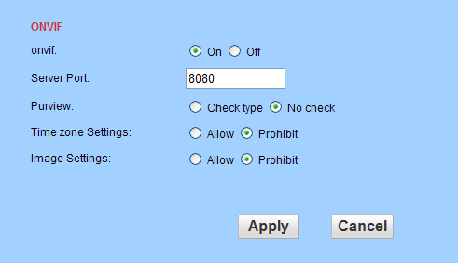
ONVIF switch:Default On
Server Port:Default Port 8080
Purview:Default No check
(Depends on the back end equipment, mainly considering some back end equipment does not support check Type)

Alarm Setting Page

External Alarm Input
choose "open" or "chose" according to the type of the external alarm detector
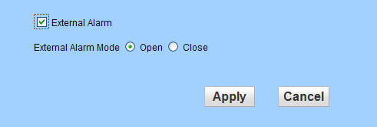

Motion Detection Setting
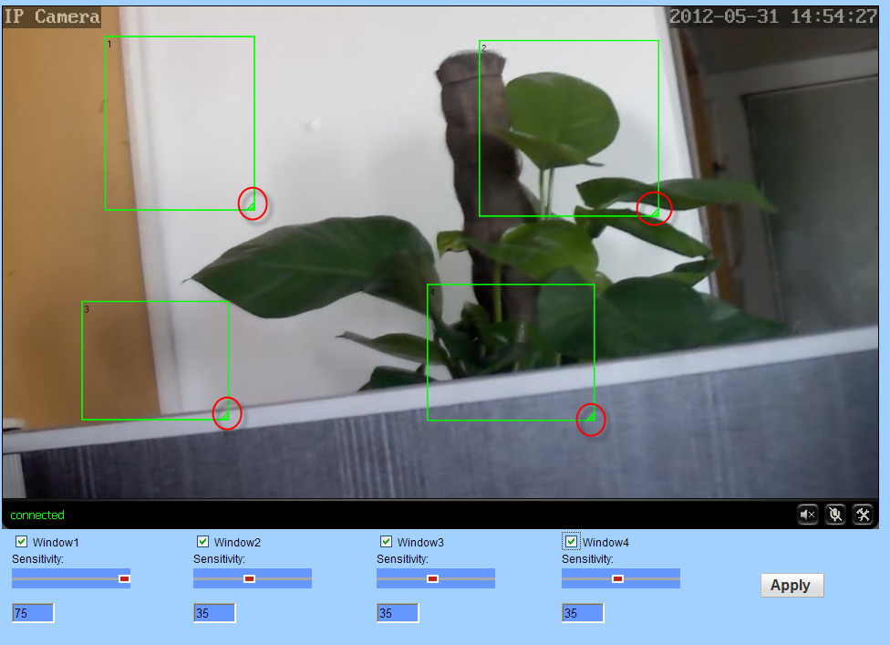
Please click “apply” after settings are done, and motion detection takes effect. The bigger the digital, and the higher sensitivity.

Alarm Mode Setting
When the alarm is triggered, user can adopt several ways to alarm.
- Send alarm info to E-mail.
- Save alarm picture on the ftp server.
- Save alarm video on the FTP server.
- Save picture on the SD Card
- Save Video on the SD card
- Settings image capture number,choose 1 to 3
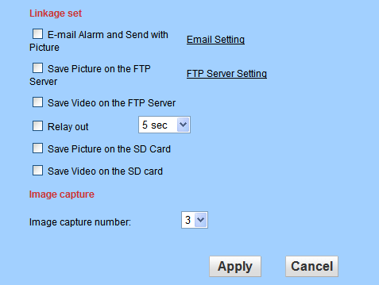
Note: Please insert the SD Card, should the “Save Video on the SD card” and “Save video on the FTP server” take effect.

Alarm Time Setting
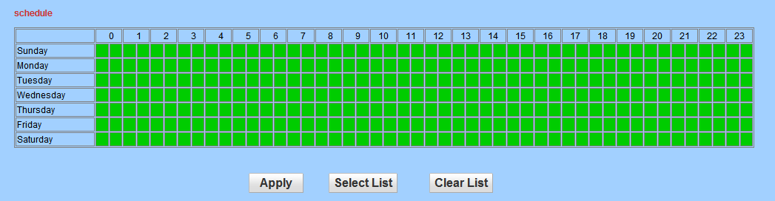
The device will trigger the alarm only during the armed time period.
Note: Please make sure your system time is correct before you set the alarm time period. Please refer to 5.5.2 to set system time.

Advance Setting

User Management
There are 3 levels of user authorization.
- Administrator：”admin” has the highest authority. It can do any settings. Factory default password: admin
- User: user can only operate the device but can’t do any setting changes. The default password is user
- Guest: User can view the video, but can’t operate the device. The default password is guest
Note: Please change these 3 level passwords when your first use to ensure your safety.

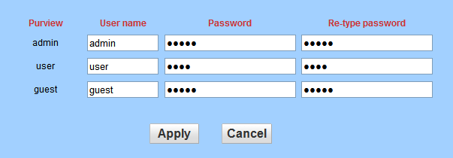

Auto Snap Setting
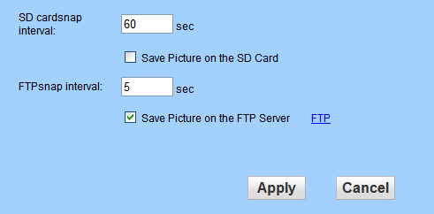
Tick “Save Picture on the SD card ”, the snap pictures will be stored onto SD card or send to ftp server;

Email Setting
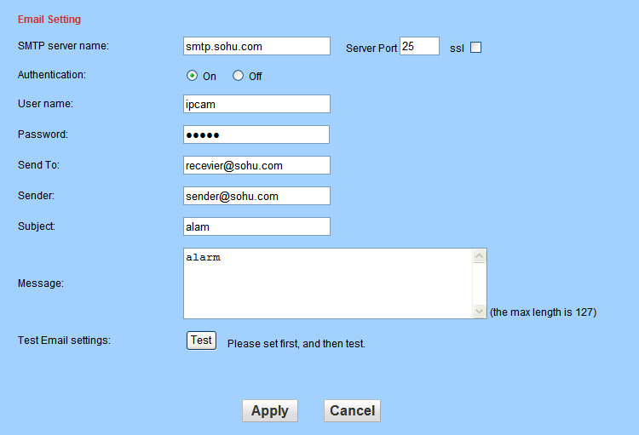

- SMTP server: fill with email server address, for example: sohu email sever, here you should fill with “smtp.sohu.com”
- In Figure , the blanks which have been filled with info should be filled. If any info is not filled right, the setting will fail.
- First click to “Apply”,second click to “Test”.

Timer record
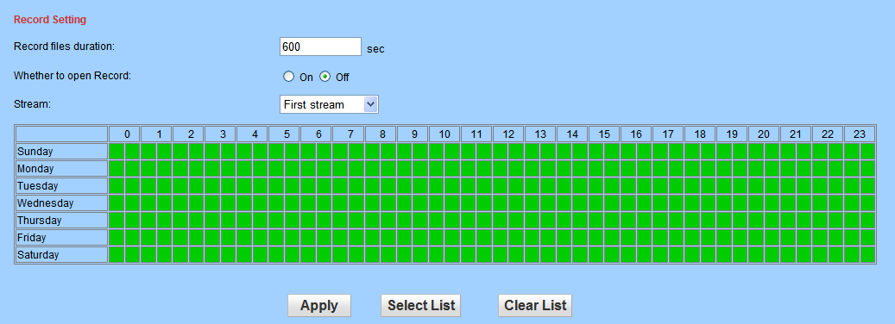
Record files duration:can be setting record files duration,default set 600 sec;
Open record:choose Whether to open Record to SD card;
Stream:setting Record Stream
Record time: setting timer record

FTP Setting
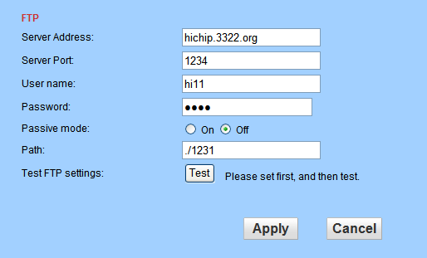
Note: in order to use FTP functions, we first need to on the FTP server application user name and password, and apply for certain storage space, and asked for the user to the storage space has written and establish directory permissions.

Terminal protocal

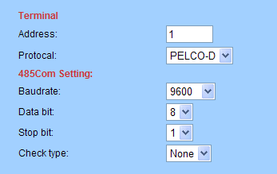

IP camera support RS485 agreement, when using, need to choose to use the agreement, address and Baud rate;
IP camera only support PELCO-D and PELCO-P two kind of agreement

System Setting

Date and Time Setting
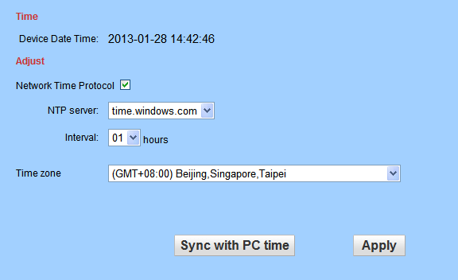

Please refer to above Figure . There are three options to set the time and date. One is manually, another is keeping the same as the time and date on the computer, and the third one is getting it from the NTP server.

Initialize Setting
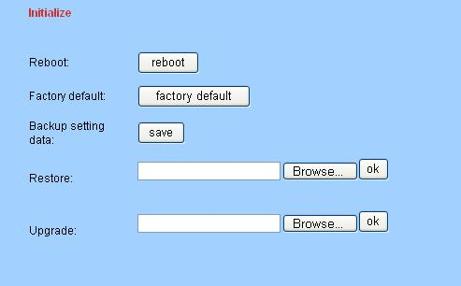
- Reboot button to restart the equipment, if you have set the pre-position, and it will turn this position.
- Click “Factory Default” button, equipment will restart and back to all the default settings.
- Click “save”, it will save all the present settings.
- “Restore” part, select the setting file you have saved, click OK, it will recover all the settings.
- “Upgrade” part, select the firmware file for upgrading, click OK, and you are able to upgrade the equipment. After the upgrading, equipment will restart. Upgrading took a little long, please wait patiently. If upgrading is finished, it will show you a message to remind you.

Device Information
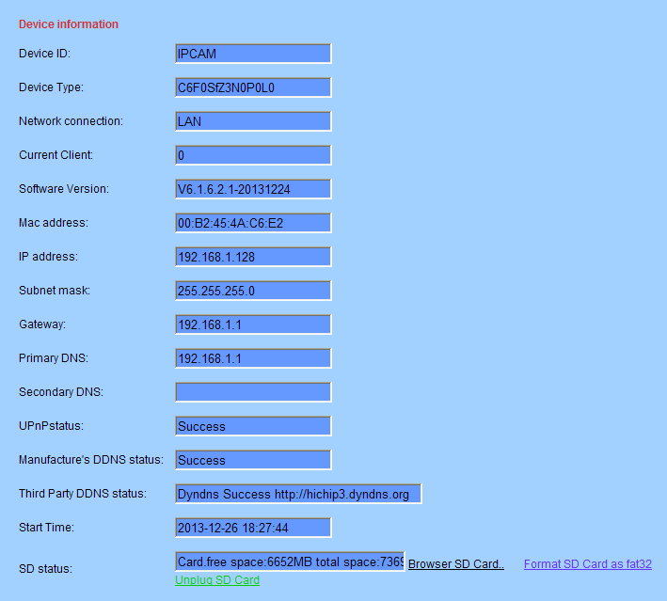

- Device ID is set by factory. Every ID is unique
- Network Connection status will display “LAN” when connected by wired cable and display “Wireless LAN” connected by wireless Router.
- SD status will remind if SD card inserted and display the free capacity. Click “Browse” to view the contents in SD card and, “Format SD Card as fat32” to format SD Card and, “Unplug SD Card” to stop the work of SD Card.
The device supports max 32G SD card. Please format the SD card to FAT32 before use the card on Camera. Please check if the SD Card matches the camera or not before purchase the SD Card.

FAQ
1.Forget password
There is a "Reset" button on the back panel of the IP camera,press it 5 times to restore all default parameters (Factory settings),user name and password are both "admin"

Solution：

- NO video Image displayed in IE browser
Possible reason:ActiveX not installed
Solution:ActiveX must be installed when visiting IP camera for the first time via internet Explore.
How to install:Visit IP camera,click [Download Address],file download dialog will pop up,select [Run] or [Save] to download,After download finishes,installation interface will pop up,click "install", the installation of ActiveX will start automatically,"Register OCX success" dialog box will pop up to remind the completion of installation process.
- Fail to visit IP camera via IE browser
Possible Reason 1:Network is disconnected.
Solution:Connect your PC to network,checking whether it works properly or not.check whether there is cable failure or network failure caused by pc virus,until PCs can be connected with the command of ping.
Possible reason 2: IP Address has been occupied by other devices
Solution: Stop the connection between IP camera and Network, hook up IP camera to PC
separately, reset IP address according to the proper operations recommended.
Possible reason 3: IP addresses are in different subnets.
Solution: Check IP address, subnet masking address of the DVS and the settings of
Gateway.
Possible reason 4: Physical address of network conflict with IP camera
Solution: modify the physical address of IP camera.
Possible Reason 5: Web port has been modified
Solution: Contact Network Administrator to obtain related information.
- There is no sound while monitoring
Possible Reason: No audio input connection
Solution: Check audio connection of the host
Possible Reason 2: the audio option of IP camera is off
Solution: Check audio parameter settings to see if you have opened the audio.

- Fail to visit IP camera via IE after upgrade
Solution: Delete the caching of Browser.
Steps: Open IE—click “Tools”—select “Internet Options”—click “delete files” button in
“Internet temporary files”, select “delete all offline contents”, then click “OK”
and re-log in IP camera.

Thank you for using the network cameras, as a result of each type of the difference between the system software upgrade or cause appearance or function and this manual different, please feel free to contact with the manufacturer. For these changes I'm sorry we can not inform you.

END

